Modelling Dollar Amounts to $100 Behaviours/Strategies
- Student models amount in one way (using smaller denominations).  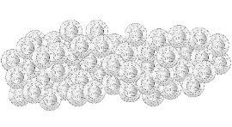  “I used toonies to make $98 because I know how to  skip-count by 2s:  2, 4, 6, …, 94, 96, 98.” | - Student models amount in more than one way, but trade was not accurate.  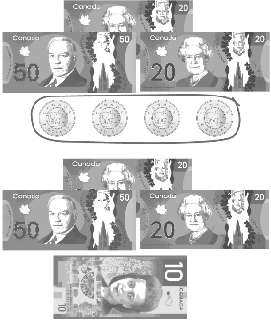  “I traded 4 toonies for a $10 bill.” | - Student models amount in more than one way and skip-counts to check.  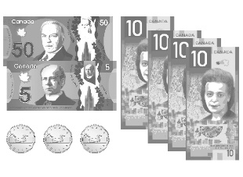  "50, 60, 70, 80, 90, 95, 96, 97, 98. The collection has a value  of $98." | - Student successfully models amounts in different ways and finds fewest number of coins/bills needed.  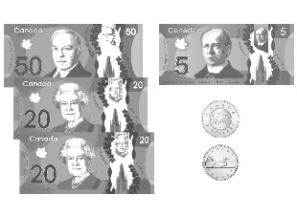  “To find the fewest number, I traded smaller coins/bills for larger coins/bills until I could make no more.” trades.”
Observations/Documentation

