Using Known Doubles Behaviours/Strategies
- Student guesses and is unable to  extend known sums to solve other equations.  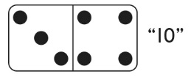 | - Student counts all the dots by 1s  and is unable to extend known  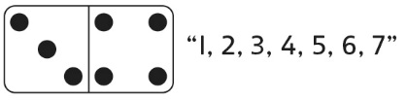  sums to solve other equations. | - Student counts on to find the  number of dots and is unable to  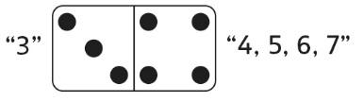  extend known sums to solve other equations. | - Student extends known sums to  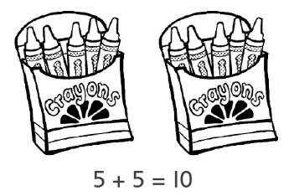  solve other equations, but refers to doubles pictures.
Observations/Documentation
- Student has quick recall of known  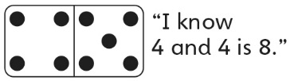  sums (doubles), but cannot extend them to solve other equations. | - Student extends known sums to  solve other equations, but cannot  explain strategy used.  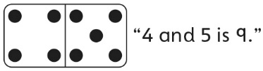 | - Student fluently extends known  sums to solve other equations,  but struggles to write the number  sentence. | - Student fluently extends known  sums to solve other equations and writes number sentences.
Observations/Documentation

