Conceptual Understanding of Story Problems Behaviours/Strategies
- Student reads story problem, but  is unable to model add-to and  take-from situations with concrete materials. | - Student models the problem, but  uses the wrong operation to solve it. | - Student models and solves the  problem, but cannot use symbols  and equations to represent it. | - Student successfully models, solves, and symbolizes addition and subtraction problem types and represents thinking on the Think Board.
Observations/Documentation
Addition and Subtraction Computational Behaviours/Strategies
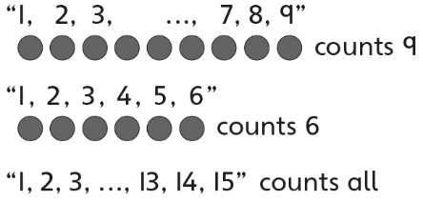  - Student counts three times to add or subtract quantities. | - Student counts on or back to add  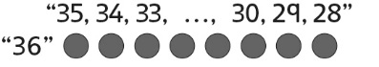  or subtract quantities. | 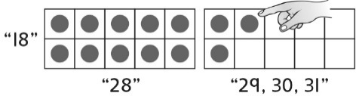  - Student counts efficiently to add or subtract quantities (e.g., makes 10 and then counts on or subitizes). | - Student uses mental strategies  flexibly and accurately to add or  subtract quantities.  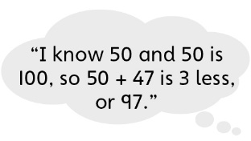
Observations/Documentation

