Story Problems 3
Master 73a

(Part Unknown: Joining)

Note: Story Problem Card 3 is for use as an accommodation. 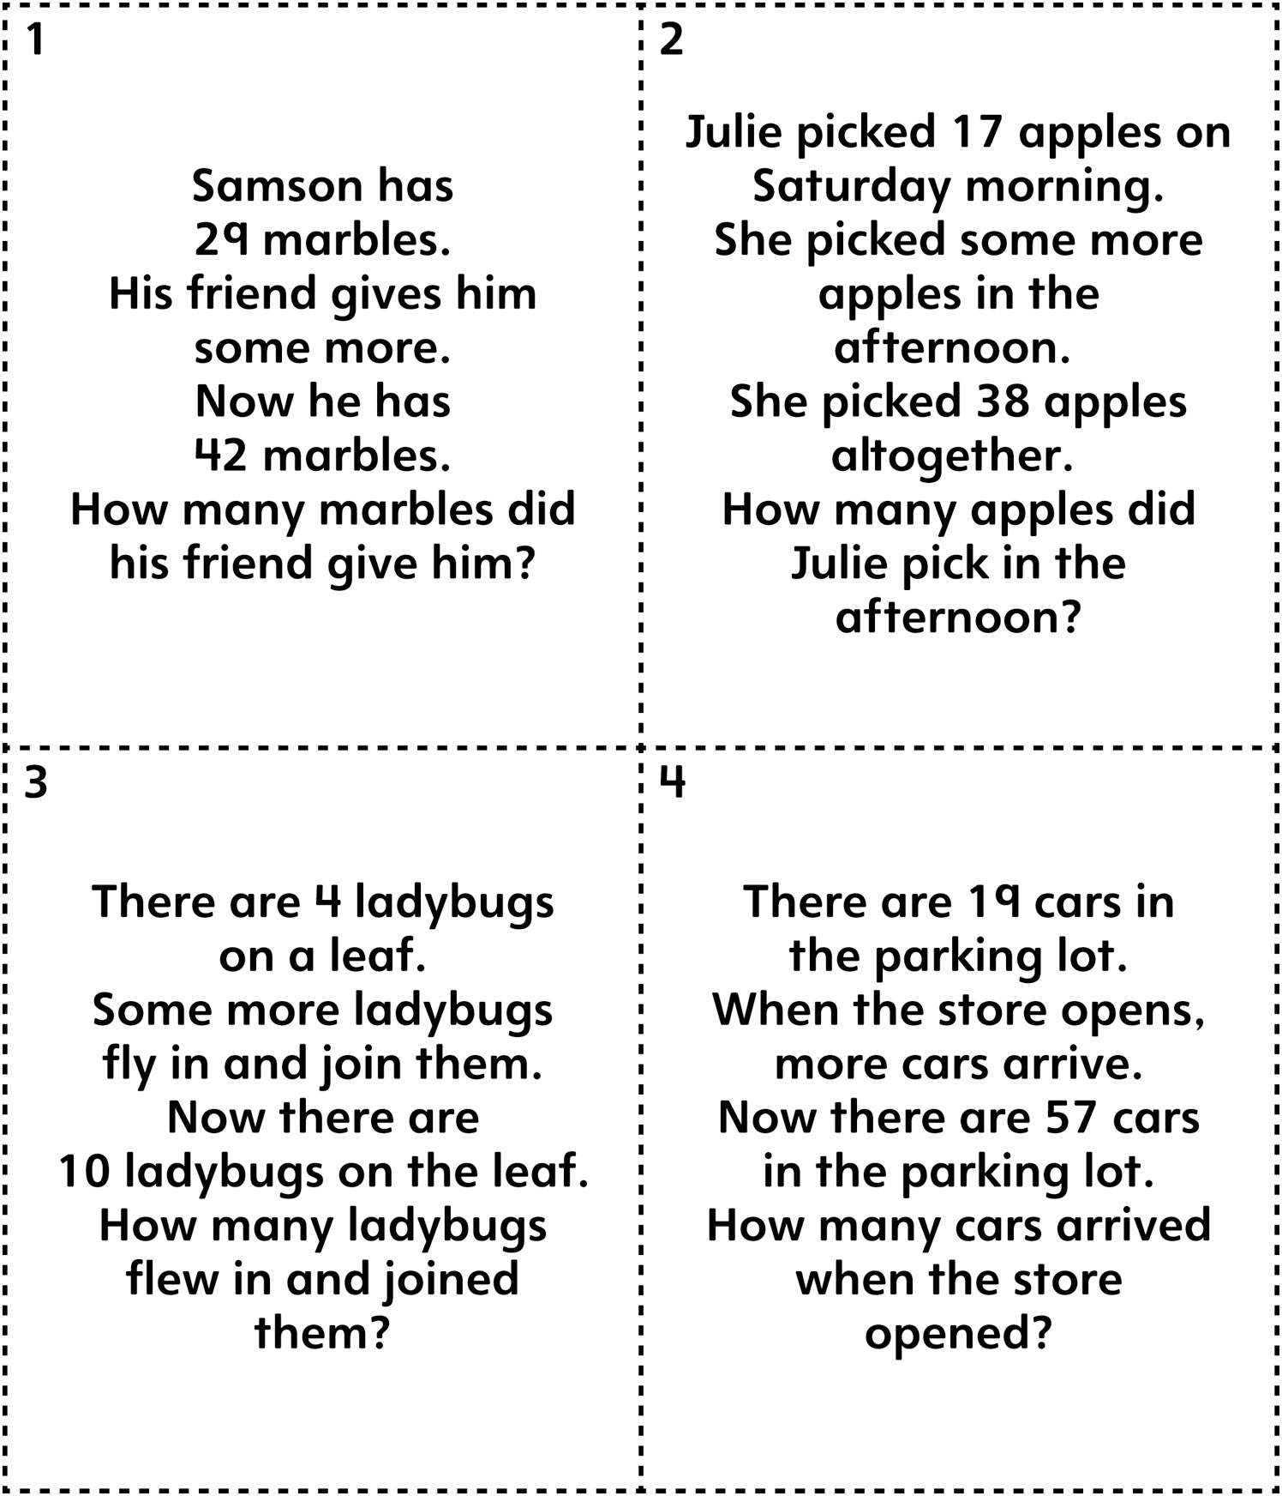
Story Problems 3
Master 73b

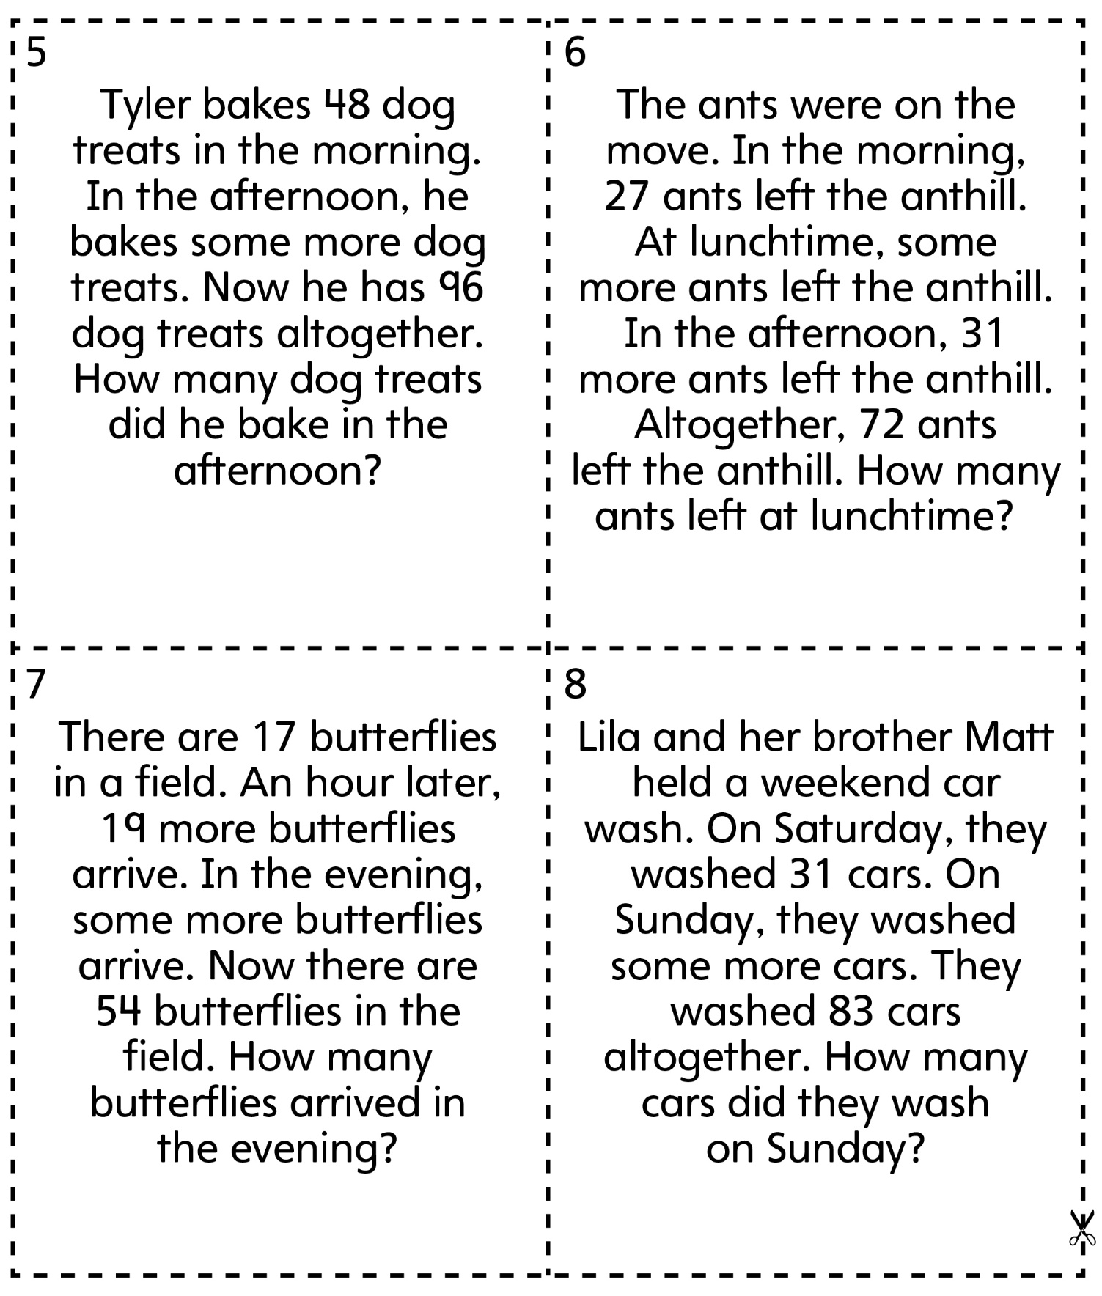
(Part Unknown: Joining)

