Operational Sense Behaviours/Strategies
1. Student uses counting on a number line to show addition.  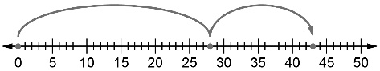  28 = ? − 15  “I counted to 28 on the number line.  Then, I counted another 15 to show:  28 + 15 = 43” | 2. Student decomposes and recomposes numbers (uses associative property one way).  28 + 15 = 28 + 2 + 13  28 + 2 + 13 = 30 + 13  30 + 13 = 43 | 3. Student recognizes that there are multiple ways to decompose and recompose numbers and that the result will be the same.  “I know another way to make the addition easier.”  28 + 15 = 23 + 5 + 15  = 23 + 20  = 43 | 4. Student uses strategies efficiently and flexibly to solve equations of different types  “I can break a number down in different ways in different situations.”
Observations/Documentation

