**Target Number Cards**

**Master 57a**

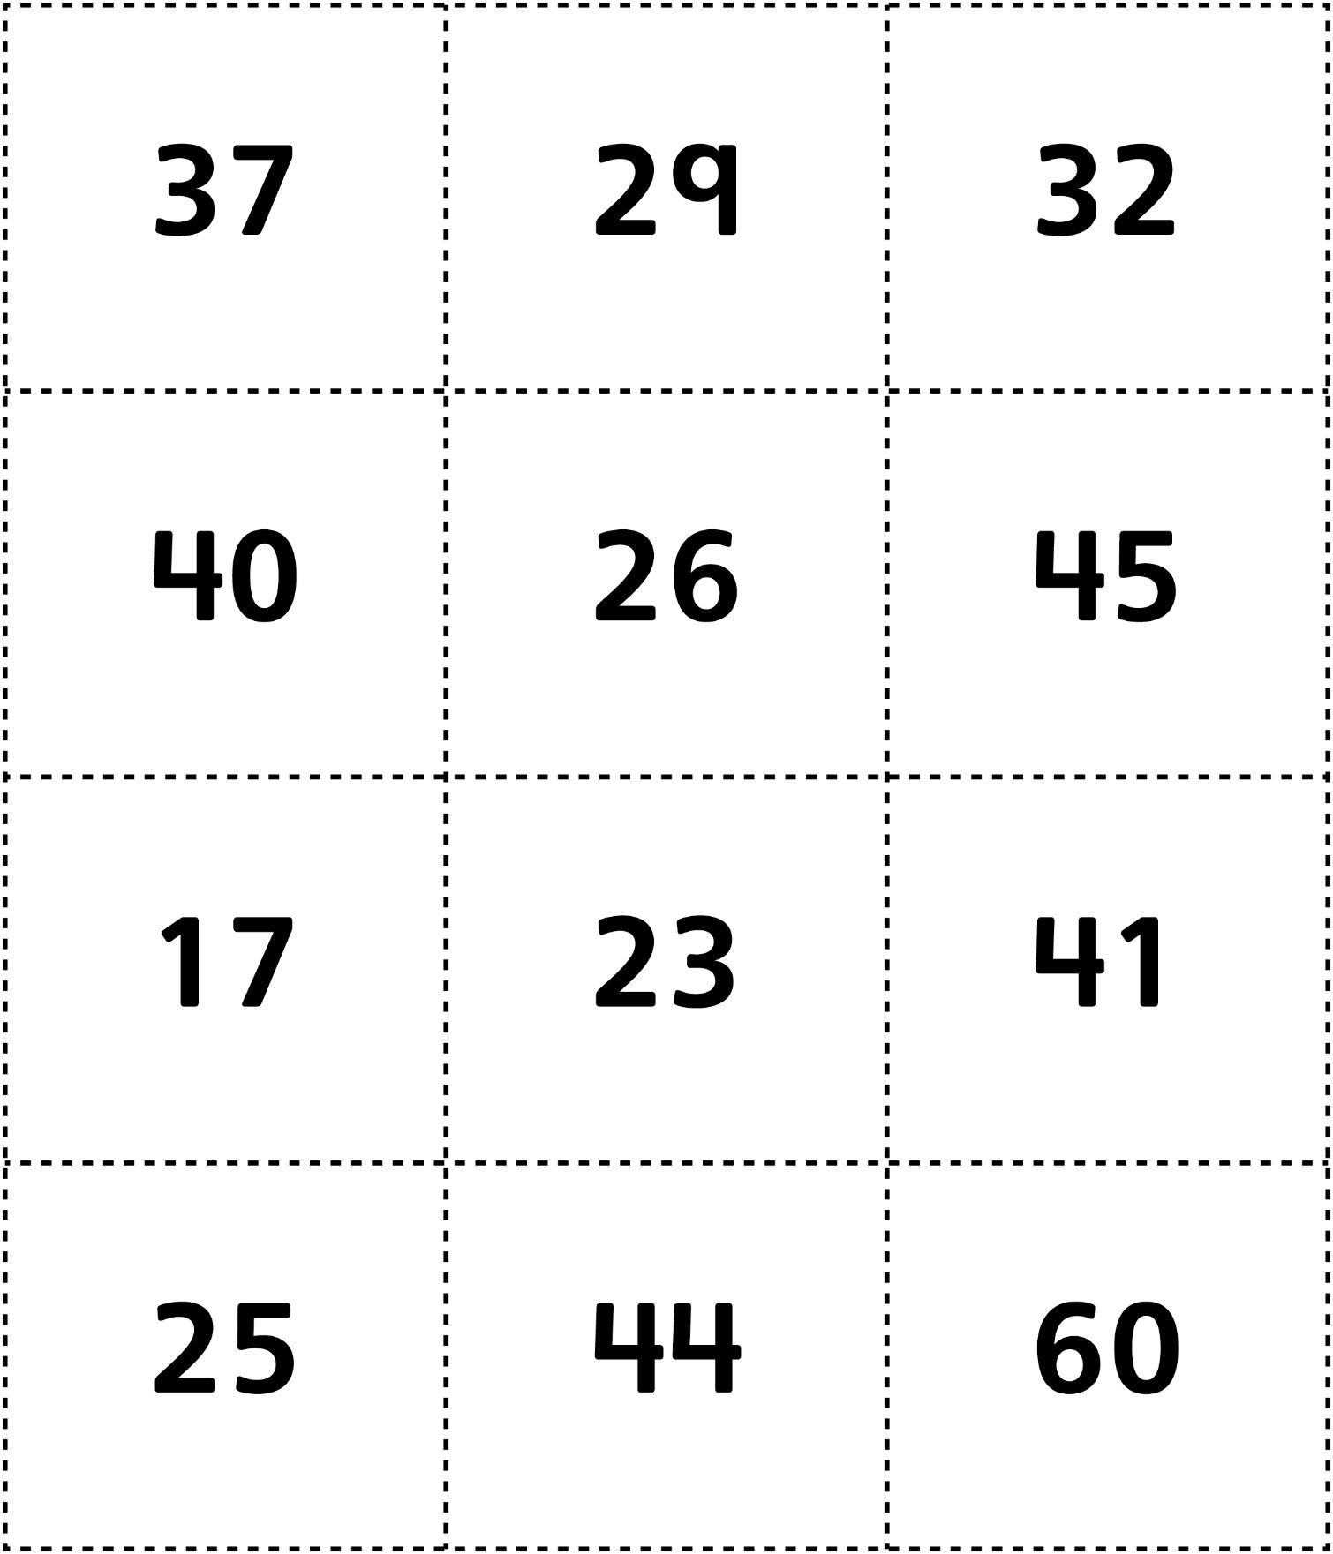

**Target Number Cards**

**Master 57b**

**(for Accommodations)**

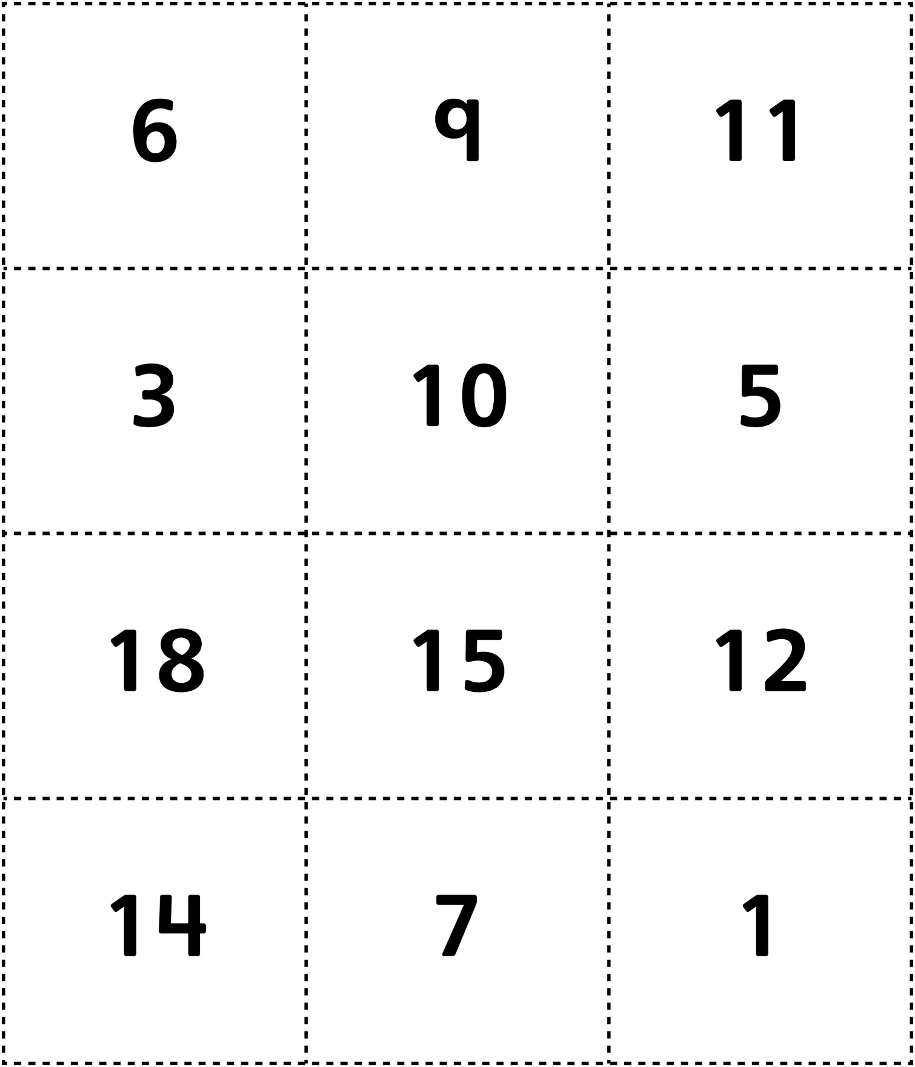

**Target Number Cards**

**Master 57c**

**(for Extension)**



