Making a Whole with Unit Fractions Behaviours/Strategies
- Student does not understand that a unit fraction represents the parts of whole and cannot make the whole object or set.  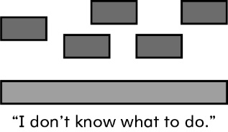  “I don’t know what to do.” | - Student recognizes that a unit fraction is part of a whole but is unable to make a whole and struggles with the concept of size of part and size of whole.  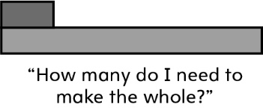 | - Student recognizes a unit fraction and can read it but is unable to put together more than one unit fraction to make a whole object or set.  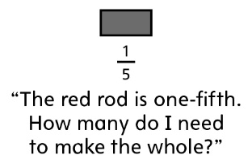
Observations/Documentation
- Student can make a whole object or set using smaller unit fractions but struggles with larger unit fractions (e.g., makes a whole with one-half but struggles with one-eighth).  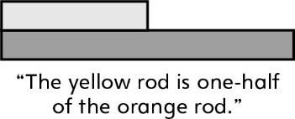  “The yellow rod is one-half of the orange rod.” | - Student can make a whole from any given unit fraction but does not yet explain how the unit fraction relates to the making of the whole.  “The yellow rod is one-half of the orange. I need two yellows to cover a whole orange rod. The red rod is one-fourth of the brown. I need four reds to cover a whole brown rod.” | - Student can make a whole from any given unit fraction and can explain the relationship between the unit fraction and the number of pieces needed to make a whole.  “One-fifth tells me I need 5 parts to make a whole.”
Observations/Documentation

