Composing and Decomposing 3-Digit Numbers Behaviours/Strategies
1. Student composes and a  three-digit number using 35 Base Ten Blocks.  “I modelled 134.” | 2. Student trades 1 ten for 10 ones to compose a lesser three-digit number using 35 Base Ten Blocks.  “I traded 1 hundred for 10 tens.  I need 25 more ones to have 35 Base Ten Blocks.”  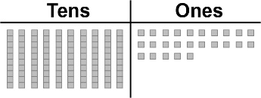  “I modelled 125.” | 3. Student continues to trade 1 ten for 10 ones until they can no longer model a three-digit number.  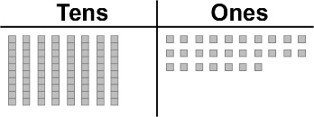  “If I continue trading, I will not get a three-digit number.  107 is the least number I  can make.” | 4. Student uses place value to represent a number in different ways.  “One hundred seven  1 hundred, 0 tens, 7 ones;  8 tens, 27 ones  107 ones  IIIIIIII•••••••••••••••••••••••••••”
Observations/Documentation

