Number Relationships Behaviours/Strategies
- Student partitions quantities into groups of 2, but struggles to identify even and  odd numbers.  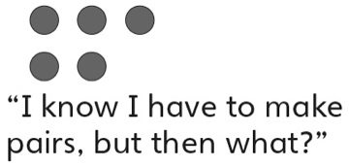 |  | - Student models numbers with manipulatives to help order on number line. |  | - Student compares and orders written numbers using benchmarks.  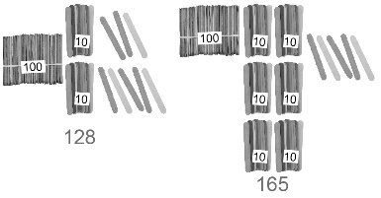  “I know 245 is less than 250 and 259 is greater than 250. So, 259 is greater than 245.”
Observations/Documentation
- Student compares numbers, digit by digit.  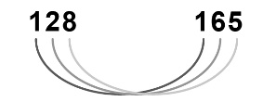  “Both have 1 hundred. 128 has 2 tens and 165 has 6 tens. So, 165 is greater than 128. |  | - Student successfully uses benchmarks to compare and order.  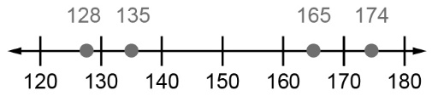  The numbers from least to greatest are:  128, 135, 165, 174. |  | - Student performs number relationship tasks with ease and communicates thinking using  math language.
Observations/Documentation

