Counting On and Back Behaviours/Strategies
- Student uses correct start number, but omits numbers or mixes up the order when saying the number name sequences forward and backward.  “11, 12, 14, 16, 17” | - Student says the number name  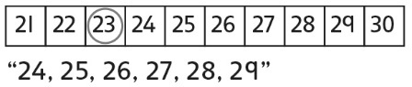  sequences forward and backward from a given number, but relies on the hundred chart. | - Student says number name sequences forward and backward from a given number, but struggles to bridge tens or hundreds.  “Ninety-nine, one-ten, one-eleven” | - Student says the number name  sequences forward and backward from a given number and uses number patterns to bridge tens and hundreds.
Observations/Documentation
Skip-Counting Forward Behaviours/Strategies
- Student uses correct start number, but mixes up the numbers or omits numbers when skip-counting forward by 2s  or 10s.  “5, 15, 20, 30, 40” | - Student skip-counts forward  from 0, but struggles to skip-count forward from any number.  “It is much easier to skip-count  forward starting at 0.” | - Student skip-counts forward by 20s, 25s, and 50s starting at 0, but uses fingers or the hundred chart to help.  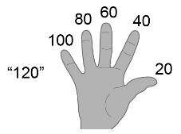 | - Student fluently skip-counts forward within 1000 by 2s and 10s from any number and by 20s, 25s, and 50s from 0.  “325, 335, 345, 355, 365, 375”  “0, 50, 100, 150, 200, 250, 300”  “0, 25, 50, 75, 100, 125, 150”
Observations/Documentation

