Skip-Counting by 2s Game Cards
Master 16a

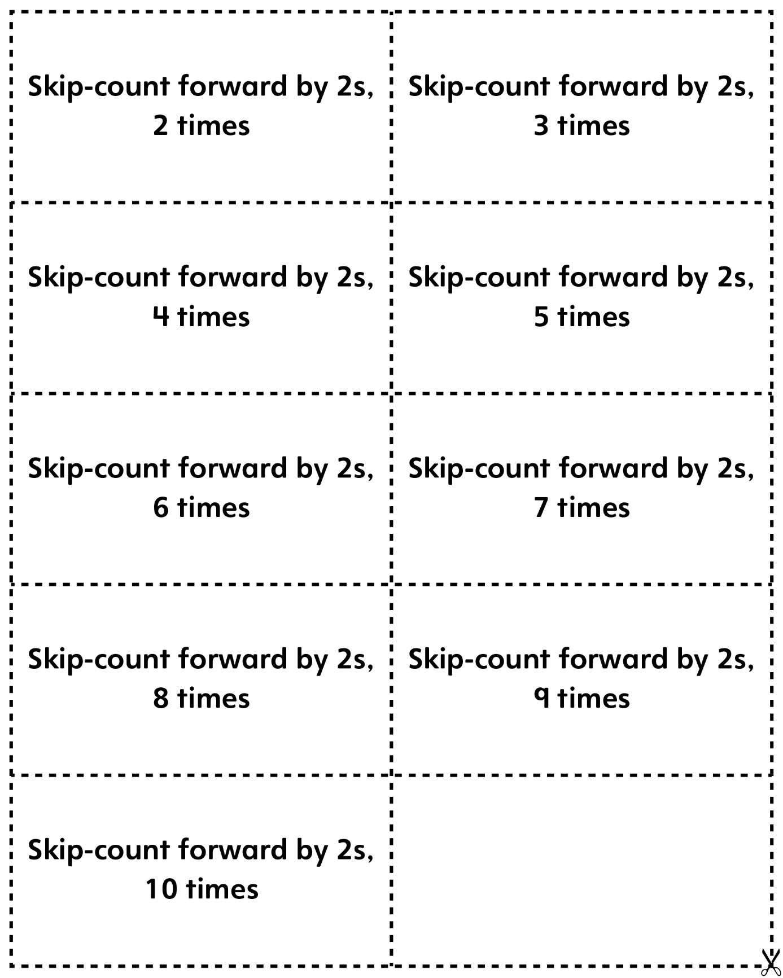
Skip-Counting by 10s Game Cards
Master 16b

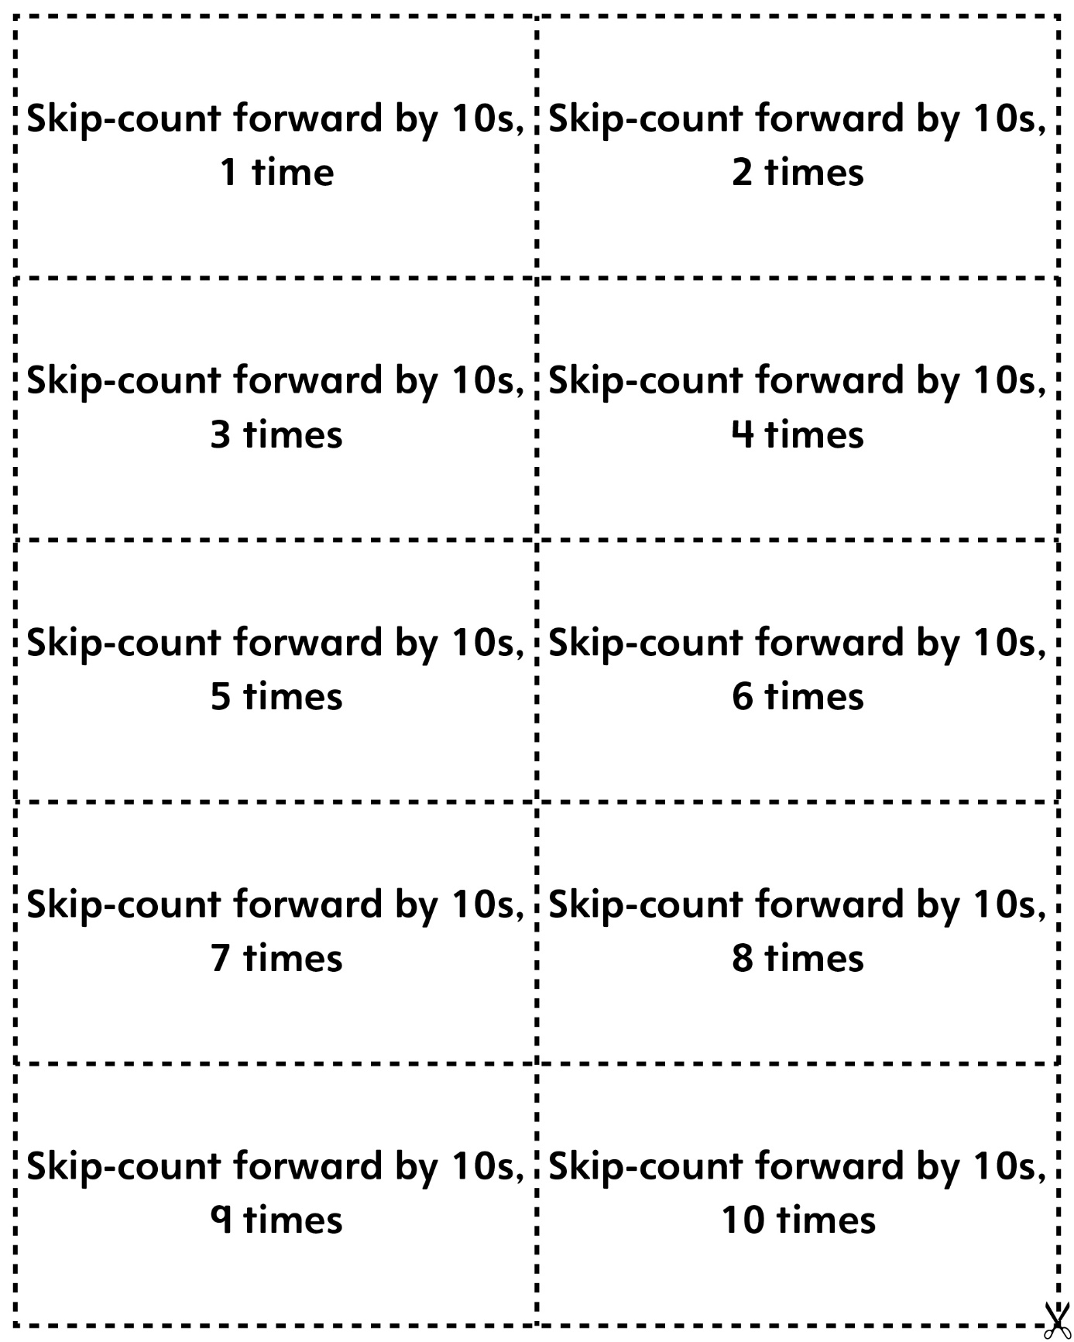

Skip-Counting by 20s Game Cards
Master 16c

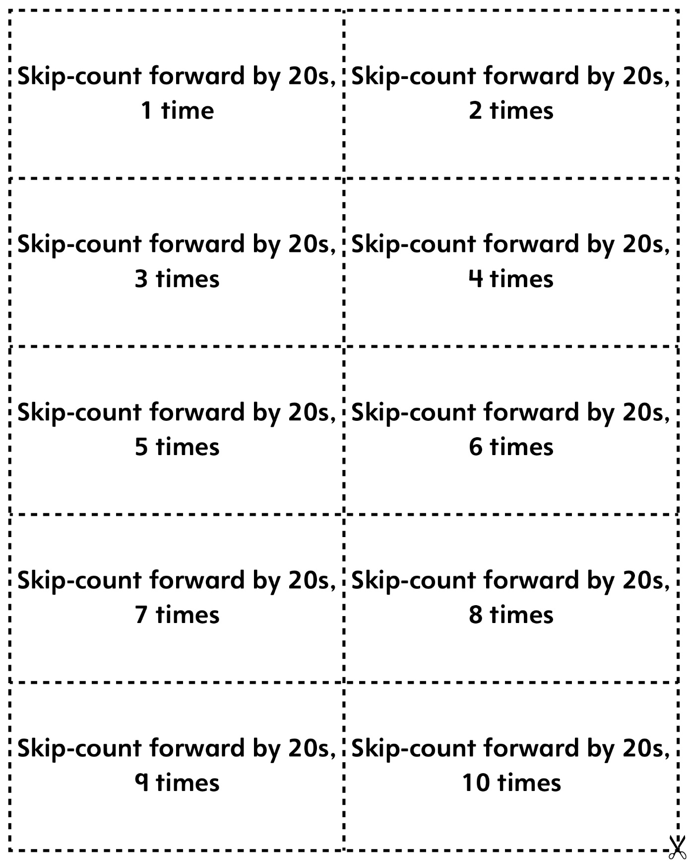
Skip-Counting by 25s Game Cards
Master 16d

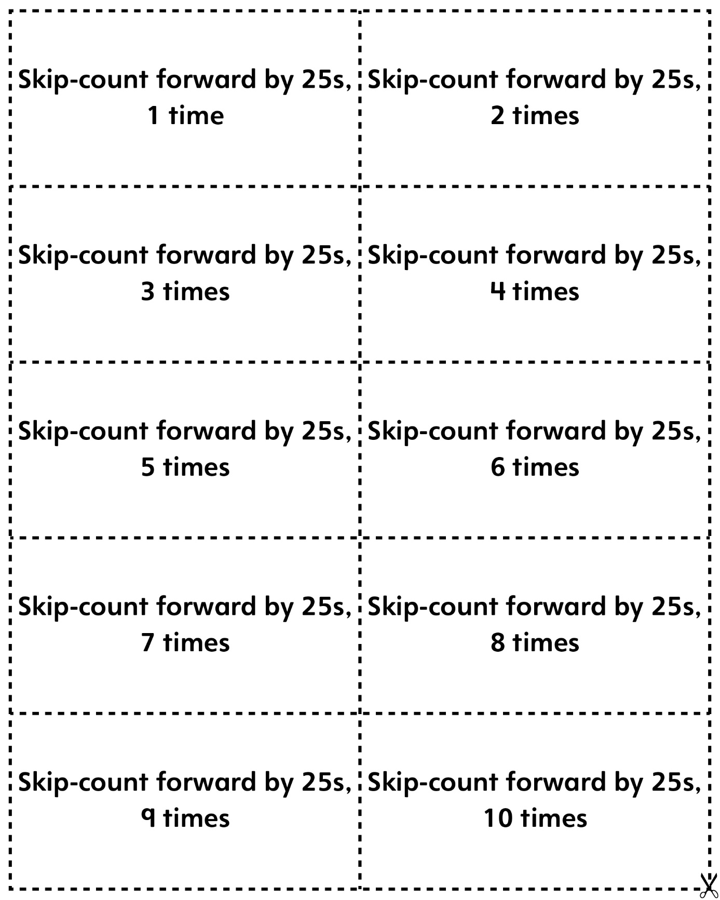
Skip-Counting by 50s Game Cards
Master 16e

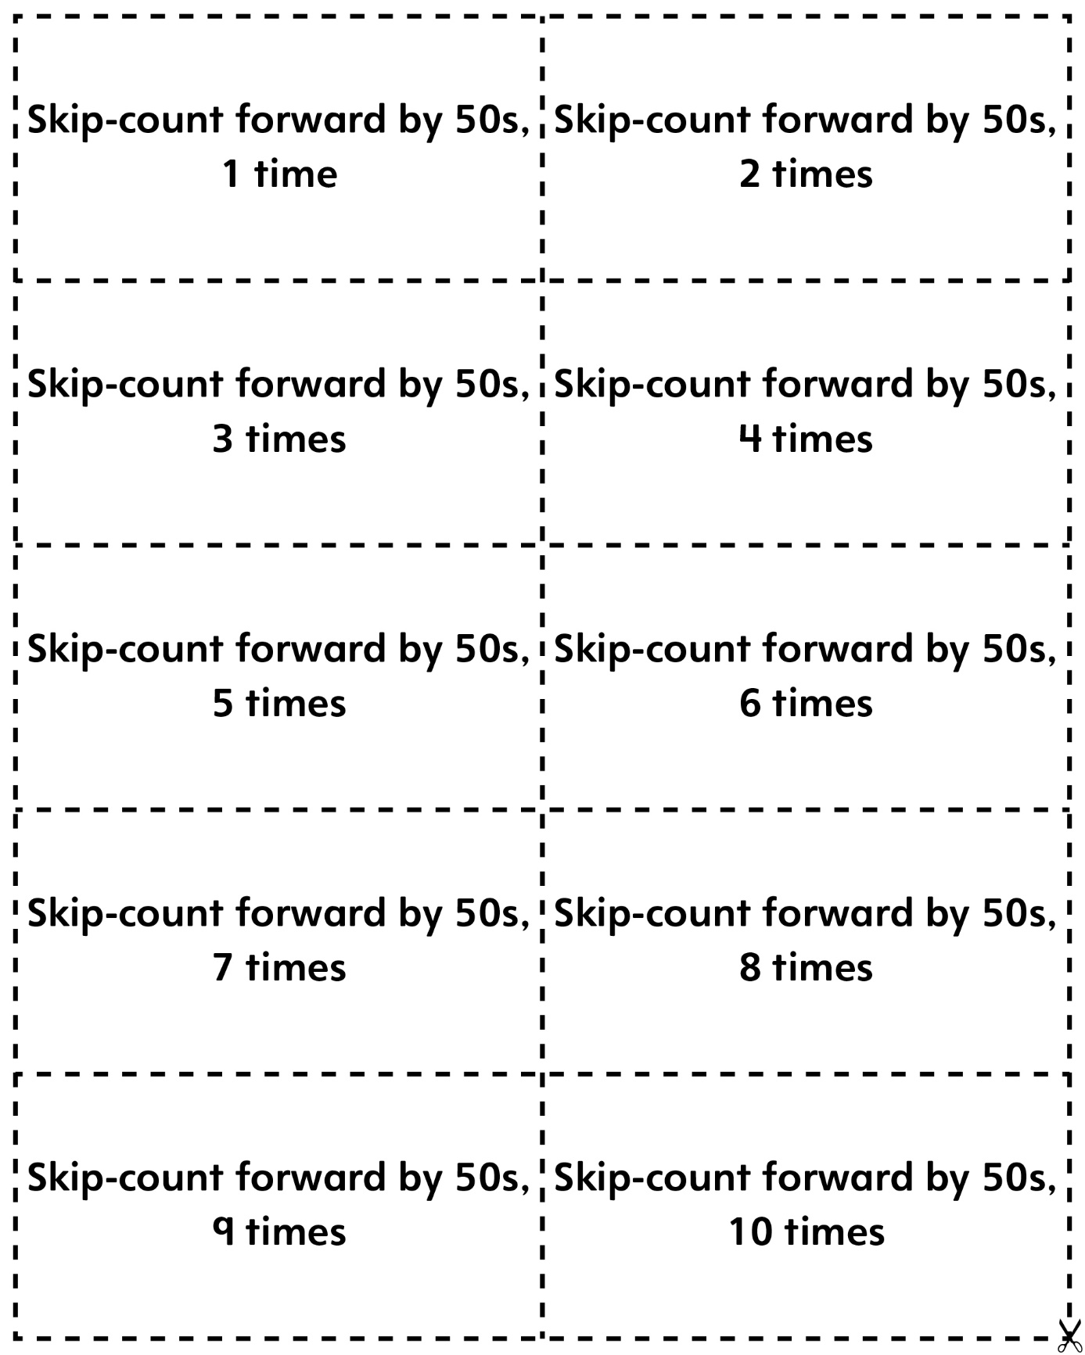

Skip-Counting Game Cards
Master 16f
(Blank Cards)

