Counting On and Back Game Cards
Master 15a

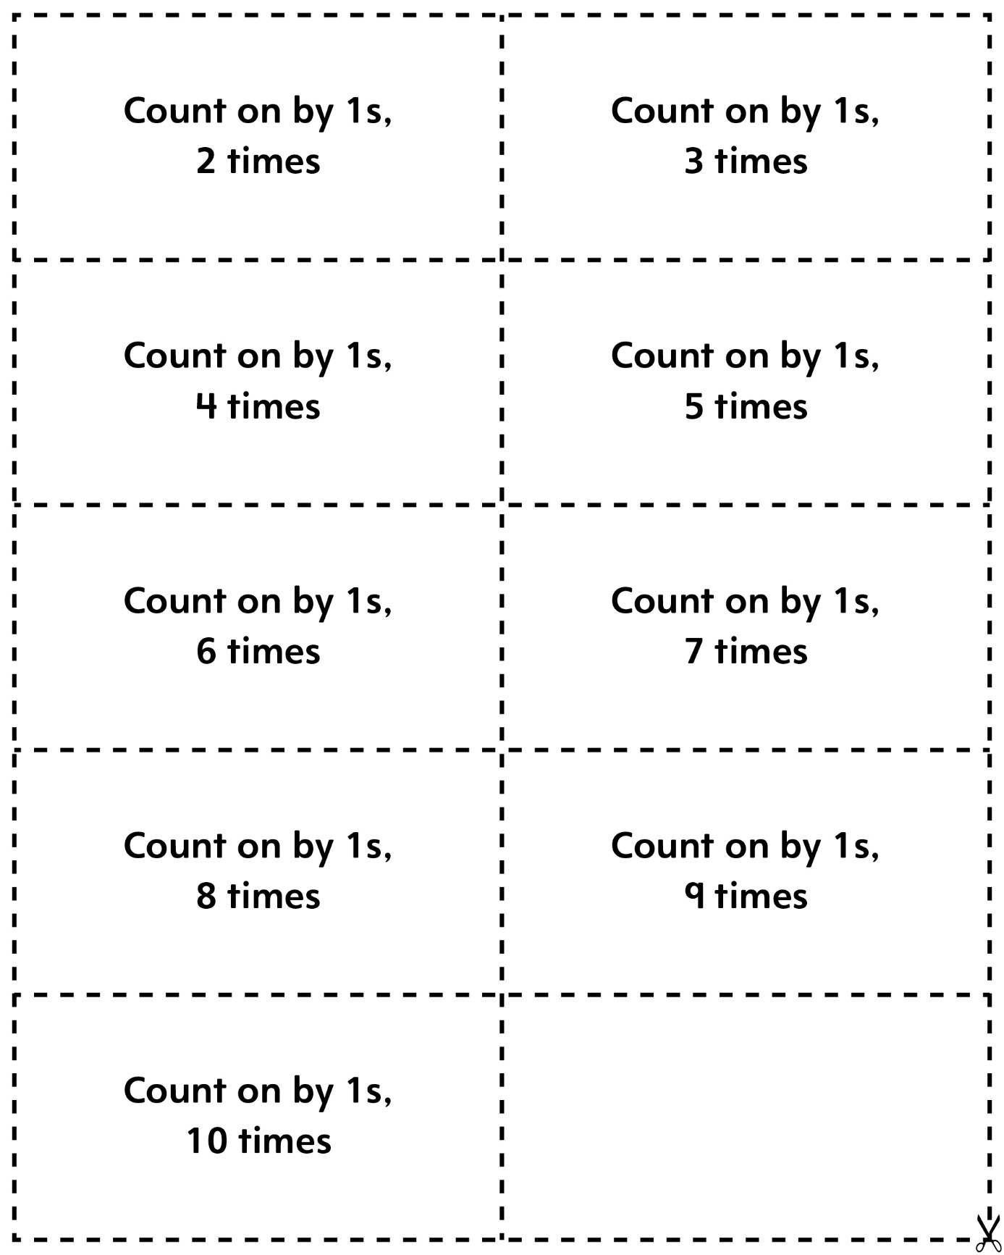
Counting On and Back Game Cards
Master 15b

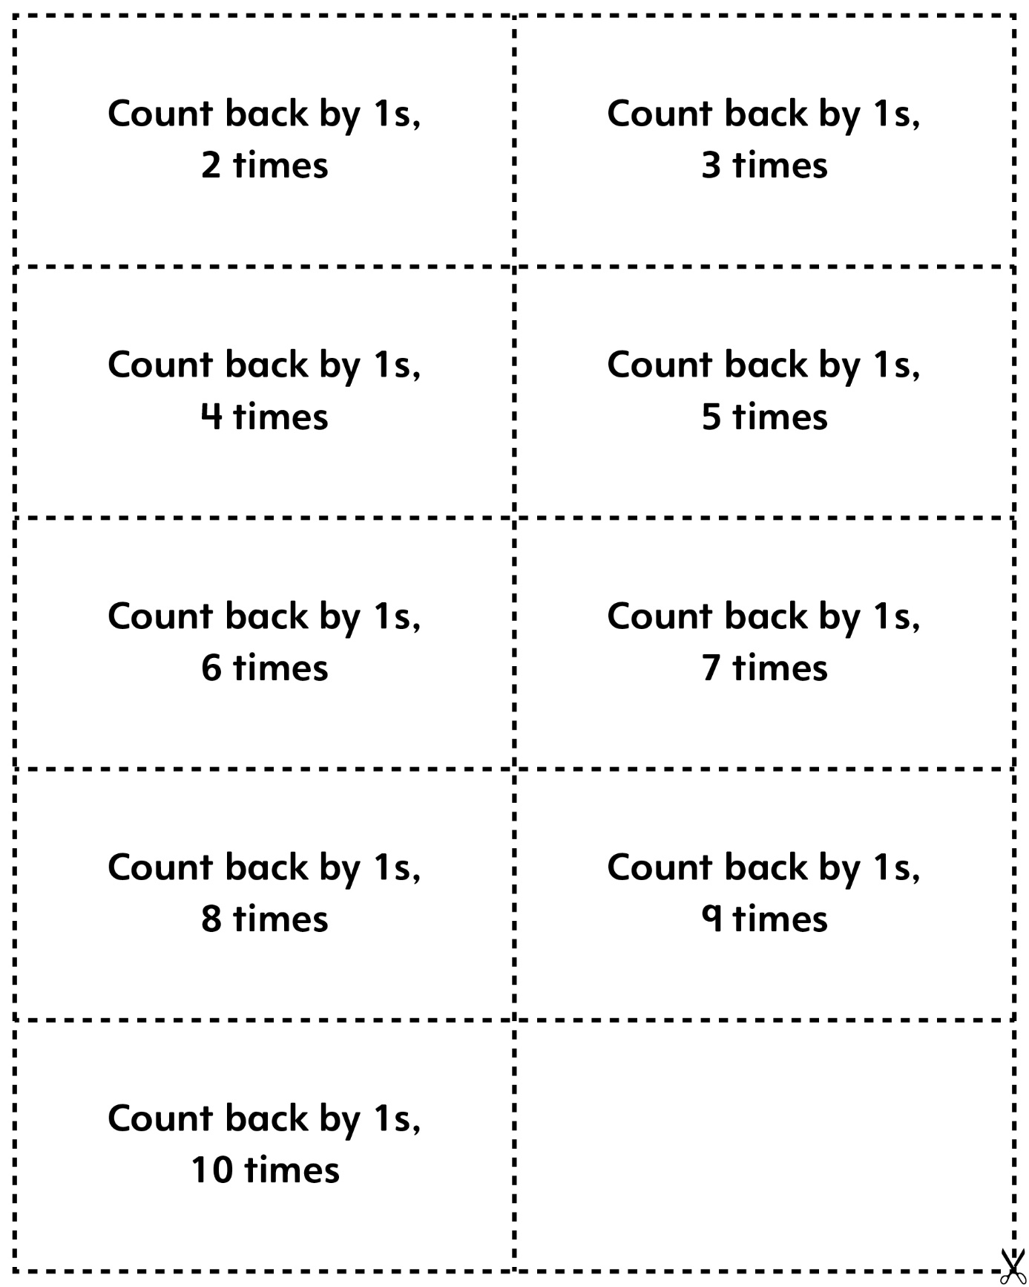

Counting On and Back Game Cards
Master 15c

(Blank Cards)

