Skip-Counting Forward Behaviours/Strategies
- Student fluently counts forward by 1s from  a given number, but struggles to skip-count. | 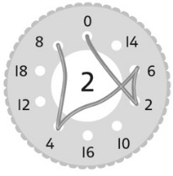  - Student draws lines to join  the numbers, but mixes up  the numbers in the  skip-counting sequence. | - Student fluently skip-counts by 2s and 10s, but has difficulty skip-counting by 25s.  “I find it hard to count by 25s.”
Observations/Documentation
- Student skip-counts by 2s and 10s,  but struggles when the start number is  a multiple of 2 or 10. | - Student fluently skip-counts by 20s, 25s, and 50s, but struggles to notice and explain patterns in the skip-counting numbers.  “I don’t see patterns in the numbers.” | - Student fluently skip-counts by 20s. 25s. and 50s, and notices and explains patterns in the skip-counting numbers.
Observations/Documentation

