Relating Months and Years Behaviours/Strategies
- Student chooses a card, but does not know the months of the year. | - Student reads the months on the calendar, but struggles with the use of ordinal numbers in context.  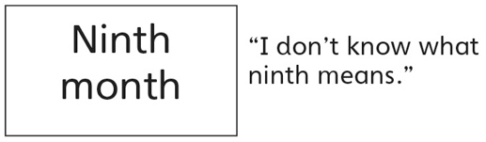 | - Student understands the use of ordinal  numbers in context, but struggles to say the  number name sequence starting with 1 and  counting forward.  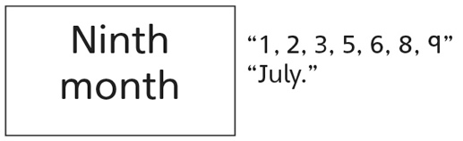
Observations/Documentation
- Student understands the use of ordinal numbers in context, but relies on a calendar to answer clue cards. | - Student understands the use of ordinal numbers in context, but is unable to order the months without referring to a calendar. | - Student understands the relationship of units  of time (e.g., months and years), successfully  answers all clue cards, and orders the cards by  month.
Observations/Documentation

