**Month Clue Cards**

**Master 20a**

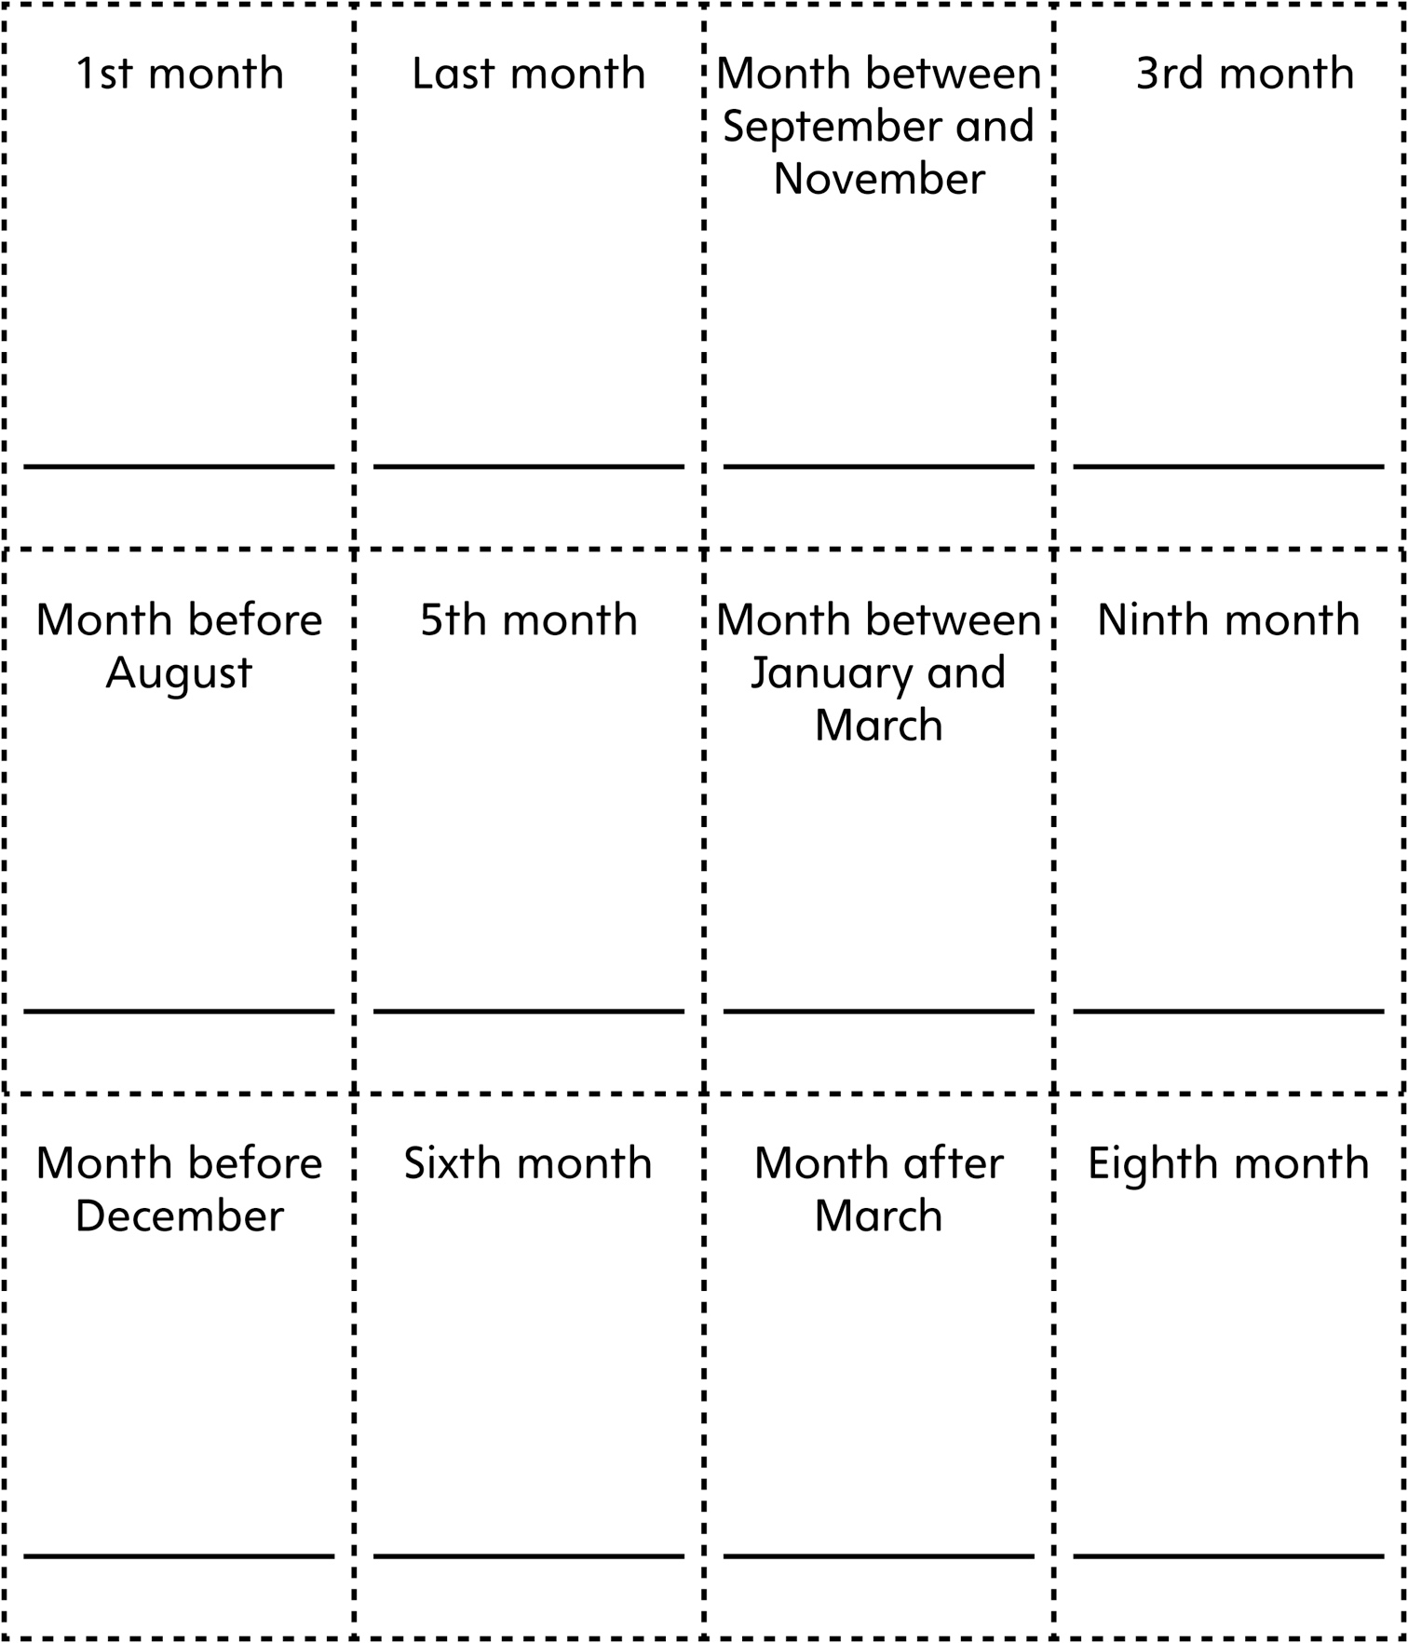

**Month Clue Cards   
(for Accommodations)**

**Master 20b**

