Measurement Hunt
Master 8

Length of Eraser  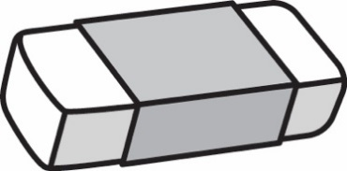  Our estimate is  ____________________________  Our measure is  ____________________________ | Length of Teacher’s Desk  Our estimate is  ____________________________  Our measure is  ____________________________
Length of Pencil  Our estimate is  ____________________________  Our measure is  ____________________________ | Length of Book  Our estimate is  ____________________________  Our measure is  ____________________________

