**Calendar Clue Cards**

**Math Every Day: Master 12a**

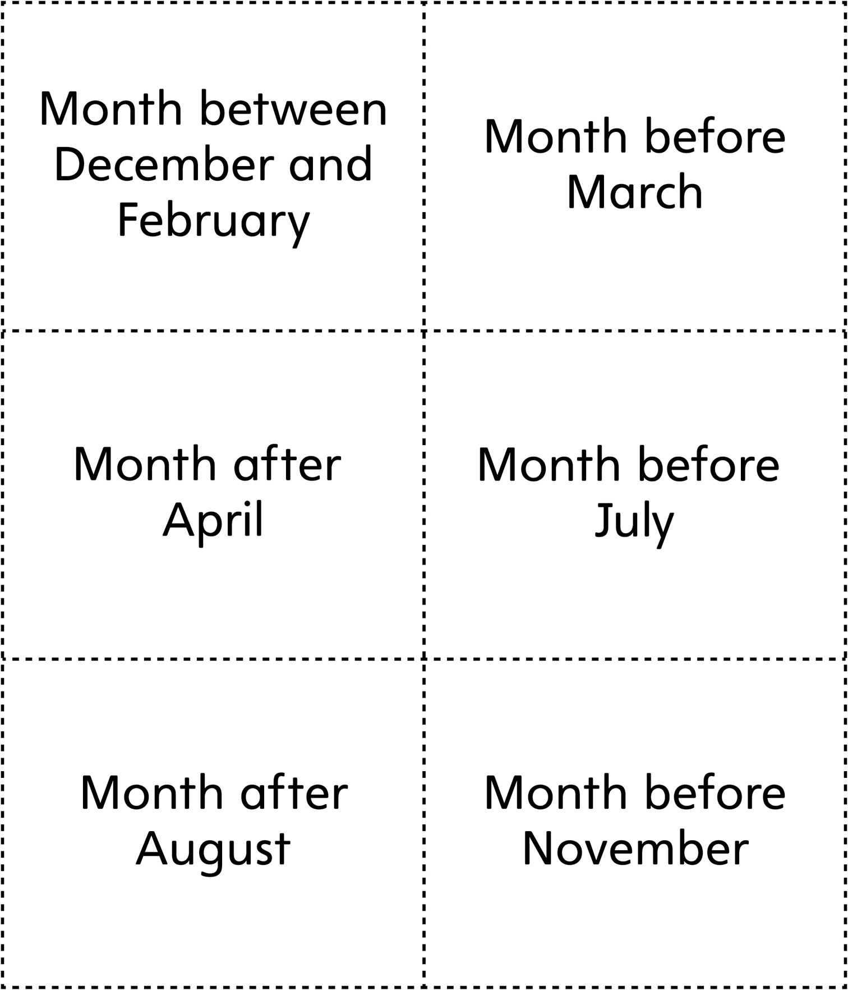

**Calendar Clue Cards**

**Math Every Day: Master 12b**

