Geometry Poem
Math Every Day: Master 13

Solids aren’t flat, they’re fat.
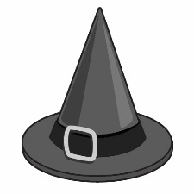
A cone is like a pointy hat.
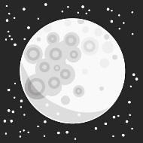
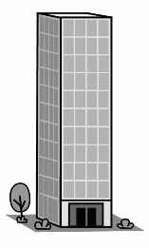
A sphere is like a full moon in the sky.

A prism is a building high.
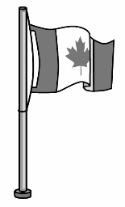
A cylinder is like a tall flag pole.
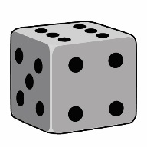
A cube is something fun you roll.

Solids are here. Solids are there.

Solids are almost everywhere.

