Skip-Counting Forward Behaviours/Strategies
- Student enters numbers into  calculator, but struggles to  skip-count by 2s and 10s and mixes up the numbers or omits numbers in the skip-counting sequence.  “10, 20, 40, 50, 70” | - Student skip-counts by 2s and 10s, but struggles when the start  number is not a multiple of  the number.  “3, 10, 20, 30, ...” | - Student skip-counts by 2s and 10s from any given number, but uses fingers or hundred chart to help.  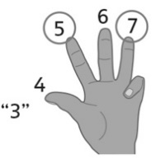 | - Student fluently skip-counts by  2s and 10s from any  given number.
Observations/Documentation

