Identifying the Core Behaviours/Strategies
- Student chooses a pattern, but struggles to  identify the core of the pattern and cannot  identify the attribute that is changing. | - Student identifies the attribute that is changing, but struggles to identify the core  of the pattern. | - Student identifies the core of a pattern when it  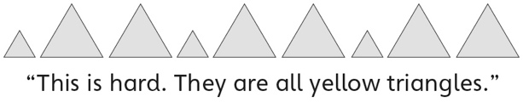  involves colour or shape, but struggles when the attribute that is changing is size, thickness, or number.
Observations/Documentation
- Student identifies the core of a pattern, but  struggles to identify what would come next in  the pattern.  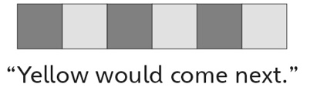 | - Student identifies the core of a pattern and  what comes next in the pattern, but struggles  to use math language to describe the core. | - Student successfully identifies the core of a  pattern and what comes next in the pattern,  and uses math language to explain thinking.
Observations/Documentation

