Grouping Objects Behaviours/Strategies
- Student counts by 1s rather than grouping  objects, but mixes up number sequence.  “1, 2, 3, 5” | - Student counts by 1s rather than grouping  objects, but does not coordinate number words with counting actions (e.g., misses items in the count, or counts items more than once).  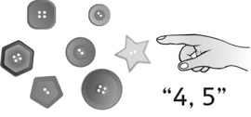 | - Student groups objects, but not all groups are  equal.
Observations/Documentation
- Student groups objects, but always makes  groups of 2 regardless of the quantity. | - Student groups objects in 2s, 5s, and 10s, but  ignores the leftover items.  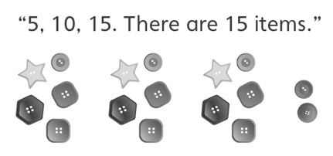 | - Student flexibly groups objects in 2s, 5s, and 10s, and includes any leftover items in the total.  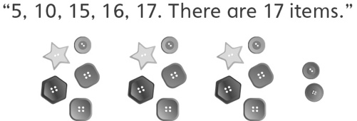
Observations/Documentation

