**Ten-Frame Cards**

**Intervention: Master 22a**

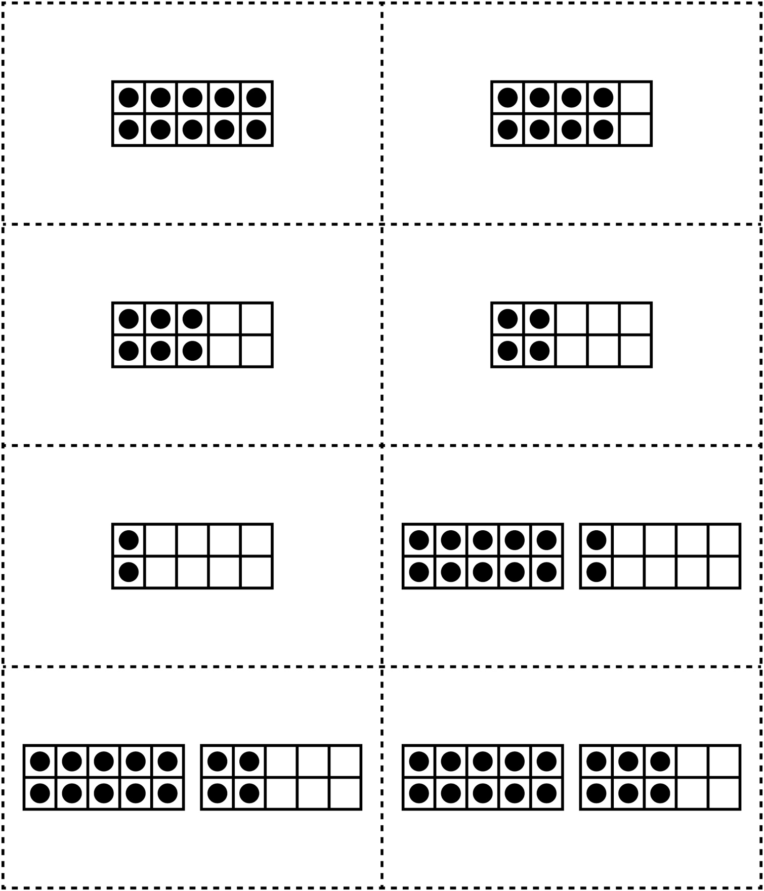

**Ten-Frame Cards**

**Intervention: Master 22b**

