**Measuring Other Animals**

**Intervention: Master 41a**

How long is my neck?

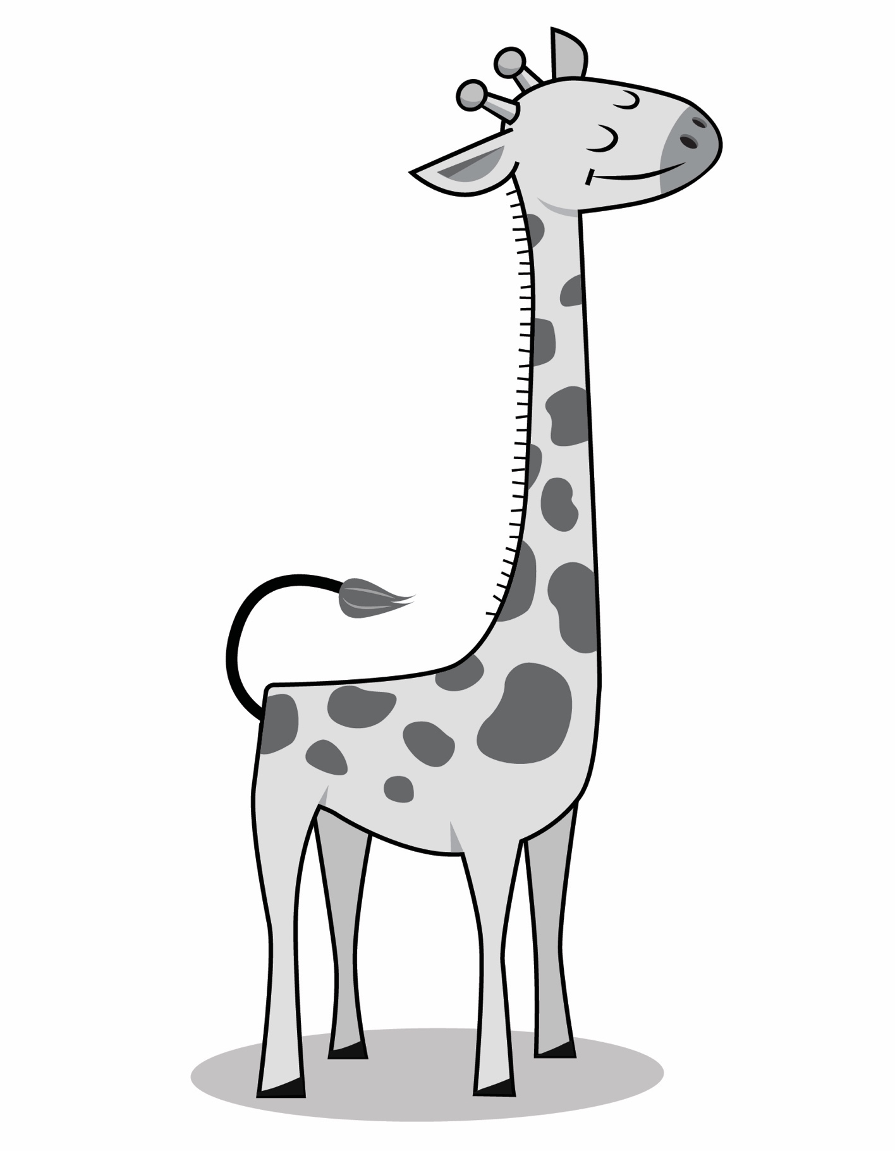

**Measuring Other Animals**

**Intervention: Master 41b**

How long are my ears?

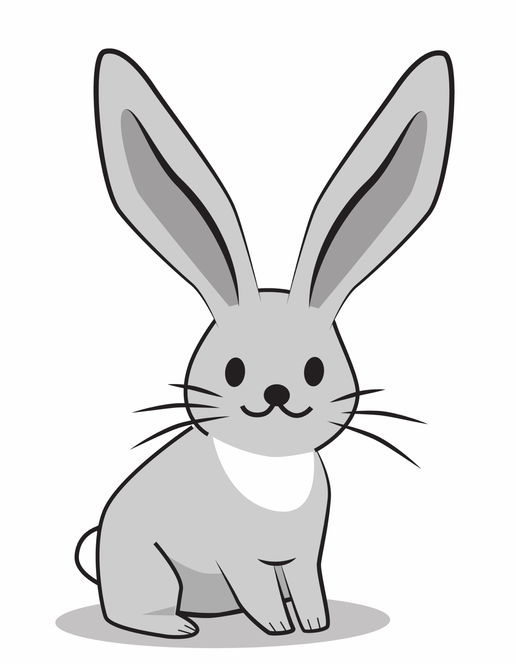

**Measuring Other Animals**

**Intervention: Master 41c**

How long is my tail?

