Sorting Objects Behaviours/Strategies
- Student sorts a set of objects, but  can only sort by colour (cannot  sort in different ways). | - Student sorts a set of objects in  different ways, but struggles to  determine which group has the  most objects.  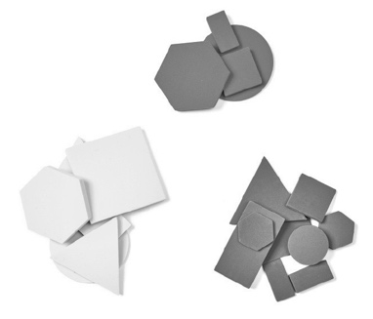 | - Student sorts a set of objects in  different ways and aligns objects  to compare, but thinks the longer  line always has more.  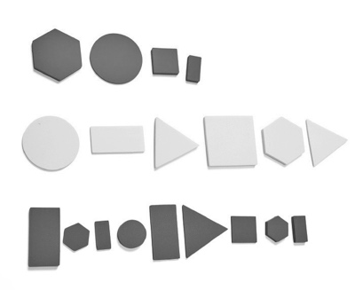 | - Student successfully sorts a set  of objects in different ways using  a single attribute and makes  comparisons.
Observations/Documentation

