Exploring Transformations Behaviours/Strategies
1. Student identifies and names simple 2-D shapes in a picture that do not overlap, but does not recognize shapes that overlap with other shapes or are combinations of other shapes.  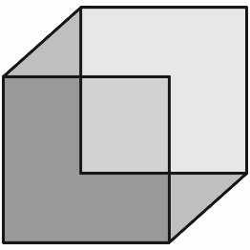  “I see 3 squares and 2 triangles.” | 2. Student identifies many shapes including those created by the overlap or combination of other shapes.  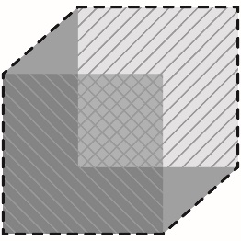  “I see 3 squares and 2 triangles.  I also see 3 different hexagons.” | 3. Student identifies 2-D shapes in the diagram as well as a 3-D object the diagram could represent.  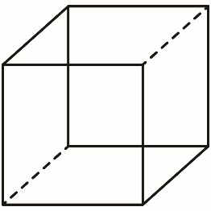  “I see squares, triangles, and hexagons, but I also see a cube.” | 4. Student recognizes the relationships between 2-D shapes and 3-D objects as well as how identical shapes can be related by transformations.  “I see squares, triangles, and hexagons. I also see a cube. The triangles are reflections in a mirror line. One of the larger squares can be translated to the other. The whole shape can be rotated around a point in the centre of the small square.”
Observations/Documentation

