**Master 36a**

**Hidden Shapes 1**

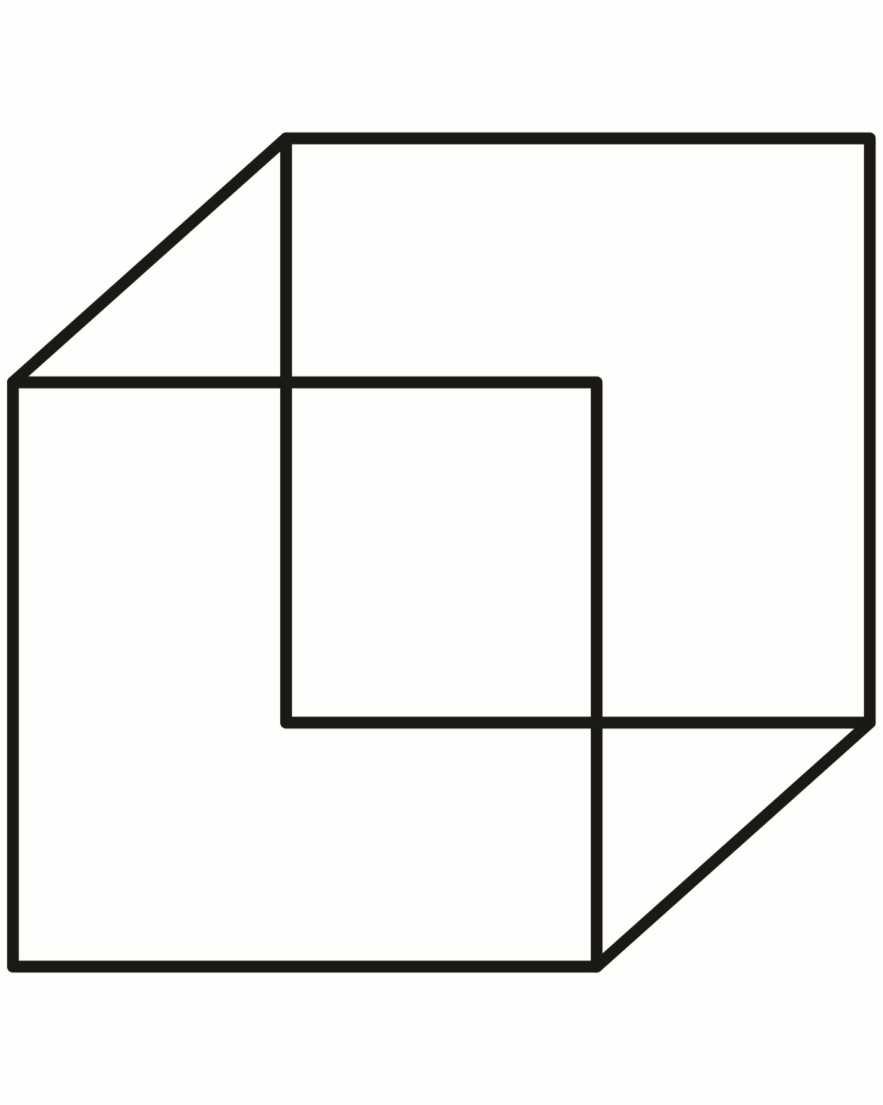

**Master 36b**

**Hidden Shapes 1**

