Creating Symmetrical Designs Behaviours/Strategies
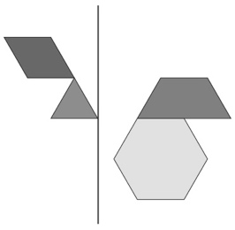  - Student constructs a 2-D design, but places  blocks randomly and creates an unsymmetrical design. | - Student constructs a 2-D design, but places the same blocks with the same orientation on each side of the line.  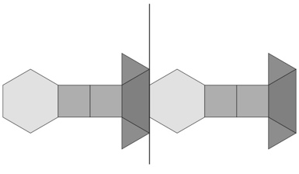 | - Student constructs a 2-D design, but places one or more Pattern Blocks incorrectly.  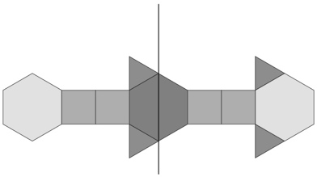
Observations/Documentation
- Student constructs a 2-D symmetrical design, but cannot decide if partner’s design is symmetrical.  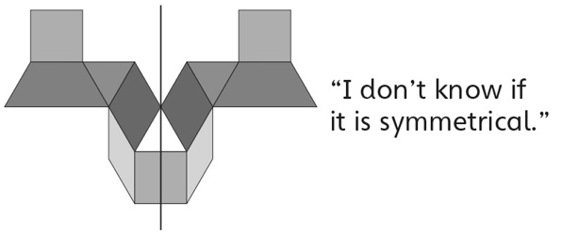 | - Student constructs a 2-D symmetrical design  and decides if partner’s design is symmetrical,  but struggles to describe her or his own design. | - Student successfully constructs a 2-D  symmetrical design, decides if partner’s design  is symmetrical, and talks about his or her own  design using math language.
Observations/Documentation

