**Pictures for Symmetry**

**Master 28a**

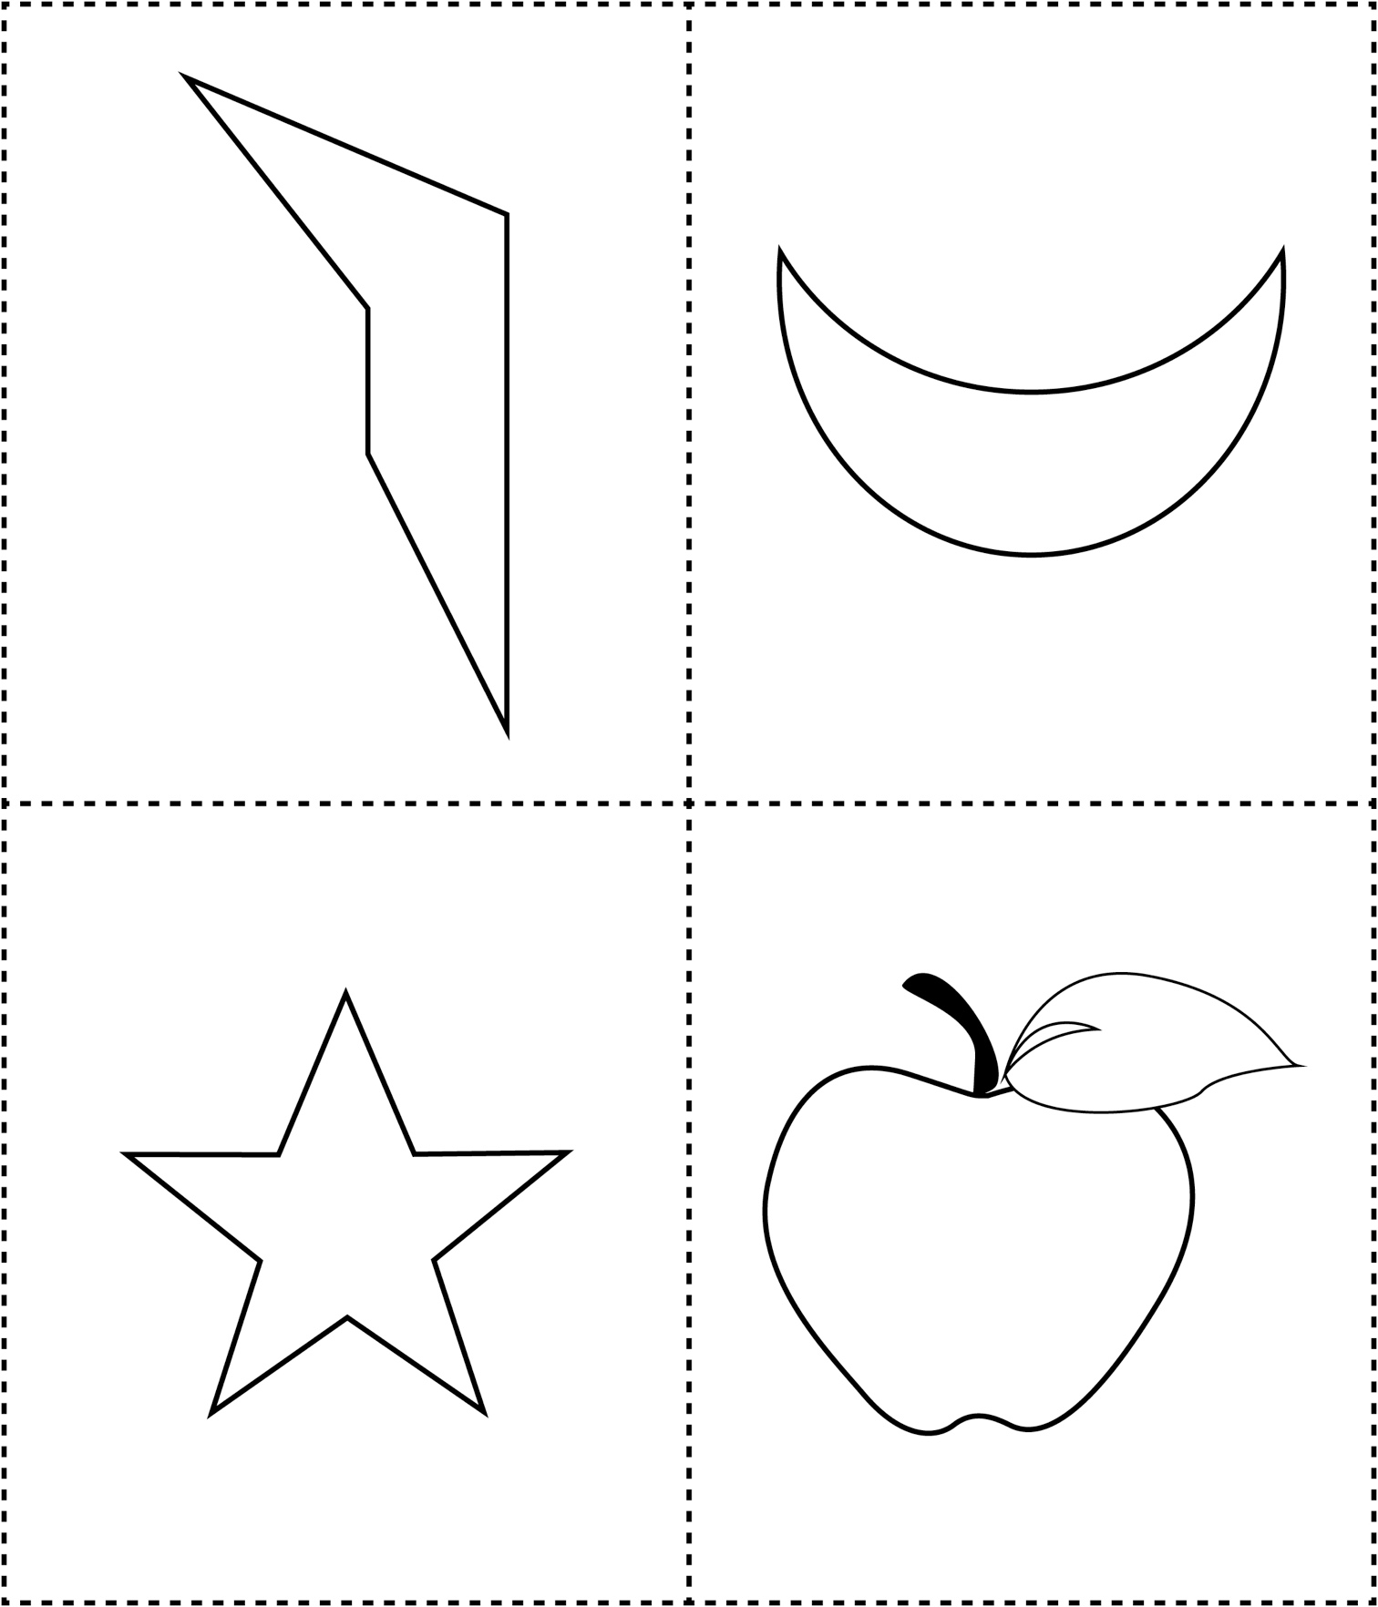

**Pictures for Symmetry**

**Master 28b**

