Identifying 3-D Solids Behaviours/Strategies
- Student looks at a 3-D solid, but  struggles to analyze its geometric attributes.  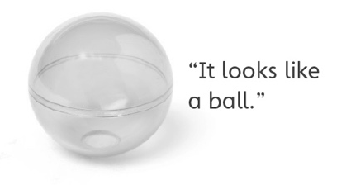 | - Student identifies some 3-D solids in the environment, but struggles when orientation or size of object does not match his or her mental image of solid.  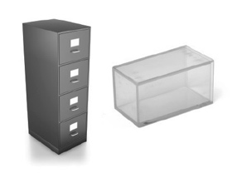 | - Student identifies 3-D solids in  the environment, but struggles to  explain why an object is an example of the given 3-D solid. | - Student successfully analyzes  geometric attributes of 3-D  solids, identifies 3-D solids in the environment, and explains thinking.
Observations/Documentation
Constructing 3-D Solids and Their Skeletons Behaviours/Strategies
- Student chooses materials, but  struggles to construct the solid  with given attributes.  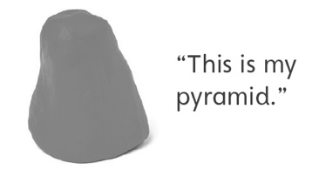 | - Student looks at a 3-D solid, but  struggles to construct skeleton and does not know where to start.  “I don’t know what to do.” | - Student analyzes geometric  attributes of a 3-D solid, but makes error(s) constructing skeleton.  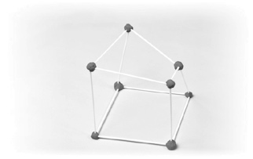 | - Student successfully constructs model and skeleton of a 3-D solid with given attributes.
Observations/Documentation

