Sorting Shapes Using Two Attributes Behaviours/Strategies
- Student randomly places shapes  without thinking about attributes  and is unable to sort set of shapes  based on two attributes.  “I didn’t know where to  put the shapes.” | - Student chooses a shape, but is  unable to analyze its geometric  attributes and is unable to sort  shapes based on two attributes.  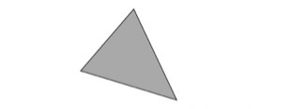  “It looks like a pizza slice.” | - Student sorts some shapes based  on two attributes, but struggles  when orientation or shapes are  unfamiliar.  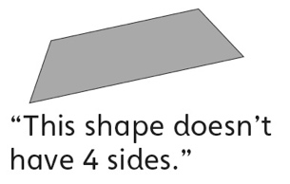 | - Student sorts a set of shapes based on single attributes, but struggles to sort using both attributes simultaneously (ignores overlap).  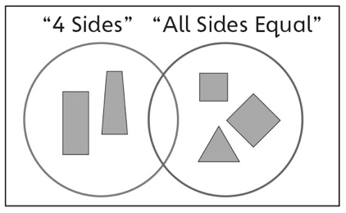
Observations/Documentation
- Student sorts a set of shapes based on two attributes, but struggles to explain why the shapes were placed where they were.  “I just know they go where  I put them.” | - Student sorts a set of shapes  based on two attributes, but  struggles to identify the sorting  rules used to sort the shapes.  “I don’t know what attributes  they used.” | - Student sorts a set of shapes based on two attributes and identifies the sorting rules in given sorts, but has difficulty communicating them.  “I can’t explain it.” | - Student sorts a set of shapes  based on two attributes and  identifies and describes the sorting rules in given sorts.

