Tipi Teachings –
Learning through Stories
Master 15a

- Listen to the beginning of the video from Elder Mary Lee.
a) Where is she from?
b) Who did she learn from?
c) What is she going to share?

Tipi Teachings –
Learning through Stories (cont’d)
Master 15b

- Listen to the tipi teachings shared from Elder Mary Lee.
Answer the following questions to collect data.
Use the diagrams on the next page to help show your learning.
Consider recording information using tally marks, words, or counts.

a) What is the meaning of the first three poles?
b) What are the first three poles used for?
c) How many poles are there altogether?
d) What materials are tipis made from?
e) What is the meaning of the materials used?
f) What does the tipi look like?

Tipi Teachings –
Learning through Stories (cont’d)
Master 15c

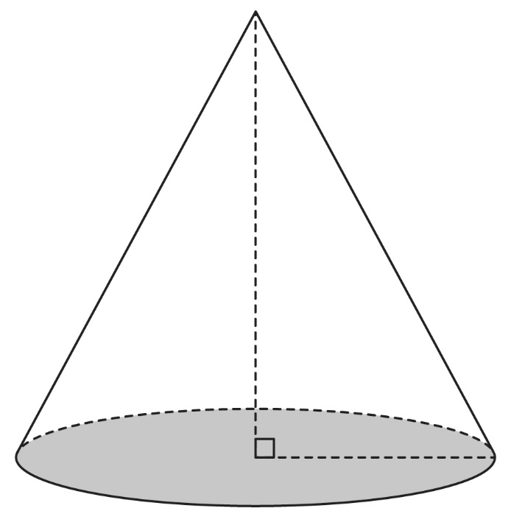
Tipi Teachings –
Learning through Stories (cont’d)
Master 15d

- In pairs, compare your diagrams.
How are they alike?
How are they different?

