That’s 10! Line Master 1 (Assessment Master)
Name: _____________________________

Add and subtract to 10 | Not observed | Sometimes | Consistently
Models add-to and take-from 10
Uses +, −, = to symbolize addition and subtraction
Add and subtract to 10
Compose and decompose 10
Identifies parts of a whole
Models and describes different ways to make numbers
Strengths:

Next Steps:

Connecting Home and School Line Master 2–1

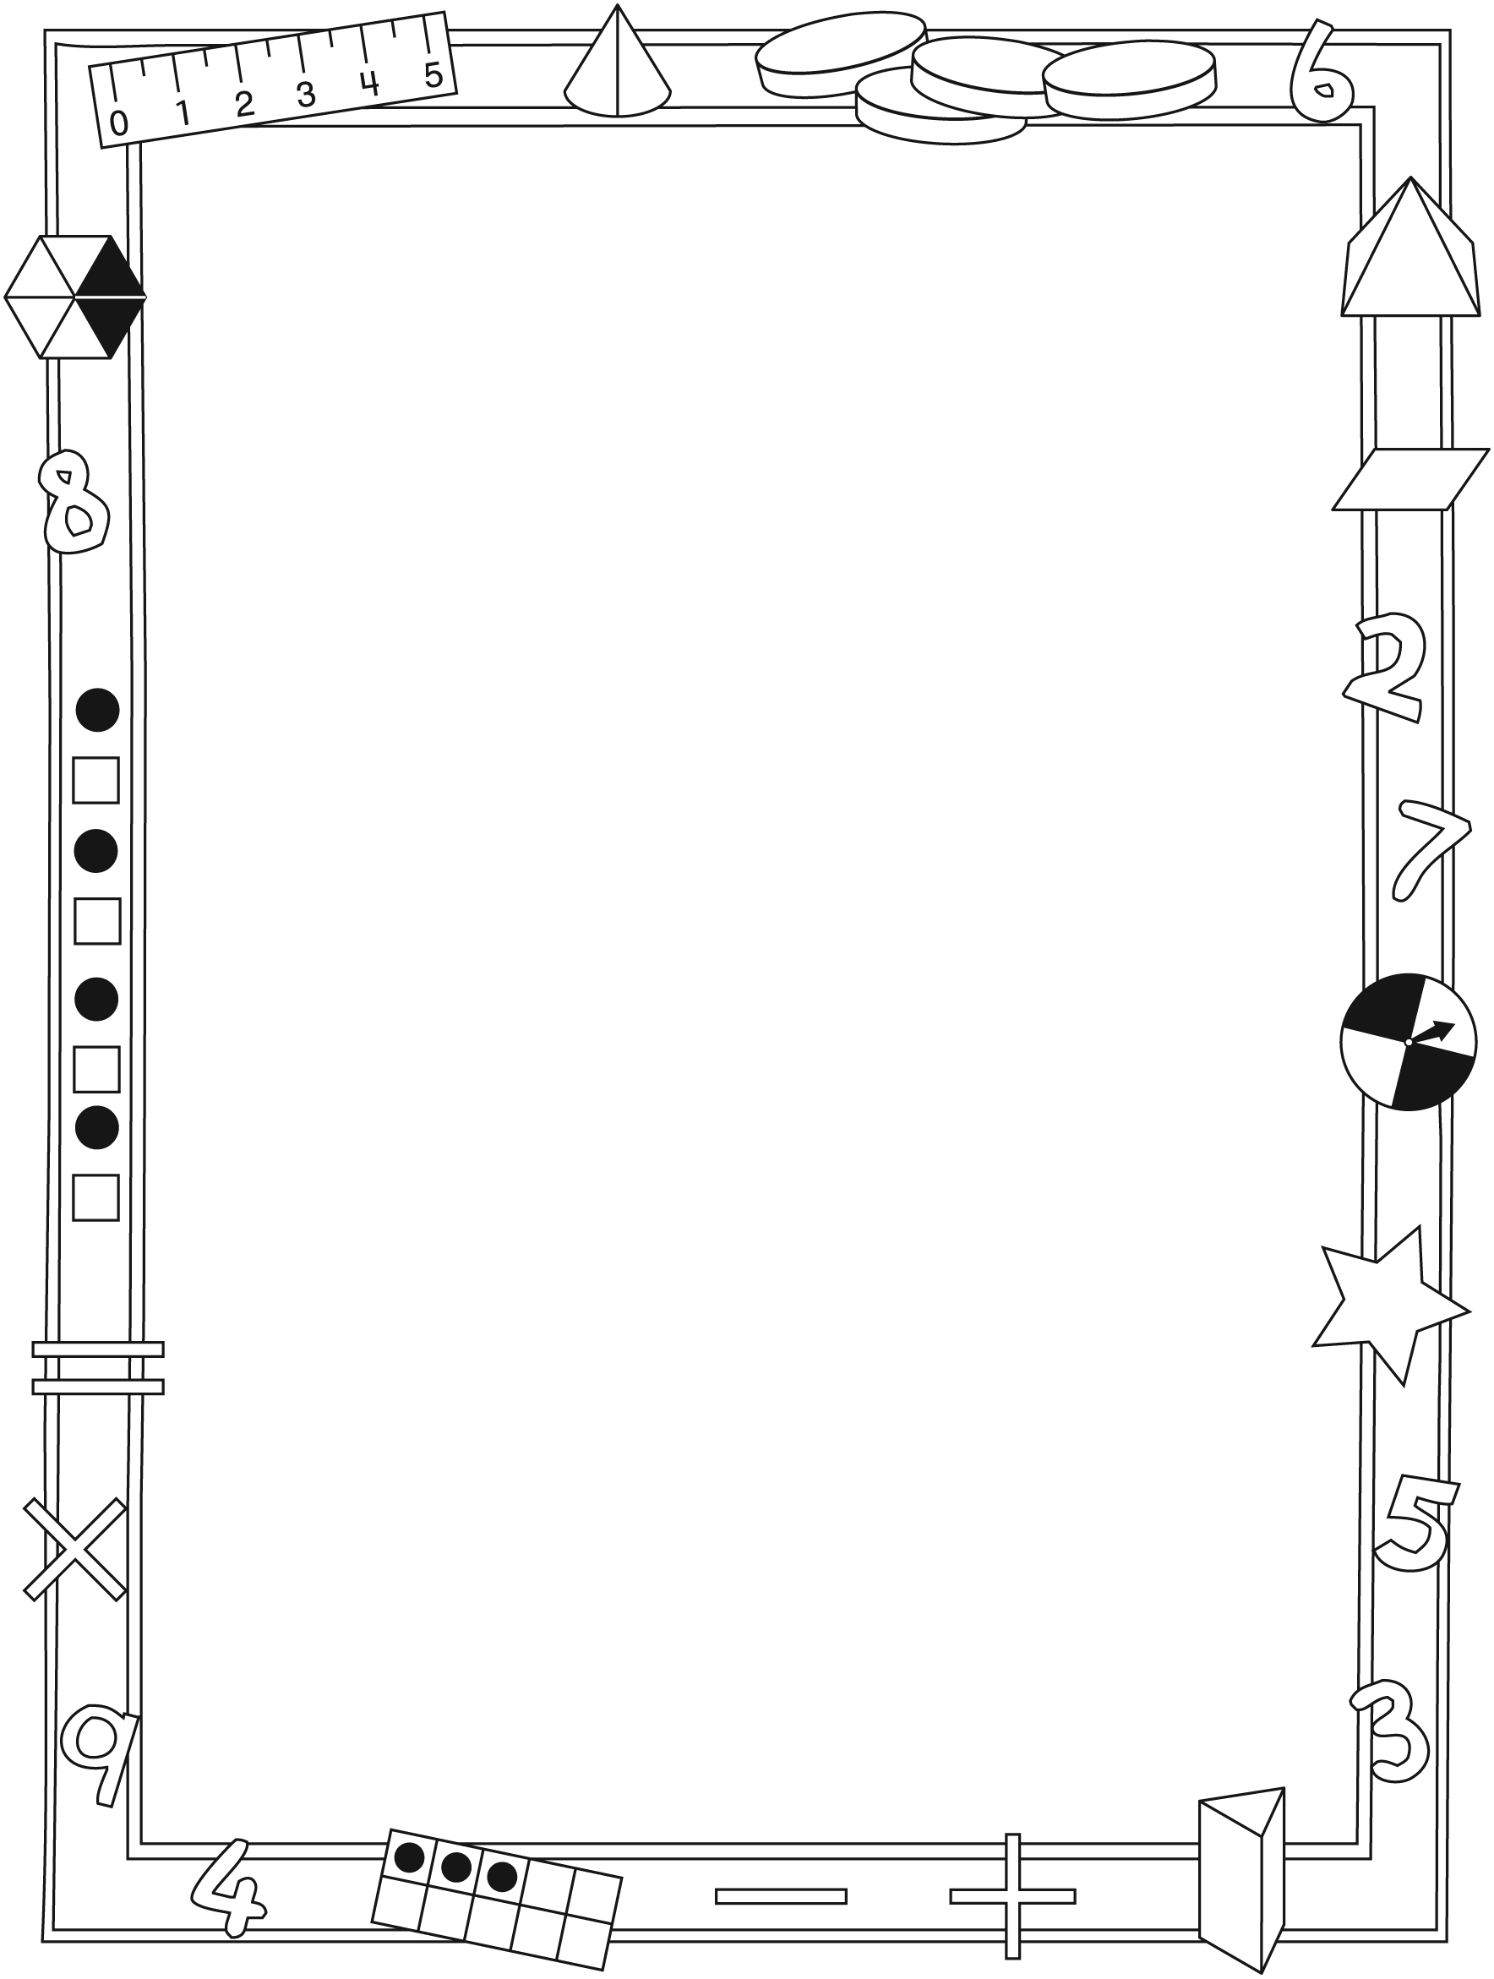

NOTE TO THE TEACHER

You may wish to send families a That’s 10! letter outlining a familiar activity or two they can do at home with their children.

Create a letter using this template and select one or two activities from the suggestions on the next page. Simply delete these instructions and cut and paste the activities you have selected, adapting them to fit your needs.
Connecting Home and School Line Master 2–2

Dear Family:

We have been working on That’s 10!, which focuses on Add and Subtract to 10 and Compose and Decompose 10. Try this activity at home with your child.

– – – – – – – – – – – – – – – – – – – – – – – – – – – – – – – – – – – – – – – – – –

Reading the Story: As you read, enjoy predicting how many baskets Scott will need to put in the box. Use small objects (e.g., buttons or bread tags) and re-create the story. How many different ways could Scott put those berries in a box? After you read, you might use the small objects and the mat on the inside back cover to re-create the story or to play your own fruit store game.

– – – – – – – – – – – – – – – – – – – – – – – – – – – – – – – – – – – – – – – – – –

How Many Are Hidden?: Collect 10 small objects (e.g., buttons, bread tags, or coins) and a small yogurt or margarine container. Count the objects with your child. Have your child close her/his eyes while you put some objects under the upside down container. Place the rest on the top. Ask your child to open her/his eyes and decide how many objects are hidden. Lift the container and check the prediction. Next have your child hide some objects while you close your eyes!

– – – – – – – – – – – – – – – – – – – – – – – – – – – – – – – – – – – – – – – – – –

Sort My Sets: Collect an assortment of objects such as different buttons, coins, pebbles, Lego pieces, etc. Ask your child to sort 10 objects and describe how they were sorted and how many are in each group (e.g., 3 green buttons,
2 blue buttons, and 5 black buttons is 10 buttons). Then ask your child to sort the same objects in one or more other ways (e.g., 7 buttons with 2 holes and
3 buttons with 4 holes). Repeat with other mixes of objects.

– – – – – – – – – – – – – – – – – – – – – – – – – – – – – – – – – – – – – – – – – –

Sincerely,

___________________________

Ten-Frame Line Master 3

Let’s Make 10 Line Master 4
Name: _____________________________

Blueberries | Raspberries | Total

Berry Stories—Number Sentences Line Master 5
Name: _____________________________

1. ______________________________________________________________

2. ______________________________________________________________

3. ______________________________________________________________

4. ______________________________________________________________

5. ______________________________________________________________

6. ______________________________________________________________

7. ______________________________________________________________

8. ______________________________________________________________

9. ______________________________________________________________

10. ______________________________________________________________

More Berries Game Cards Line Master 6

Below are optional extra cards to extend the game beyond 10.

Shake and Spill Line Master 7
Name: _____________________________

Side 1 | Side 2 | Total

– – – – – – – – – – – – – – – – – – – – – – – – – – – – – – – – – – – – – – – – – –
Name: _____________________________

Side 1 | Side 2 | Total

Today’s Special Line Master 8
Name: _____________________________

TODAY’S SPECIAL IS…

BUY 10 get ______________________________________________________

How Many Berries? Line Master 9
Scott had 10 baskets of berries.
He sold 4.

How many baskets does he have left? ____________________
– – – – – – – – – – – – – – – – – – – – – – – – – – – – – – – – – – – – – – – – – –
There were 3 baskets of berries on the shelf.
Scott added 7 more.

How many baskets were there altogether? ____________________
– – – – – – – – – – – – – – – – – – – – – – – – – – – – – – – – – – – – – – – – – –
Mr. Lin bought 2 baskets of berries.
Then he bought 8 more.

How many baskets did he have altogether? ____________________
– – – – – – – – – – – – – – – – – – – – – – – – – – – – – – – – – – – – – – – – – –
Create your own berry word problem…

