**Cats and Kittens!** **Line Master 1** (Assessment Master)

**Name:** \_\_\_\_\_\_\_\_\_\_\_\_\_\_\_\_\_\_\_\_\_\_\_\_\_\_\_\_\_

|  |  |  |  |
| --- | --- | --- | --- |
| **Add and Subtract to 20** | **Not observed** | **Sometimes** | **Consistently** |
| Models add-to and take-from to 20 |  |  |  |
| Uses +, −, = to symbolize parts–whole and addition and subtraction |  |  |  |
| Adds and subtracts to 20 |  |  |  |
| **Compare quantities to 20** |  |  |  |
| Compares quantities to 20 by matching or counting |  |  |  |
| Determines how many more/less |  |  |  |
| Knows what number is one or two more and one or two less than another number |  |  |  |

**Strengths:**

**Next Steps:**

**Connecting Home and School Line Master 2–1**

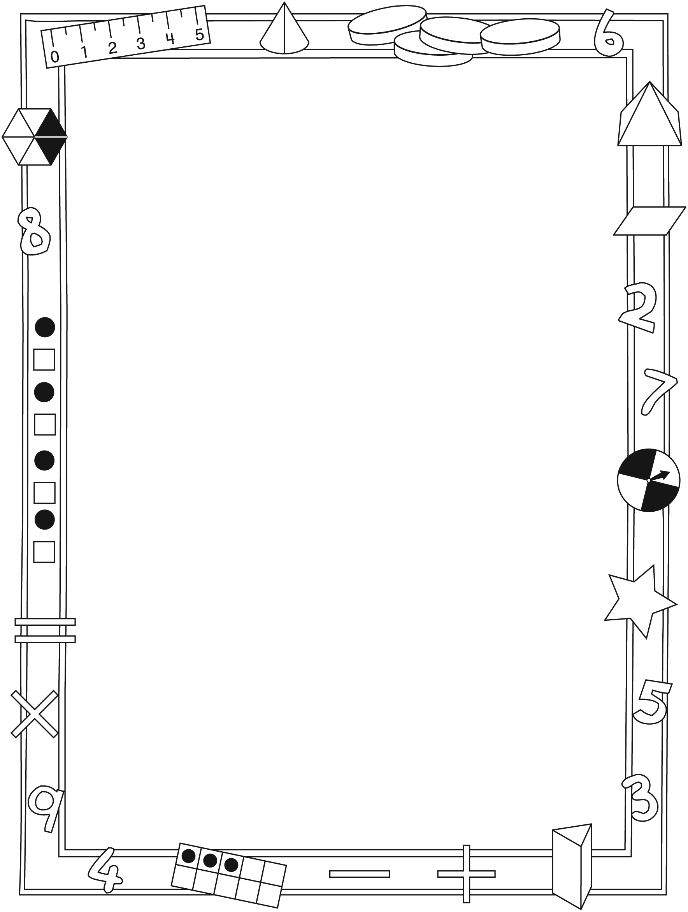

**NOTE TO THE TEACHER**

You may wish to send families a ***Cats and Kittens!*** letter outlining a familiar activity or two they can do at home with their children.

Create a letter using this template and select one or two activities from the suggestions on the next page. Simply **delete these instructions and cut and paste the activities you have selected**, adapting them to fit your needs.

**Connecting Home and School Line Master 2–2**

Dear Family:

We have been working on***Cats and Kittens!*** which focuses on Adding and Subtracting to 20 and Comparing Quantities to 20. Try this activity at home with your child.

✂ – – – – – – – – – – – – – – – – – – – – – – – – – – – – – – – – – – – – – – – – – –

**Reading the Story:** As you read the story, count and talk about the cats and kittens. As kittens are adopted, predict how many are left before you turn the page. Work together to identify the missing, adopted kitten(s). After reading, use 20 small objects and the Math Mat on the inside back cover to re-tell the story (or tell others) by placing an object in each space and then “adopting” (removing) cats and figuring out how many remain.

✂ – – – – – – – – – – – – – – – – – – – – – – – – – – – – – – – – – – – – – – – – – –

**Cat Nim:** Use 20 small objects and the Math Mat on the inside back cover to play this game. Place an object in every space on the mat. Take turns “adopting cats” by removing 1, 2, or 3 objects. Whoever removes the last counter and so empties the Math Mat, scores 1 point. Then, play to fill the mat by adding 1, 2, or 3 counters. Whoever places the last counter, scores a point. Take turns going first. Have fun!

✂ – – – – – – – – – – – – – – – – – – – – – – – – – – – – – – – – – – – – – – – – – –

**How Many 1s?** Use small objects to represent cats, and fold a piece of paper to make a hiding spot. Start with about 15 “cats.” Ask your child to turn away while you place (5) “cats” in the hiding spot. Your child then looks at the (10) visible “cats” and predicts how many are hiding. Lift the paper and count to check. Encourage the use of numbers to describe the story. For example, say: “10 and 5—that’s 15 cats.” or “5 cats are hiding and 10 cats are not. That’s 15 cats altogether.” Repeat with other combinations of that number (15) or start with another number. Invite your child to take the lead.

✂ – – – – – – – – – – – – – – – – – – – – – – – – – – – – – – – – – – – – – – – – – –

Sincerely,

\_\_\_\_\_\_\_\_\_\_\_\_\_\_\_\_\_\_\_\_\_\_\_\_\_\_\_

***Cats and Kittens!* Math Mat Line Master 3**

**Name:** \_\_\_\_\_\_\_\_\_\_\_\_\_\_\_\_\_\_\_\_\_\_\_\_\_\_\_\_\_

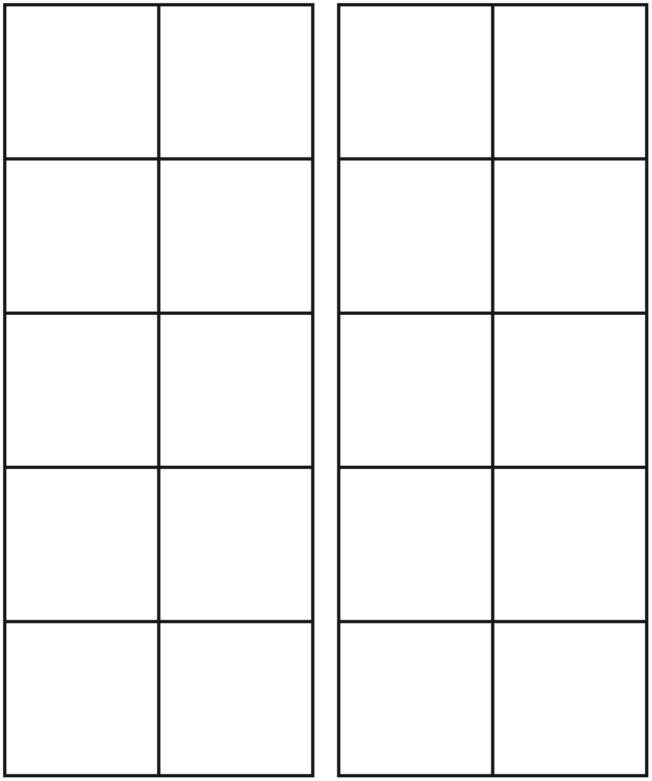

**Double Ten-Frame Line Master 4**

**Recording Sheet**

**Name:** \_\_\_\_\_\_\_\_\_\_\_\_\_\_\_\_\_\_\_\_\_\_\_\_\_\_\_\_\_

|  |  |
| --- | --- |
| a_004_mlb_lm_k2_doggy  a_004_mlb_lm_k2_doggy | a_004_mlb_lm_k2_doggy  a_004_mlb_lm_k2_doggy |
| a_004_mlb_lm_k2_doggy  a_004_mlb_lm_k2_doggy | a_004_mlb_lm_k2_doggy  a_004_mlb_lm_k2_doggy |

**Rolling Number Sentences Line Master 5**

**Name:** \_\_\_\_\_\_\_\_\_\_\_\_\_\_\_\_\_\_\_\_\_\_\_\_\_\_\_\_\_

|  |  |  |  |
| --- | --- | --- | --- |
| **Round** | **My Numbers** | **My Number Sentences** | **My Score** |
| 1 |  |  |  |
| 2 |  |  |  |
| 3 |  |  |  |
| 4 |  |  |  |
| 5 |  |  |  |

**Numeral Cards (1–20) Line Master 6–1**



|  |  |  |
| --- | --- | --- |
| 1 | 2 | 3 |
| 4 | 5 | 6 |
| 7 | 8 | 9 |
| 10 |  |  |

**Numeral Cards (1–20) Line Master 6–2**



|  |  |  |
| --- | --- | --- |
| 11 | 12 | 13 |
| 14 | 15 | 16 |
| 17 | 18 | 19 |
| 20 |  |  |

**Hundred Chart Line Master 7**

|  |  |  |  |  |  |  |  |  |  |
| --- | --- | --- | --- | --- | --- | --- | --- | --- | --- |
| **1** | **2** | **3** | **4** | **5** | **6** | **7** | **8** | **9** | **10** |
| **11** | **12** | **13** | **14** | **15** | **16** | **17** | **18** | **19** | **20** |
| **21** | **22** | **23** | **24** | **25** | **26** | **27** | **28** | **29** | **30** |
| **31** | **32** | **33** | **34** | **35** | **36** | **37** | **38** | **39** | **40** |
| **41** | **42** | **43** | **44** | **45** | **46** | **47** | **48** | **49** | **50** |
| **51** | **52** | **53** | **54** | **55** | **56** | **57** | **58** | **59** | **60** |
| **61** | **62** | **63** | **64** | **65** | **66** | **67** | **68** | **69** | **70** |
| **71** | **72** | **73** | **74** | **75** | **76** | **77** | **78** | **79** | **80** |
| **81** | **82** | **83** | **84** | **85** | **86** | **87** | **88** | **89** | **90** |
| **91** | **92** | **93** | **94** | **95** | **96** | **97** | **98** | **99** | **100** |

**To 20 and Back Line Master 8**

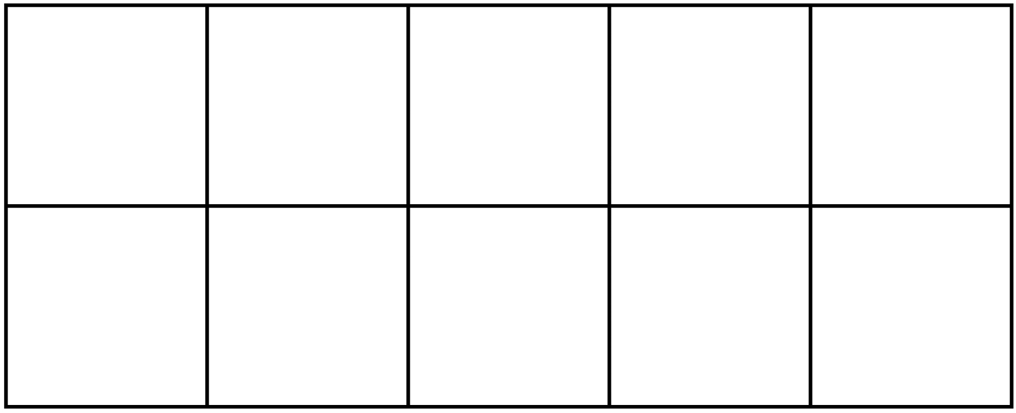



**You Need**

20 counters

**How to Play**

* Decide who will go first. If you go first, add 1, 2, or 3 counters to the mat.
* On your turn, add 1, 2, or 3 more counters to the mat.
* The player who adds the last counter scores 1 point.
* On your turn, remove 1, 2, or 3 counters.
* The player who removes the last counter scores 1 point.
* Start again, but with the other person going first.

**Target Numbers Line Master 9**

**Name:** \_\_\_\_\_\_\_\_\_\_\_\_\_\_\_\_\_\_\_\_\_\_\_\_\_\_\_\_\_

My target number is \_\_\_\_\_\_\_\_.

My number sentences are:

**Sentence Frames Line Master 10–1**

✂ – – – – – – – – – – – – – – – – – – – – – – – – – – – – – – – – – – – – – – – – – –

\_\_\_\_\_ is less than \_\_\_\_\_\_\_\_\_.

✂ – – – – – – – – – – – – – – – – – – – – – – – – – – – – – – – – – – – – – – – – – –

\_\_\_\_\_\_\_\_\_ is more than \_\_\_\_\_\_\_\_\_.

✂ – – – – – – – – – – – – – – – – – – – – – – – – – – – – – – – – – – – – – – – – – –

1 more than\_\_\_\_\_\_\_\_\_ is \_\_\_\_\_\_\_\_\_.

✂ – – – – – – – – – – – – – – – – – – – – – – – – – – – – – – – – – – – – – – – – – –

1 less than\_\_\_\_\_\_\_\_\_ is \_\_\_\_\_\_\_\_\_.

✂ – – – – – – – – – – – – – – – – – – – – – – – – – – – – – – – – – – – – – – – – – –

**Sentence Frames Line Master 10–2**

✂ – – – – – – – – – – – – – – – – – – – – – – – – – – – – – – – – – – – – – – – – – –

2 more than \_\_\_\_\_\_\_\_\_ is \_\_\_\_\_\_\_\_\_.

✂ – – – – – – – – – – – – – – – – – – – – – – – – – – – – – – – – – – – – – – – – – –

2 less than \_\_\_\_\_\_\_\_\_ is \_\_\_\_\_\_\_\_\_.

✂ – – – – – – – – – – – – – – – – – – – – – – – – – – – – – – – – – – – – – – – – – –

\_\_\_\_\_\_\_\_\_ is the same as \_\_\_\_\_\_\_\_\_.

✂ – – – – – – – – – – – – – – – – – – – – – – – – – – – – – – – – – – – – – – – – – –

**My Solution IS! Line Master 11–1**

**Name:** \_\_\_\_\_\_\_\_\_\_\_\_\_\_\_\_\_\_\_\_\_\_\_\_\_\_\_\_\_

|  |
| --- |
| Cats and kittens are playing.  There are 4 cats and 8 kittens.  How many cats and kittens are there?  Show your thinking in pictures, numbers, and words. |
| Cats and kittens are playing.  There are more cats than kittens.  How many cats and kittens are there?  Show your thinking in pictures, numbers, and words. |

**My Solution IS! Line Master 11–2**

**Name:** \_\_\_\_\_\_\_\_\_\_\_\_\_\_\_\_\_\_\_\_\_\_\_\_\_\_\_\_\_

|  |
| --- |
| Cats and kittens are playing.  There are fewer cats than kittens.  How many cats and kittens are there?  Show your thinking in pictures, numbers, and words. |
| 15 kittens are playing.  There 8 toys. Each kitten needs a toy.  How many more toys are needed?  Show your thinking in pictures, numbers, and words. |