The Amazing Seed Line Master 1
(Assessment Master)
Name: _____________________________

Estimate and Compare Length, Attributes | Not observed | Sometimes | Consistently
Estimates and compares length and height
Uses relative terms to describe length and height
Uses a baseline for comparing height and length
Estimates and compares mass
Uses relative terms to describes mass
Estimates and compares capacity
Uses relative terms to describe capacity
Estimate and Measure Using
Non-standard Units
Estimates and measures length and height using non-standard units
Estimates and measures mass using non-standard units
Estimates and measures capacity using non-standard units
Selects appropriate units and tools for measuring
Measures accurately using several units
Strengths:

Next Steps:

Connecting Home and School Line Master 2–1

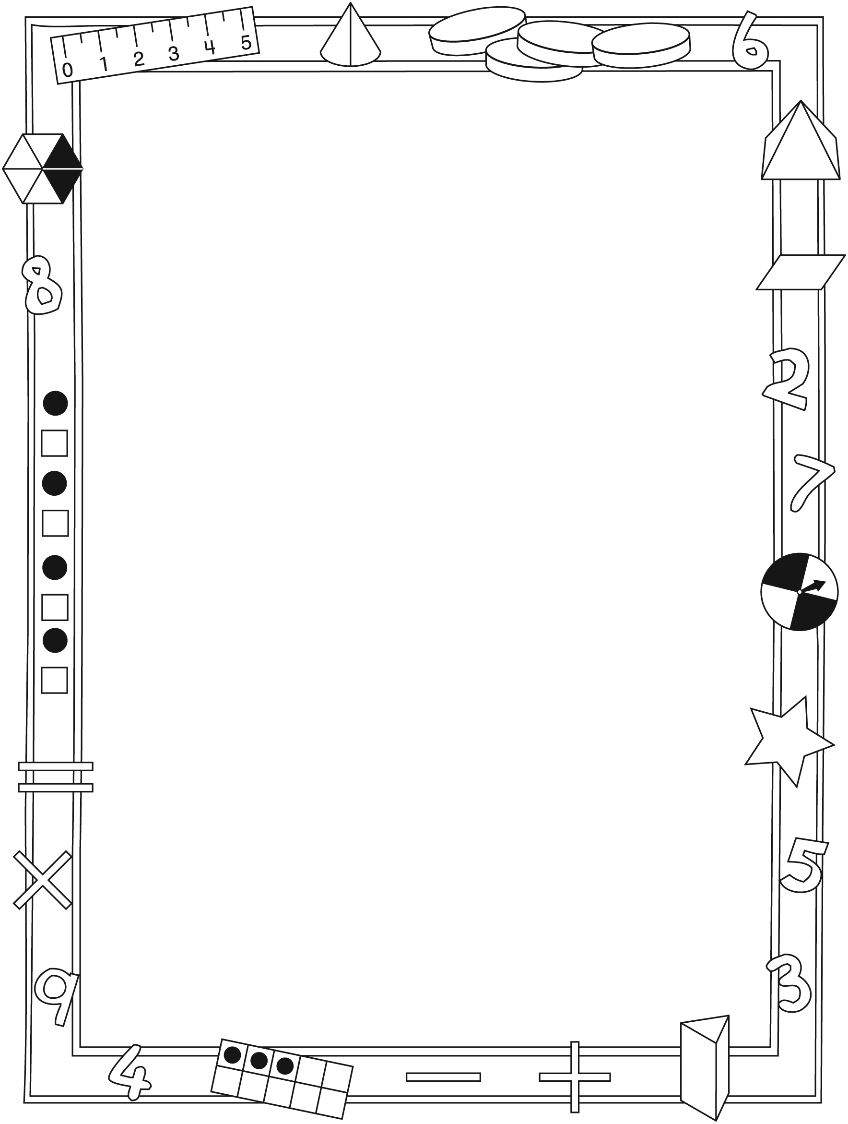

NOTE TO THE TEACHER

You may wish to send families a The Amazing Seed letter outlining a familiar activity or two they can do at home with their children.

Create a letter using this template and select one or two activities from the suggestions on the next page. Simply delete these instructions and cut and paste the activities you have selected, adapting them to fit your needs.

Connecting Home and School Line Master 2–2

Dear Family:

We have been working on The Amazing Seed, which engages children in conversations, investigations, and activities that help to develop their understanding of the big math idea that many things in our world have attributes that can be measured and compared. Particular focus is placed on estimating, comparing, and measuring length, height, mass, and capacity. Try this activity at home with your child.
– – – – – – – – – – – – – – – – – – – – – – – – – – – – – – – – – – – – – – – – – –
Reading the Story: As you read the story, enjoy talking about how the animals plant and care for the amazing seed. Focus on the different ways the animals measure and keep track of the height of their plant as it grows. Use the illustrations to prompt descriptions that include a variety of measurement words (e.g., longer, longest, shorter, shortest, taller, tallest, heavier, heaviest, lighter, lightest).
– – – – – – – – – – – – – – – – – – – – – – – – – – – – – – – – – – – – – – – – – –
Comparing Things: Use everyday situations to compare and describe the length, height, and mass of objects and people. For example, say: Please hand me the longest piece of ribbon. Let’s find a melon that feels heavier than this melon. You carry the lighter bag and I will carry the heavier bag. Of the three of us, who do you think is the tallest?
– – – – – – – – – – – – – – – – – – – – – – – – – – – – – – – – – – – – – – – – – –
Measuring Things: Your child can make a personal measuring tape by linking 10 same-size paper clips together. Have fun thinking of things that might be longer, shorter, and about the same length as 10 paper clips. Then use the paper clip measuring tape to test your estimates.
– – – – – – – – – – – – – – – – – – – – – – – – – – – – – – – – – – – – – – – – – –
Cooking: Having your child help in the kitchen offers many opportunities to focus on comparing and measuring how much something holds (capacity). For example, say: Please hand me a bowl that will hold more than this bowl. We need the largest pot to make our soup. Which container do you think is big enough to hold the leftover soup?
– – – – – – – – – – – – – – – – – – – – – – – – – – – – – – – – – – – – – – – – – –
Watch Me Grow! Consider keeping track of your child’s growth by starting a height chart, or cutting pieces of string to model her/his height. Each month, mark your child’s height. Compare and describe the change.
– – – – – – – – – – – – – – – – – – – – – – – – – – – – – – – – – – – – – – – – – –
Sincerely,

___________________________

The Amazing Seed Math Mat Line Master 3

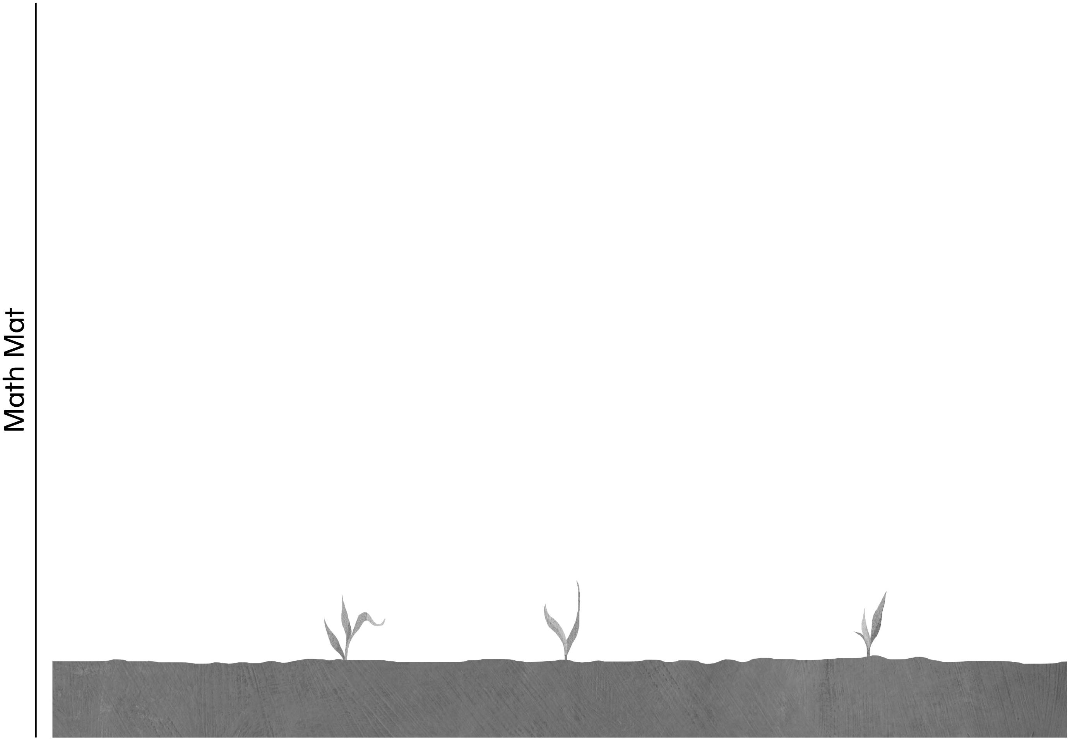

Ordering by Mass Line Master 4

– – – – – – – – – – – – – – – – – – – – – – – – – – – – – – – – – – – – – – – – – –
Name: _____________________________

I used these containers: ____________________________

My estimate from lightest to heaviest:

______________________________________________________________________________

My discovery from lightest to heaviest:

______________________________________________________________________________
– – – – – – – – – – – – – – – – – – – – – – – – – – – – – – – – – – – – – – – – – –
Name: _____________________________

I used these containers: ____________________________

My estimate from lightest to heaviest:

______________________________________________________________________________

My discovery from lightest to heaviest:

______________________________________________________________________________
– – – – – – – – – – – – – – – – – – – – – – – – – – – – – – – – – – – – – – – – – –

Grid Strips Line Master 5

My Measuring Discoveries Line Master 6
Name: _____________________________
I used _____________________ to measure.

Object | Estimate | Measurement

Which Holds More? Line Master 7
Name: _____________________________

 | More | Less
My estimate
My discovery

This is what I did:

Estimating and Line Master 8
Measuring Mass
Name: _____________________________

My object | My estimate | My discovery

My Amazing Seed Line Master 9
Name: _____________________________

Date | Observations

My Recipe Line Master 10
Name: _____________________________
My recipe for ______________________________________

You need:

This is what you do:

Solving Problems Line Master 11–1

– – – – – – – – – – – – – – – – – – – – – – – – – – – – – – – – – – – – – – – – – –

What can you find that is longer than your shoe?

– – – – – – – – – – – – – – – – – – – – – – – – – – – – – – – – – – – – – – – – – –

What can you find that is shorter than your arm?

– – – – – – – – – – – – – – – – – – – – – – – – – – – – – – – – – – – – – – – – – –

What can you find that is longer than your shoe and shorter than your arm?

– – – – – – – – – – – – – – – – – – – – – – – – – – – – – – – – – – – – – – – – – –

What can you find that is shorter than your leg and longer than your hand?

– – – – – – – – – – – – – – – – – – – – – – – – – – – – – – – – – – – – – – – – – –

Solving Problems Line Master 11–2

– – – – – – – – – – – – – – – – – – – – – – – – – – – – – – – – – – – – – – – – – –
I measured _______________________________________________.

It is __________________ units long. What unit did I use?

____________ or ____________ or ____________
– – – – – – – – – – – – – – – – – – – – – – – – – – – – – – – – – – – – – – – – – –
I measured _______________________________________________.

It is __________________ units long. What unit did I use?

__________________ or __________________ or __________________
– – – – – – – – – – – – – – – – – – – – – – – – – – – – – – – – – – – – – – – – – –
I measured _______________________________________________.

It is __________________ units long. What unit did I use?

__________________ or __________________ or __________________
– – – – – – – – – – – – – – – – – – – – – – – – – – – – – – – – – – – – – – – – – –
I measured _____________________________.

It is __________________ units long. What unit did I use?

__________________ or __________________ or __________________
– – – – – – – – – – – – – – – – – – – – – – – – – – – – – – – – – – – – – – – – – –

