Memory Book Line Master 1
(Assessment Master)
Name: _____________________________

Locate and Map Objects in the Environment | Not observed | Sometimes | Consistently
Locates objects in the environment by interpreting a map
Uses positional language to locate objects and give directions
Follows and interprets instructions that use positional language
Investigate 2-D Shapes and
3-D Solids
Identifies and describes the geometric attributes of 2-D shapes
Identifies and describes the geometric attributes of 3-D shapes
Identifies 2-D shapes on 3-D objects in the environment
Strengths:

Next Steps:

Connecting Home and School Line Master 2–1

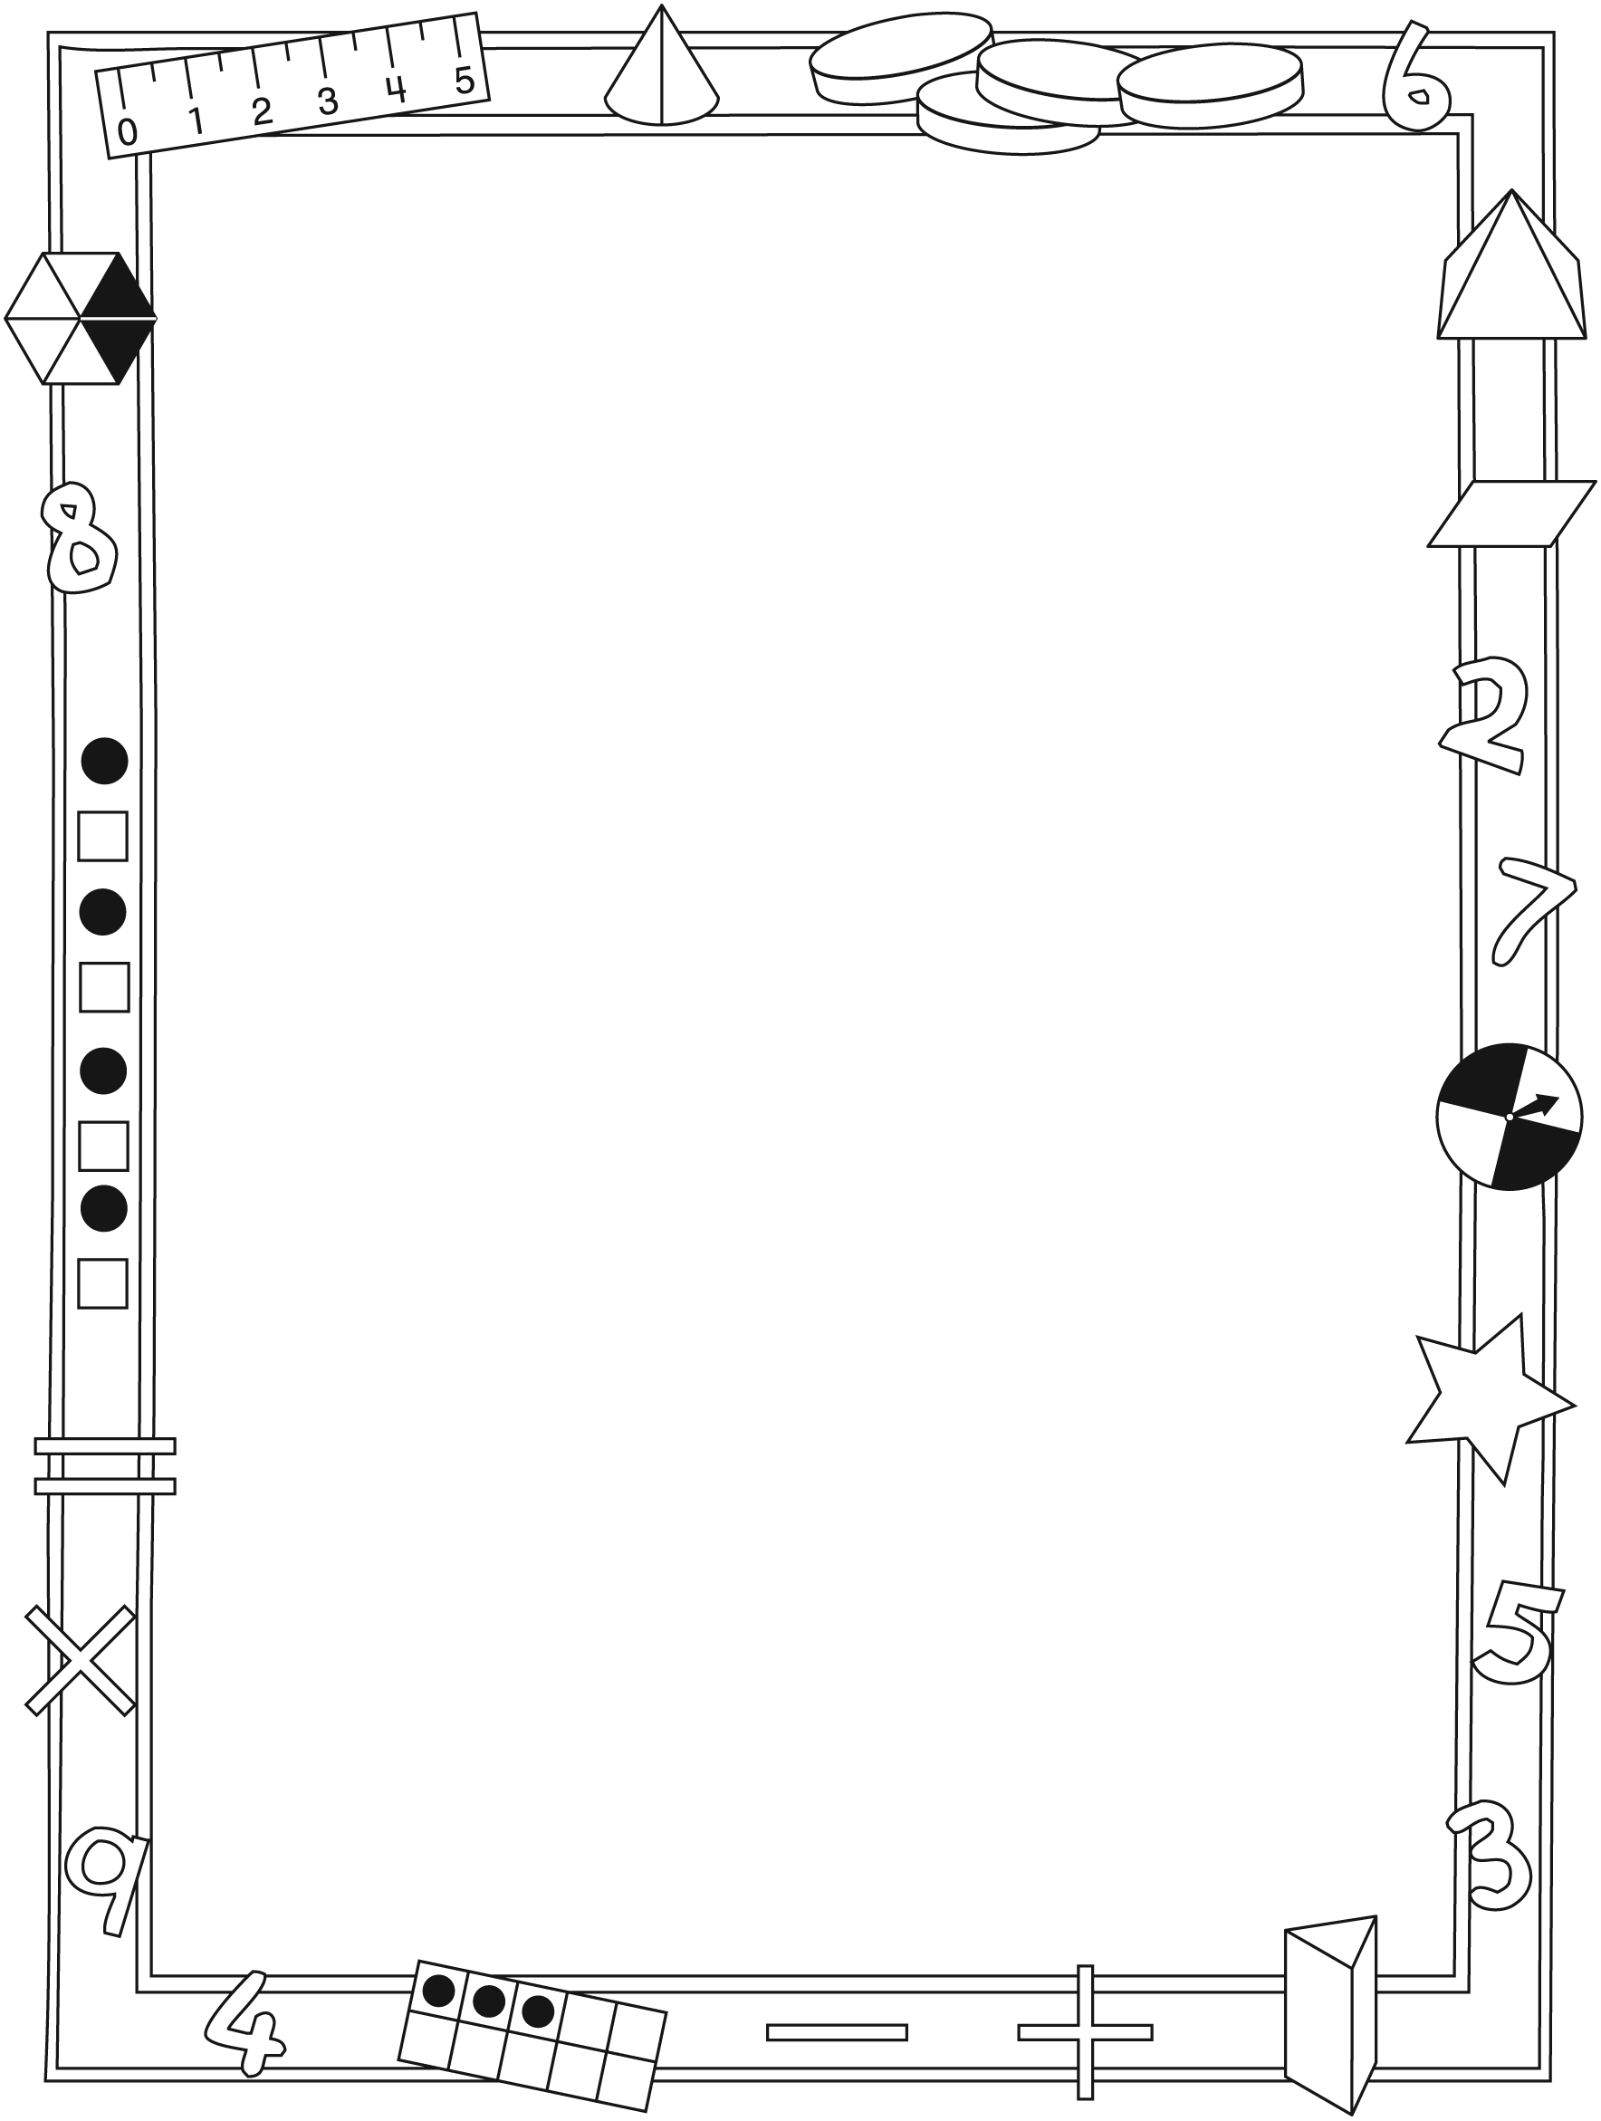

NOTE TO THE TEACHER

You may wish to send families a Memory Book letter outlining a familiar activity or two they can do at home with their children.

Create a letter using this template and select one or two activities from the suggestions on the next page. Simply delete these instructions and cut and paste the activities you have selected, adapting them to fit your needs.

Connecting Home and School Line Master 2–2

Dear Family:

We have been working on Memory Book, which focuses on locating and mapping objects in the environment, and investigating 2-D shapes and 3-D solids. Try this activity at home with your child.
– – – – – – – – – – – – – – – – – – – – – – – – – – – – – – – – – – – – – – – – – –
Reading the Story: As you read the story, encourage your child to describe the shapes on each page. Invite your child to make connections among 2-D shapes and 3-D solids. After you read, ask her/him to identify different shapes and solids in your home and compare them with shapes and solids your child encountered at school.
– – – – – – – – – – – – – – – – – – – – – – – – – – – – – – – – – – – – – – – – – –
Map Making: Together, design a map of your home or neighbourhood. Encourage your child to include landmarks or important objects. Invite your child to label the map and explain how he/she decided what to label. You might also have your child make a map of the route he/she takes to school and provide you with directions for getting there.
– – – – – – – – – – – – – – – – – – – – – – – – – – – – – – – – – – – – – – – – – –
Let’s Build: Gather a collection of 3-D objects (e.g., tissue boxes, paper towel rolls) and work with your child to create structures and sculptures. Encourage your child to be creative and think carefully about how different objects will fit together. Invite your child to identify 3-D solids and 2-D shapes during building, and then describe the completed structure.
– – – – – – – – – – – – – – – – – – – – – – – – – – – – – – – – – – – – – – – – – –
Mystery Shapes? Gather 3-D objects from around your home that have circular, rectangular, triangular, and/or square faces to trace. Trace one of the faces and challenge your child to identify which object your mystery shape came from. Invite your child to describe its attributes (e.g., number of corners, number of sides).
– – – – – – – – – – – – – – – – – – – – – – – – – – – – – – – – – – – – – – – – – –
Sincerely,

___________________________

Memory Book Math Mat Line Master 3

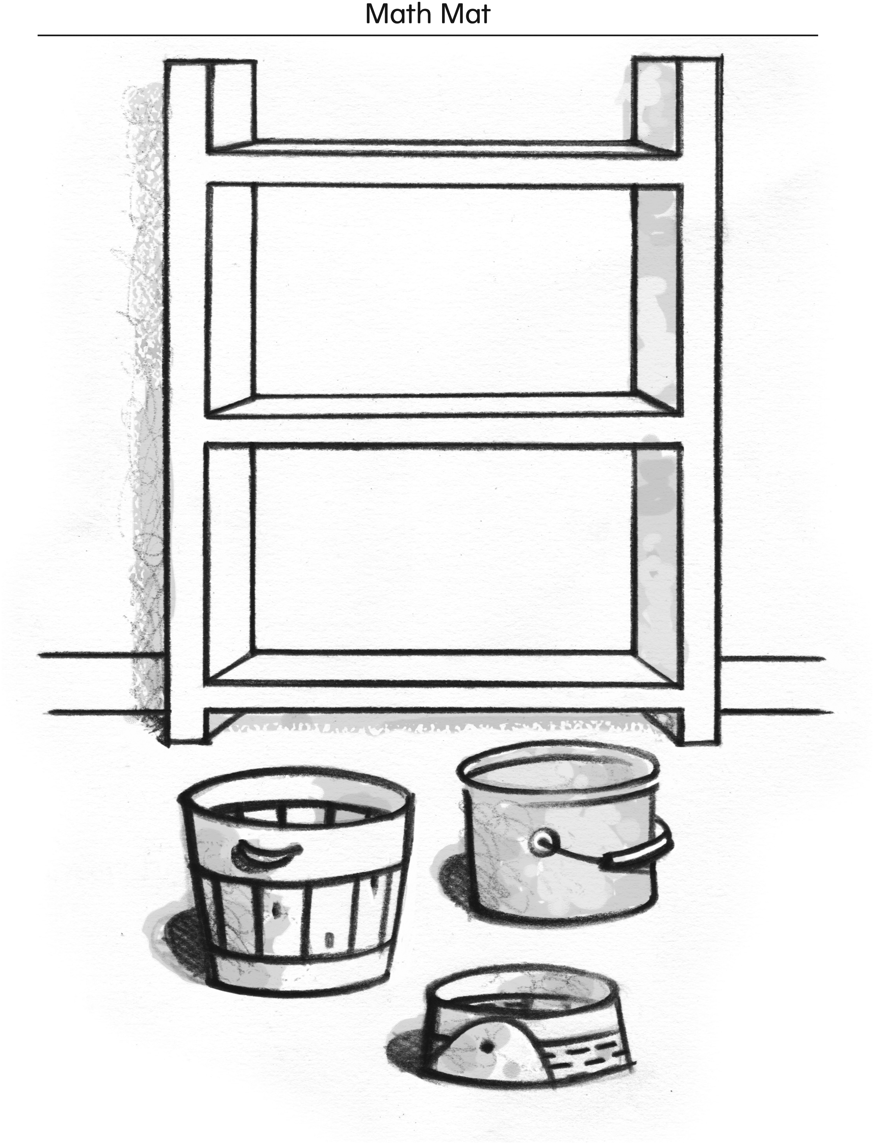

My Map Line Master 4
Name: _____________________________

List of Items on My Map

Grid Paper Line Master 5

2-D Shapes Line Master 6

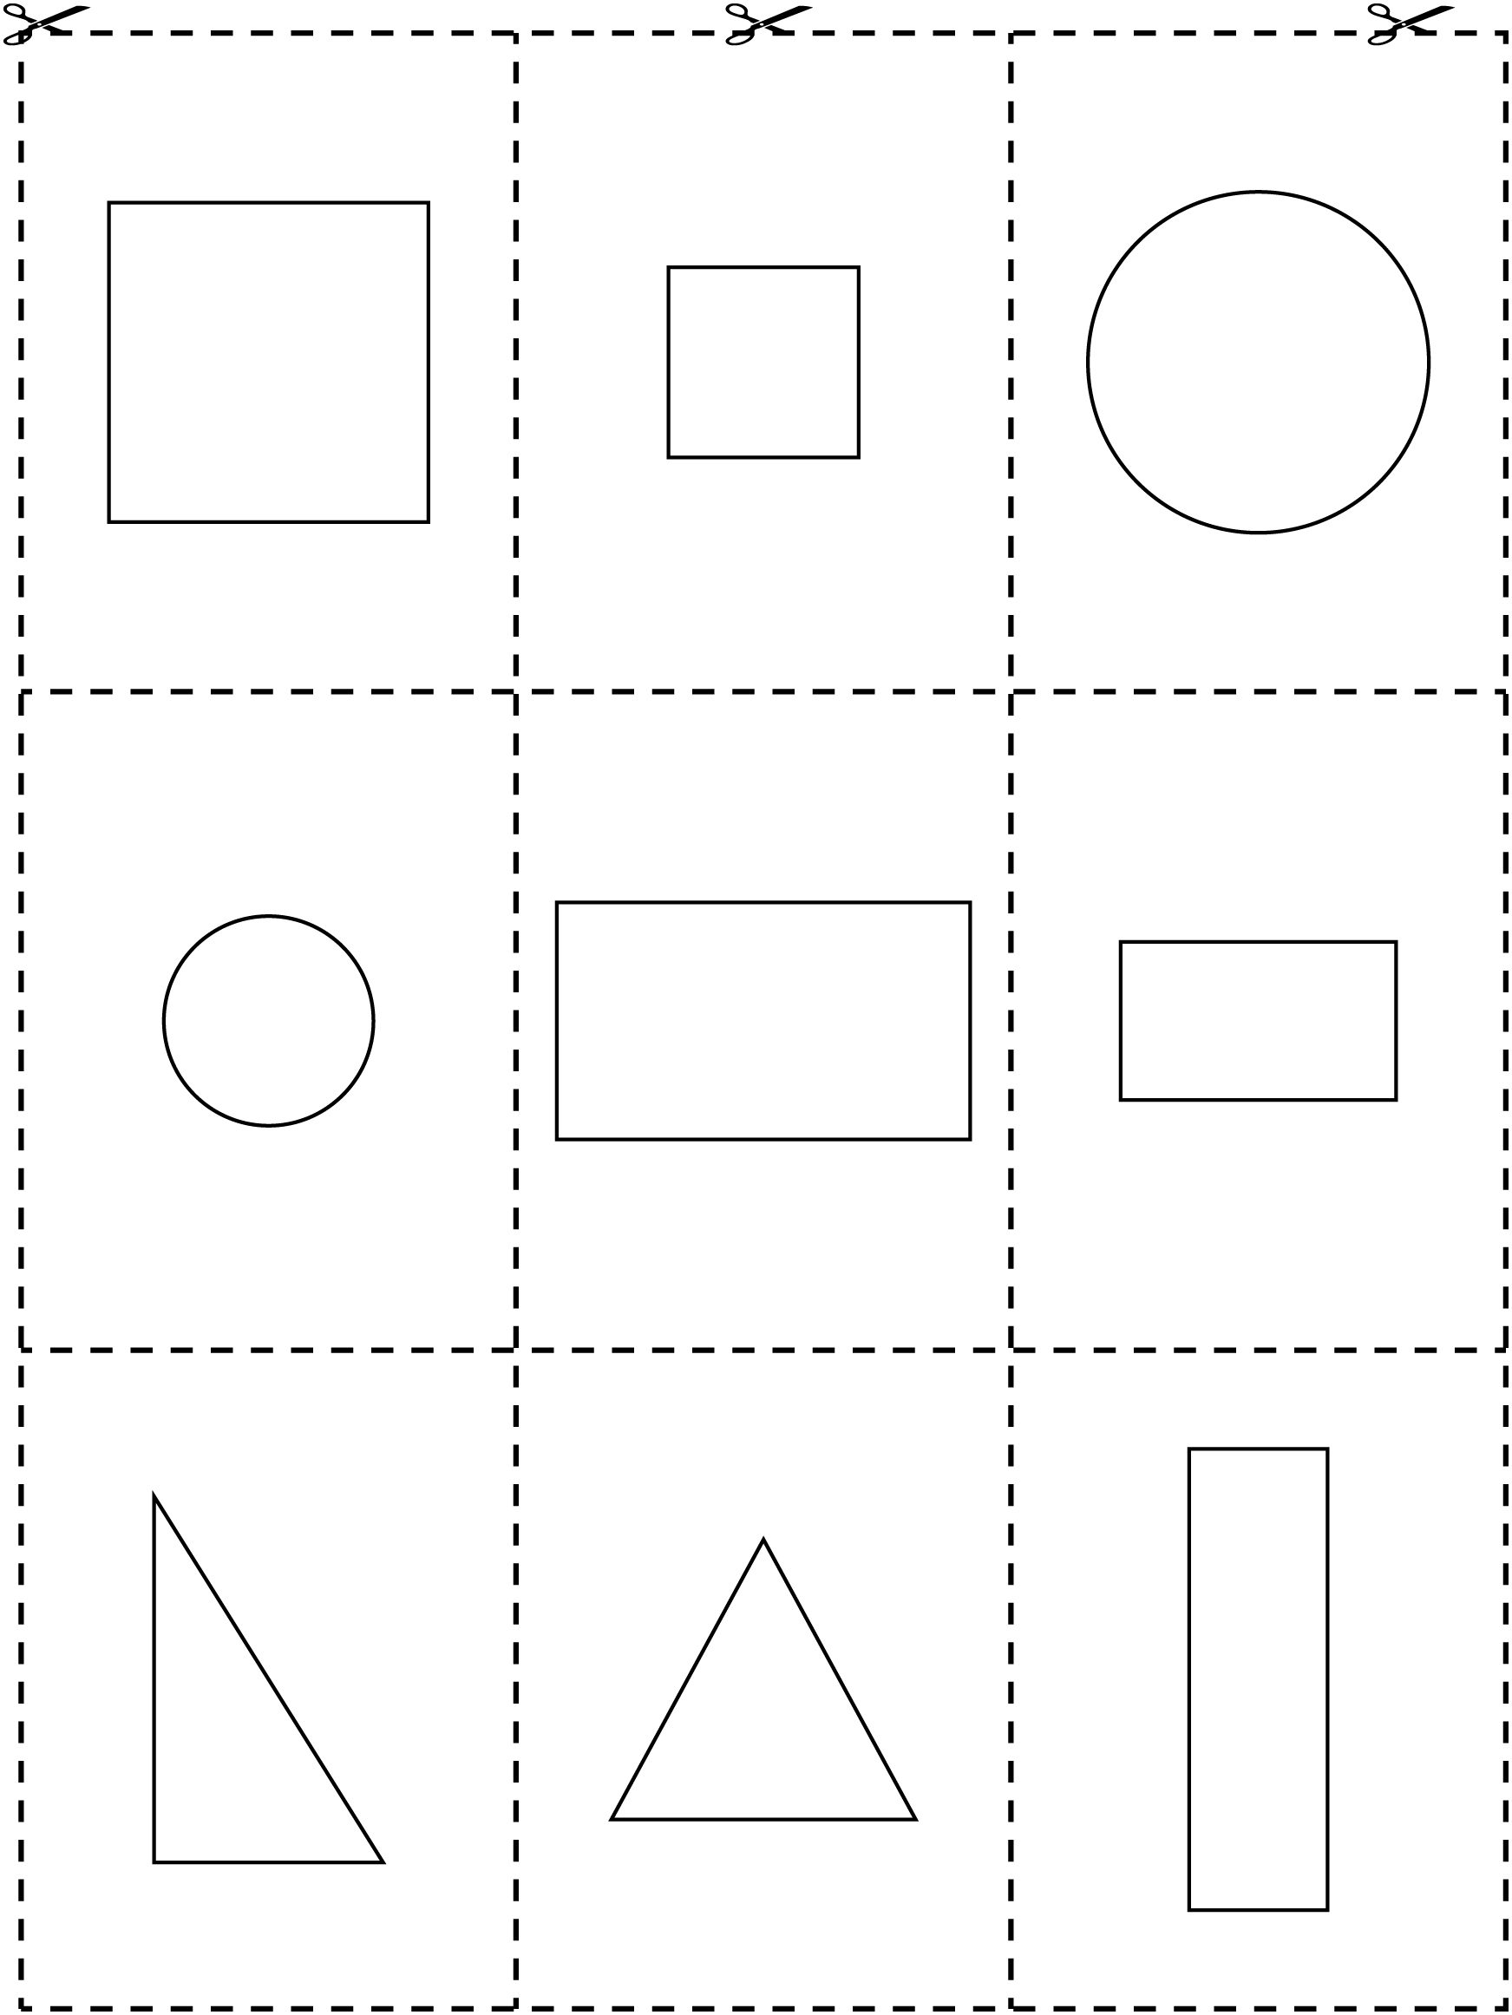

Mazes Line Master 7–1
Name: _____________________________

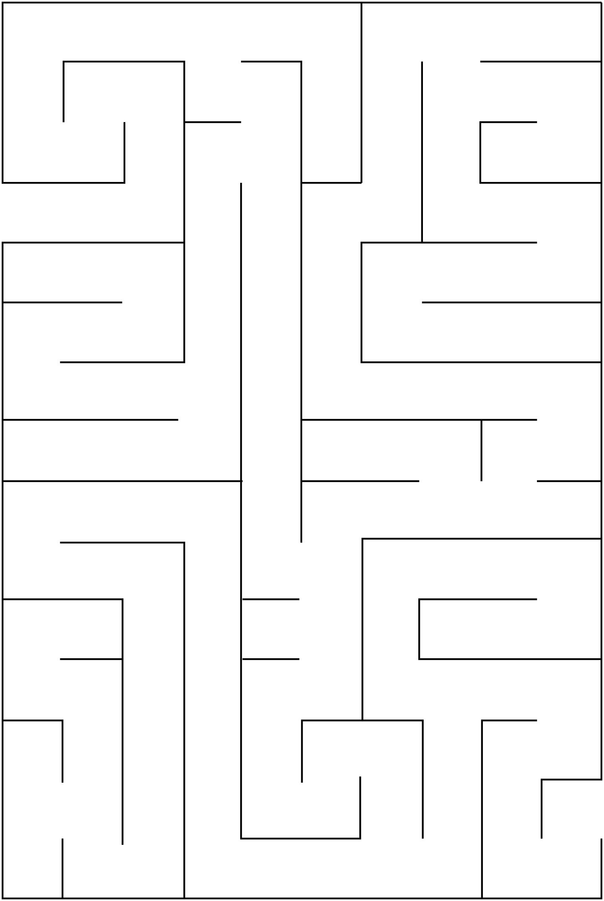

Mazes Line Master 7–2
Name: _____________________________

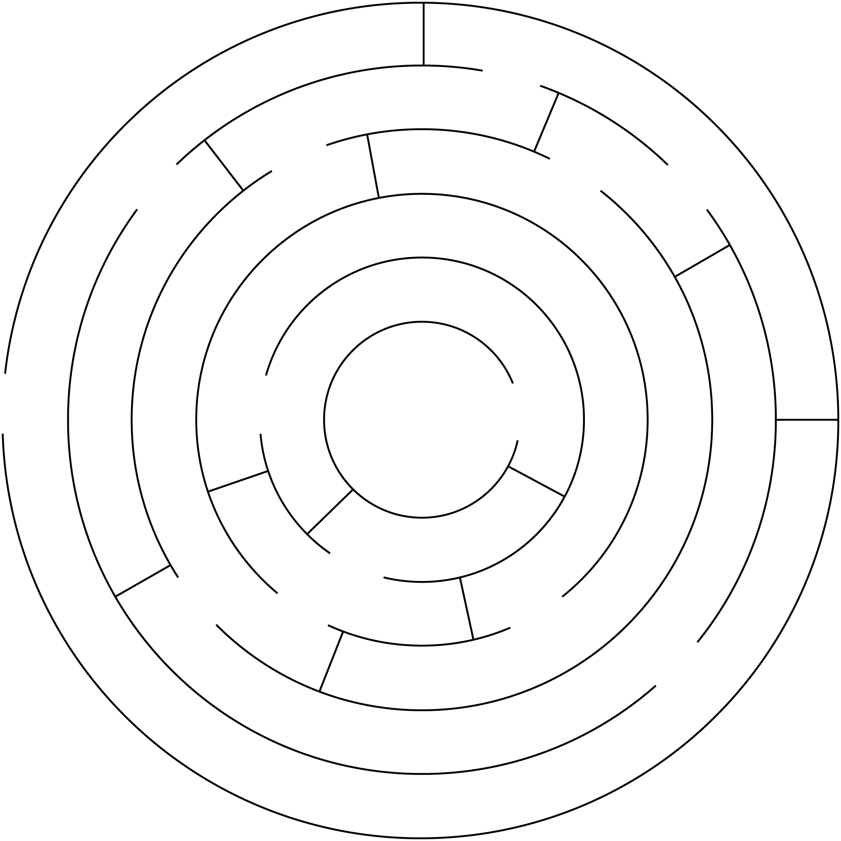

Shape Art Line Master 8
Name: _____________________________

What I made: ______________________________________________________

Shapes I used: ______________________________________________________

My Route to School Line Master 9–1
Name: _____________________________

SCHOOL

My Route to School Line Master 9–2
Name: _____________________________

My route to school:

______________________________________________________________________________

______________________________________________________________________________

______________________________________________________________________________

______________________________________________________________________________

______________________________________________________________________________

______________________________________________________________________________

Shape Problems Line Master 10–1

– – – – – – – – – – – – – – – – – – – – – – – – – – – – – – – – – – – – – – – – – –

How many sides do I have? _________________

How many corners do I have? _________________

I am a ___________________________________________.

– – – – – – – – – – – – – – – – – – – – – – – – – – – – – – – – – – – – – – – – – –

How many sides do I have? _________________

How many corners do I have? _________________

I am a ___________________________________________.

Shape Problems Line Master 10–2

– – – – – – – – – – – – – – – – – – – – – – – – – – – – – – – – – – – – – – – – – –
I have 4 sides and 4 corners.
All of my sides are the same length.
All of my corners are the same size.

What am I? ____________________________

Draw me!

– – – – – – – – – – – – – – – – – – – – – – – – – – – – – – – – – – – – – – – – – –
I have 3 sides and 3 corners.
All of my sides are different lengths.

What am I? ____________________________

Draw me!

