Animal Measures Line Master 1
(Assessment Master)
Name: _____________________________

Estimate and Measure Length | Not observed | Sometimes | Consistently
Uses a baseline
Describes measures (longer, shorter, taller, about as long as)
Estimates and measures to confirm comparison
Compare Measures According to Length
Selects and uses appropriate measures
Describes measures (longest, shortest, tallest, about as long as)
Estimates and measures to confirm order
Strengths:

Next Steps:

Connecting Home and School Line Master 2–1

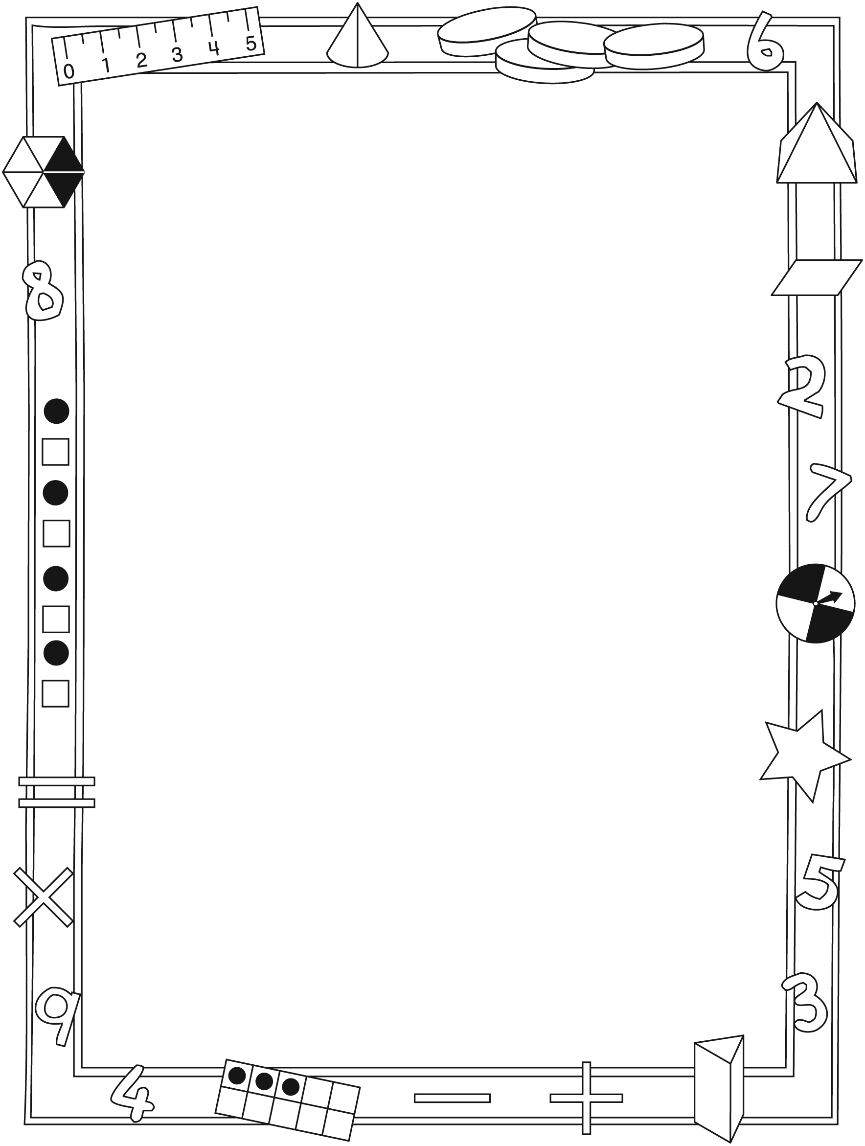

NOTE TO THE TEACHER

You may wish to send families an Animal Measures letter outlining a familiar activity or two they can do at home with their children.

Create a letter using this template and select one or two activities from the suggestions on the next page. Simply delete these instructions and cut and paste the activities you have selected, adapting them to fit your needs.

Connecting Home and School Line Master 2–2

Dear Family:

We have been working on Animal Measures, which engages children in conversations, investigations, and activities that help to develop their understanding of the big math idea that “Units can be used to measure and compare attributes.” Try this activity at home with your child.
– – – – – – – – – – – – – – – – – – – – – – – – – – – – – – – – – – – – – – – – – –
Reading the Story: As you read the book, enjoy talking about the different lengths, heights, and distances. If you have craft sticks or paper clips on hand, work with your child to find items in your home that are about the same length as some of the animals. For example, ask your child: What can you find that is as long as the walking stick? Would a saltwater crocodile fit in the bathtub? Let us know what you find out!
– – – – – – – – – – – – – – – – – – – – – – – – – – – – – – – – – – – – – – – – – –
How Many Steps? Measure distance by counting heel-to-toe steps as you walk. Encourage comparison. For example, ask: Do you think it takes more or fewer baby steps to walk from the front door to the kitchen or from the kitchen to your bedroom? Discuss a reasonable way of figuring it out and then do so. Try other distances, always estimating the greatest and least distance before measuring.
– – – – – – – – – – – – – – – – – – – – – – – – – – – – – – – – – – – – – – – – – –
What Is Longer? Have your child compare measurements such as the length of a bed and the height of a bedroom door; the length of a rug and the length of a table; or the height of a table and the height of a door handle. She/he might align objects to compare objects directly, cut a length of string to the measure and then use the cut string to compare, or make measurements using a non-standard unit such as craft sticks. Ask your child: How should we measure the (length of the bed) so we can compare it to the (height of the door)?
– – – – – – – – – – – – – – – – – – – – – – – – – – – – – – – – – – – – – – – – – –
Family Measures: In class, we measured how far we can jump. Ask your child how we did it and invite him/her to use this method to find out how far others at home can jump. Order the measurements from shortest to longest. You might also measure giant steps, arm spans, or heights.
– – – – – – – – – – – – – – – – – – – – – – – – – – – – – – – – – – – – – – – – – –
Sincerely,

___________________________

Animal Measures Math Mat Line Master 3

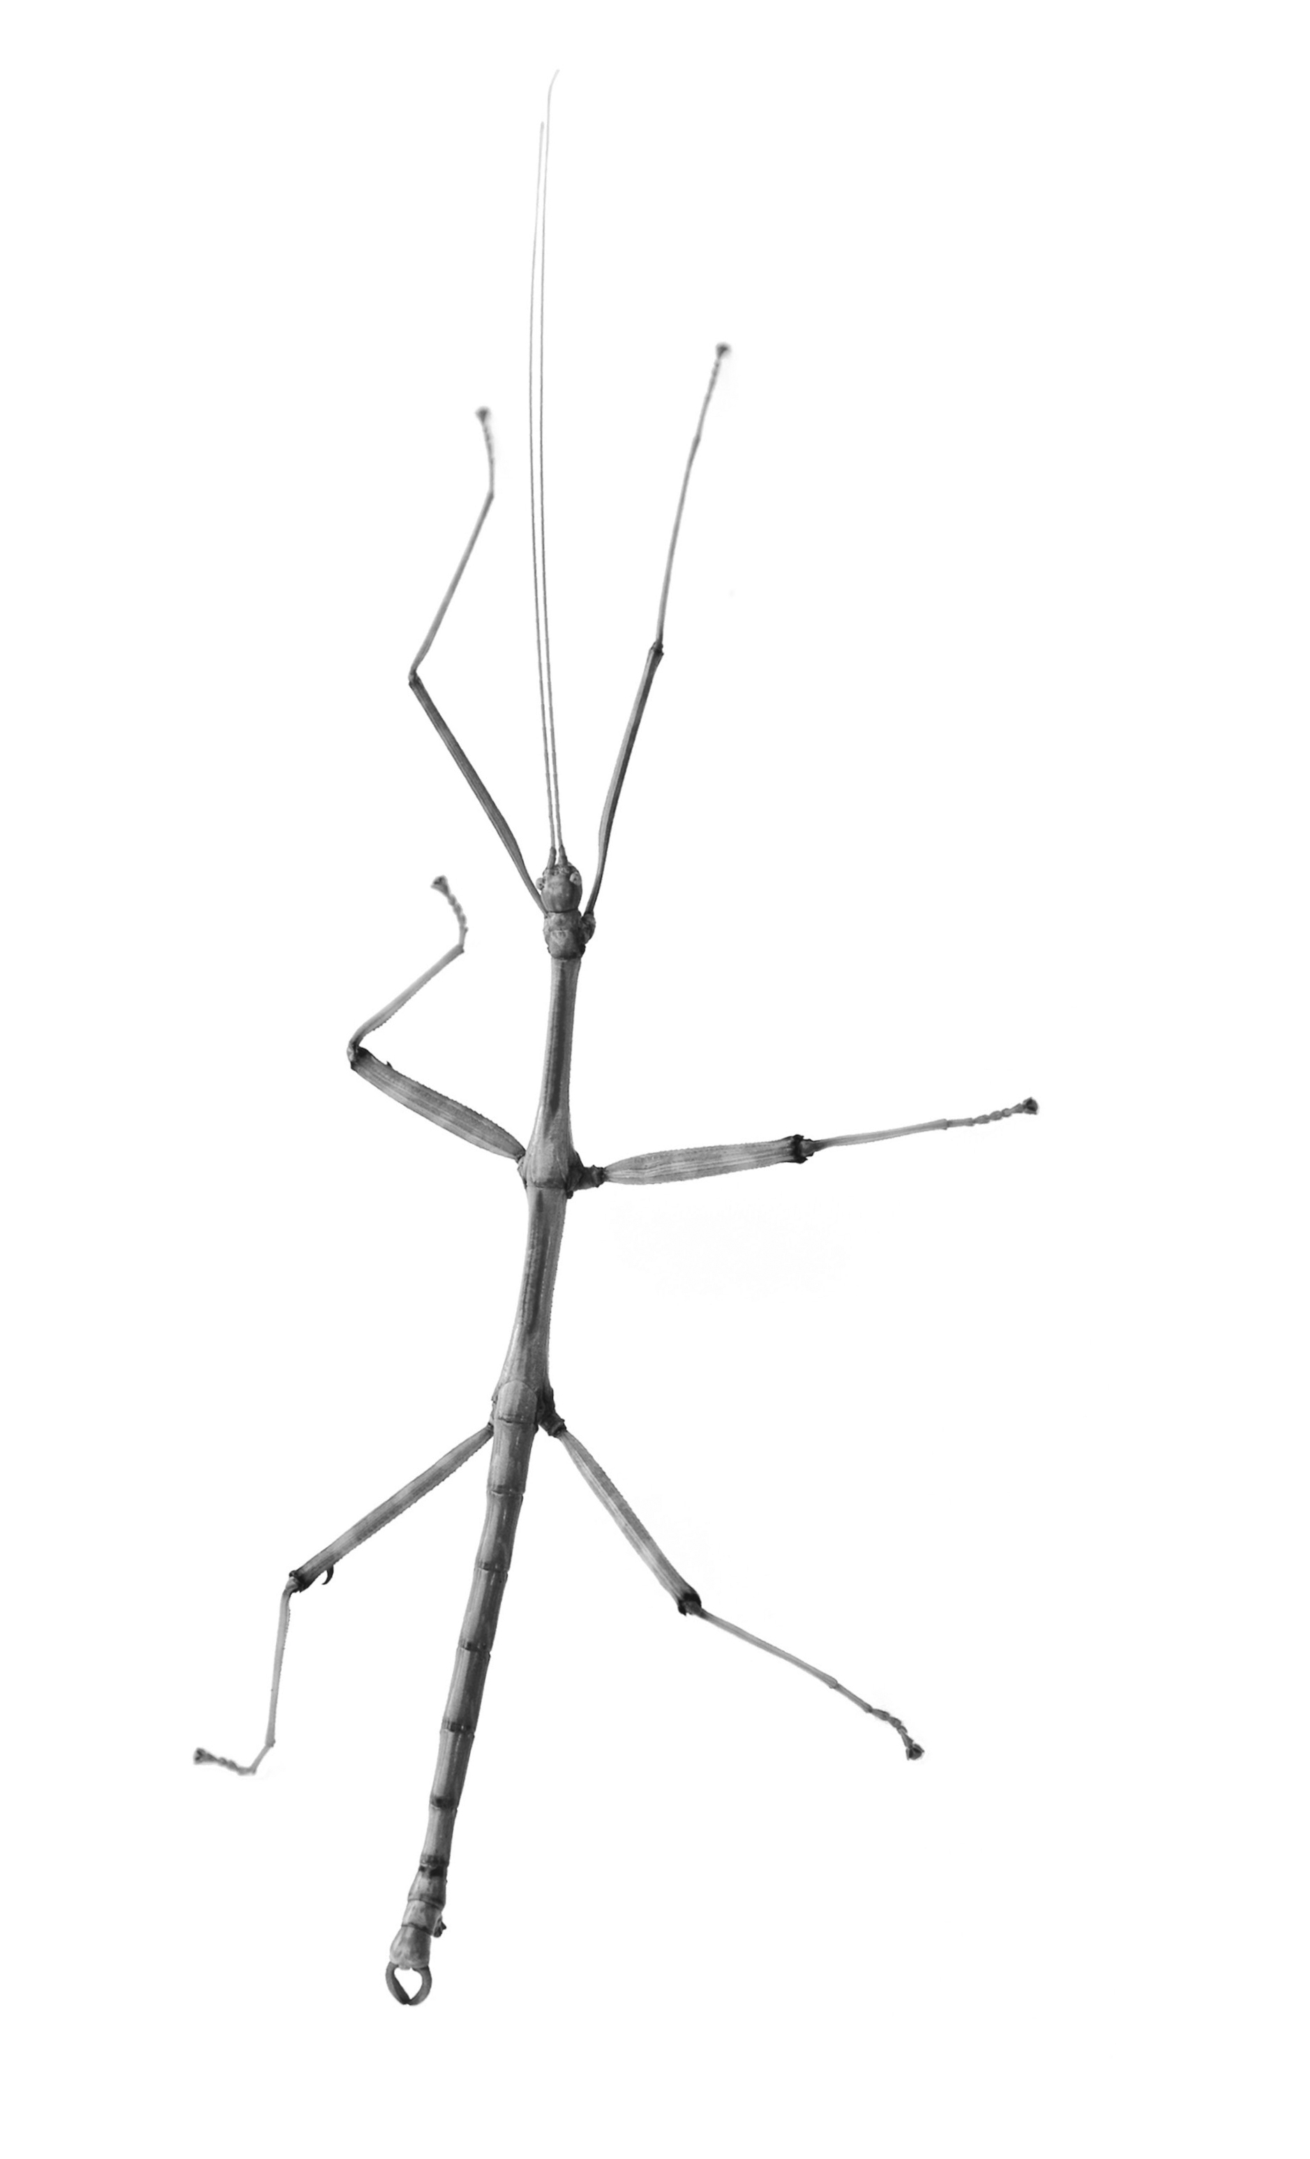

Estimate, Then Measure Line Master 4
Name: _____________________________

I am measuring… | Craft Sticks |  | Paper Clips
 | My Estimate | My Measure | My Estimate | My Measure

As Long As...? Line Master 5–1

– – – – – – – – – – – – – – – – – – – – – – – – – – – – – – – – – – – – – – – – – –
Name: _____________________________

I think a ______________________________________________ is about as long as

______________ ______________________________________________.

I measured. Now I know it is about as long as

______________ ______________________________________________.
– – – – – – – – – – – – – – – – – – – – – – – – – – – – – – – – – – – – – – – – – –
Name: _____________________________

I think a ______________________________________________ is about as long as

______________ ______________________________________________.

I measured. Now I know it is about as long as

______________ ______________________________________________.
– – – – – – – – – – – – – – – – – – – – – – – – – – – – – – – – – – – – – – – – – –

As Long As...? Line Master 5–2
Name: _____________________________

I think a ________________________________________________ is longer than

______________ ______________________________________________.

but shorter than

______________ ______________________________________________.

I measured. Now I know it is about as long as

______________ ______________________________________________.

Tall and Short Towers Line Master 6
Name: _____________________________

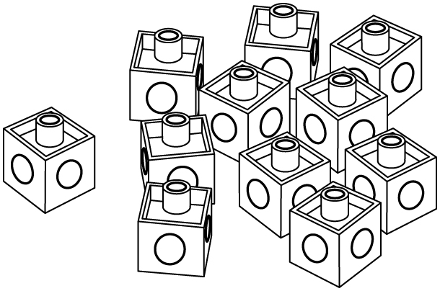You will need:
- linking cubes
- spinner

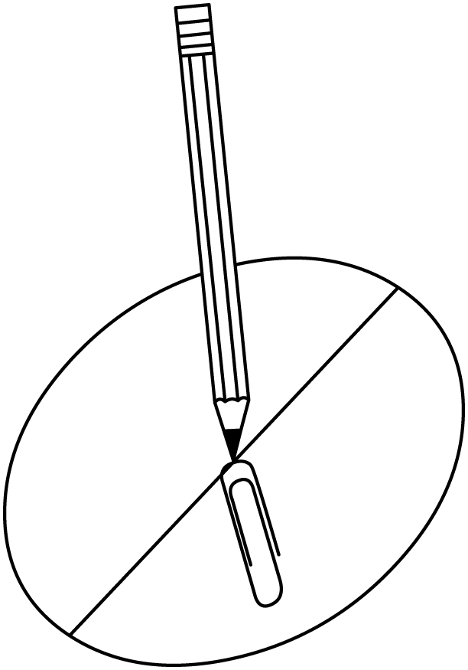How to play:
1. You and a friend each grab some linking cubes.
2. Make a tower with your own cubes.
3. Compare your tower to your friend’s tower.
4. Spin the spinner to find out who gets a point.
5. Break the towers apart and play again.
6. Play until one of you has 5 points.

Round | My Tower Is… (circle) | The Spinner Says… (circle) | My Points | My Friend’s Points
1 | taller shorter | taller shorter
2 | taller shorter | taller shorter
3 | taller shorter | taller shorter
4 | taller shorter | taller shorter
5 | taller shorter | taller shorter
6 | taller shorter | taller shorter
7 | taller shorter | taller shorter

Spinner Line Master 7

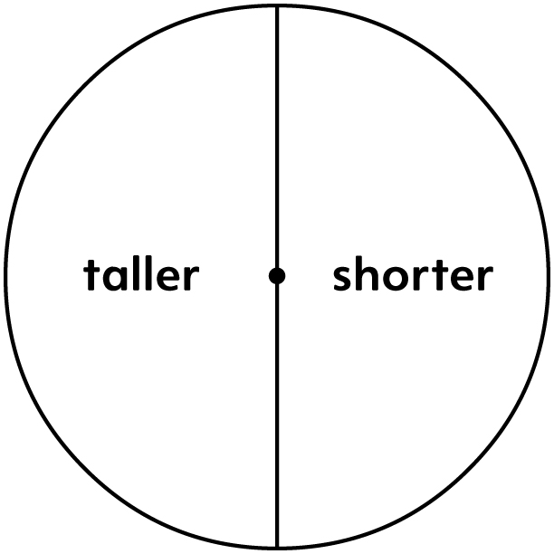

Mini-Book Template Line Master 8–1

My Measures  by ______________ | I am about as tall as...
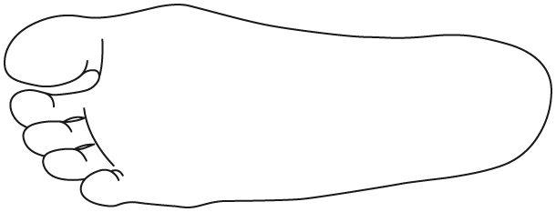  My foot is about as long as... | 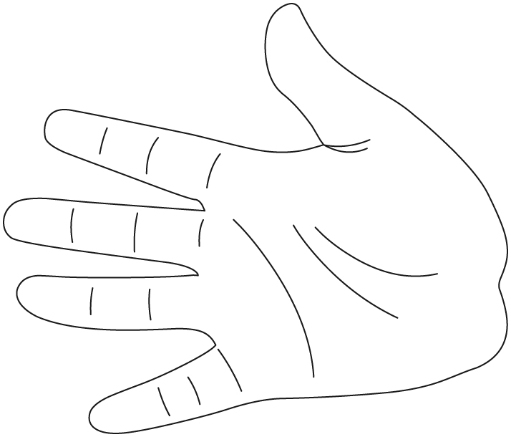  My hand is about as long as...

Mini-Book Template Line Master 8–2

I can jump about as far as... | I can reach as far as...
My giant step is about as long as... | My smile is about as long as...

How Long Is It? Line Master 9–1

– – – – – – – – – – – – – – – – – – – – – – – – – – – – – – – – – – – – – – – – – –

What can you find that is about as long as
2 craft sticks?

– – – – – – – – – – – – – – – – – – – – – – – – – – – – – – – – – – – – – – – – – –

What can you find that is longer than 2 craft sticks, but
shorter than 4 craft sticks?

– – – – – – – – – – – – – – – – – – – – – – – – – – – – – – – – – – – – – – – – – –

What can you find that is longer than 3 paper clips?

– – – – – – – – – – – – – – – – – – – – – – – – – – – – – – – – – – – – – – – – – –

What can you find that is longer than 5 paper clips,
but shorter than 8 paper clips?

– – – – – – – – – – – – – – – – – – – – – – – – – – – – – – – – – – – – – – – – – –

Which line is longer?

– – – – – – – – – – – – – – – – – – – – – – – – – – – – – – – – – – – – – – – – – –

How Long Is It? Line Master 9–2

– – – – – – – – – – – – – – – – – – – – – – – – – – – – – – – – – – – – – – – – – –

Draw a line that is about as long as one of these lines.

– – – – – – – – – – – – – – – – – – – – – – – – – – – – – – – – – – – – – – – – – –

Which path is longer?



                                         

