At the Corn Farm Line Master 1 (Assessment Master)
Name: _____________________________

Group quantities based on units of 10 | Not observed | Sometimes | Consistently
Composes teen numbers from units, of a ten and ones, and decomposes teen numbers into units, of a ten and leftover ones
Compare and order sets/quantities
to 20
Compares quantities by matching or counting to determine more/less or equal quantities
Determines how many more/less one quantity is compared to another
Uses relevant benchmarks to make mental comparisons and estimate quantities
Uses ordinal number names
Orders three quantities to 20 using sets
Strengths:

Next Steps:

Connecting Home and School Line Master 2–1



NOTE TO THE TEACHER

You may wish to send families an At the Corn Farm letter outlining a familiar activity or two they can do at home with their children.

Create a letter using this template and select one or two activities from the suggestions on the next page. Simply delete these instructions and cut and paste the activities you have selected, adapting them to fit your needs.

Connecting Home and School Line Master 2–2

Dear Family:

We have been working on At the Corn Farm, which focuses on Grouping Quantities Based on Units of 10 and Comparing and Ordering Sets/Quantities to 20. Try this activity at home with your child.

 – – – – – – – – – – – – – – – – – – – – – – – – – – – – – – – – – – – – – – – – – –

Reading the Story: As you read, follow along with the children in the story as they estimate and count. Ask your child if the numbers they estimate are more than, less than, or equal to the numbers they count. After you read, you might gather several sets of up to 20 small objects for you and your child to estimate together. Whose guess will be closer?

 – – – – – – – – – – – – – – – – – – – – – – – – – – – – – – – – – – – – – – – – – –

10 and More: Use the Math Mat on the inside back cover of At the Corn Farm and 20 small, identical (or similar) objects as counters. Find a page that includes numbers from 11 to 19, or just call out a number. Invite your child to count aloud as you (or your child) place counters on the Math Mat, making a separate group with the first 10. Then, ask: Is our number greater than 10 or less than 10? So, how many more do we need to add (take away) to show our number? Continue with other numbers for as long as your child remains interested.

 – – – – – – – – – – – – – – – – – – – – – – – – – – – – – – – – – – – – – – – – – –

How Many 1s? Draw 11 to 19 circles (or attach 11 to 19 stickers) in a line on strips of paper. Fold squares of paper in half to create tents. Out of sight of your child, choose 1 of the strips you created and write the number it represents on the outside of a tent. (For example, for a line of 12 circles, write “12” on a tent.) Place the tent over the strip in a way so that only 10 of the circles can be seen. Then, ask your child to tell you how many circles are hidden. Continue playing with the other strips.

 – – – – – – – – – – – – – – – – – – – – – – – – – – – – – – – – – – – – – – – – – –

Sincerely,

___________________________

Sorting Mat Line Master 3

Name: __________________________

10s | 1s

10s and 1s Charts Line Master 4
Name: __________________________

10s | 1s |  | 10s | 1s

10s | 1s |  | 10s | 1s

Numeral Cards (11–20) Line Master 5
11 | 12 | 13
14 | 15 | 16
17 | 18 | 19
20

Double Ten-Frame Line Master 6

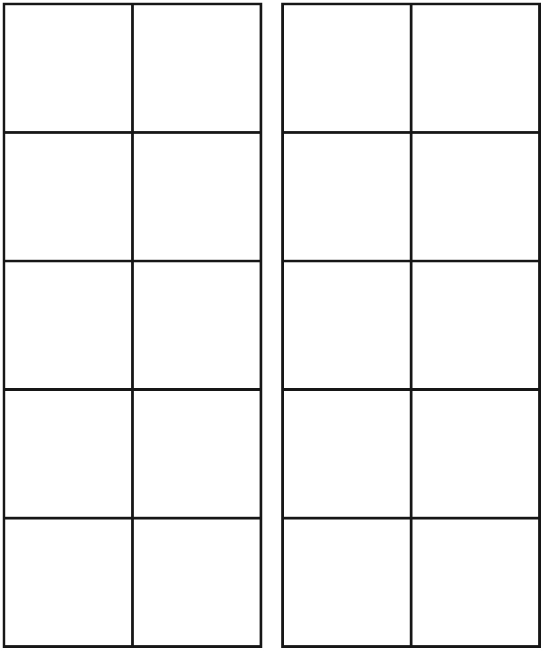
Teen Numbers Recording Sheet Line Master 7

 – – – – – – – – – – – – – – – – – – – – – – – – – – – – – – – – – – – – – – – – – – – – – – – – – – – – – – – – – – – –
Name: _____________________________ Number: _____________________________
 – – – – – – – – – – – – – – – – – – – – – – – – – – – – – – – – – – – – – – – – – – – – – – – – – – – – – – – – – – – –
Name: _____________________________ Number: _____________________________
 – – – – – – – – – – – – – – – – – – – – – – – – – – – – – – – – – – – – – – – – – – – – – – – – – – – – – – – – – – – –
Name: _____________________________ Number: _____________________________
 – – – – – – – – – – – – – – – – – – – – – – – – – – – – – – – – – – – – – – – – – – – – – – – – – – – – – – – – – – – –
Name: _____________________________ Number: _____________________________
 – – – – – – – – – – – – – – – – – – – – – – – – – – – – – – – – – – – – – – – – – – – – – – – – – – – – – – – – – – – –
Ordering Corn Cobs Line Master 8–1
Name: _____________________________

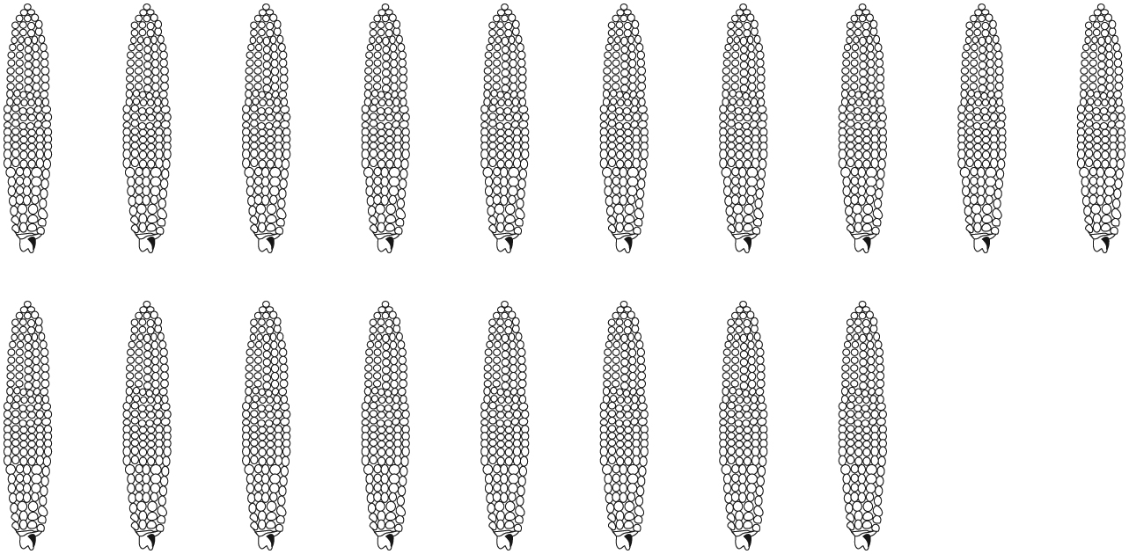
Number of cobs
Order from greatest to least

 |  | 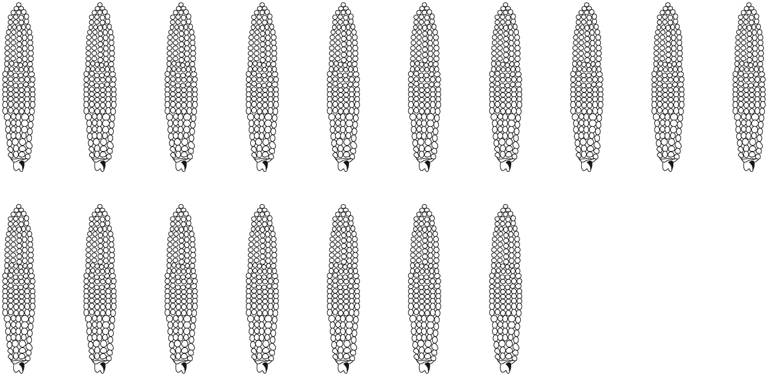 | 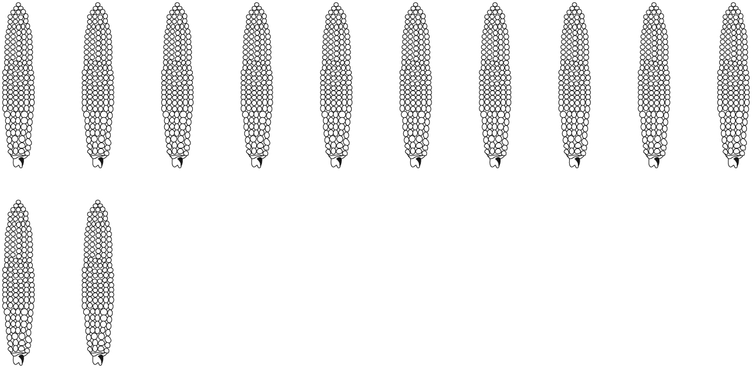
Number of cobs
Order from greatest to least

Ordering Corn Cobs Line Master 8–2
Name: _____________________________

 | 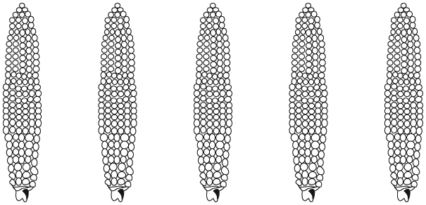 | 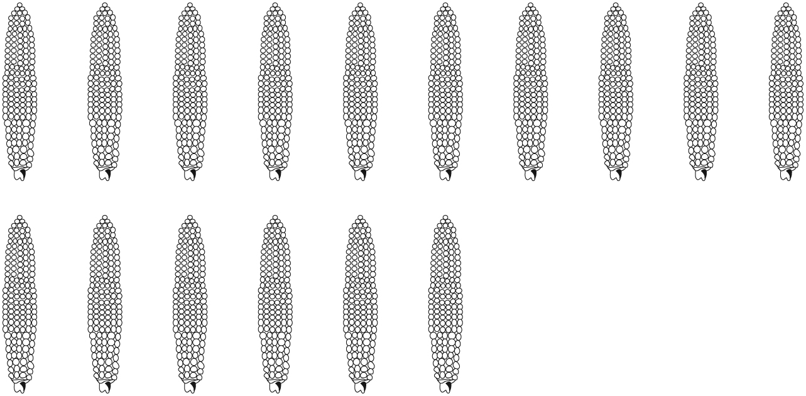 | 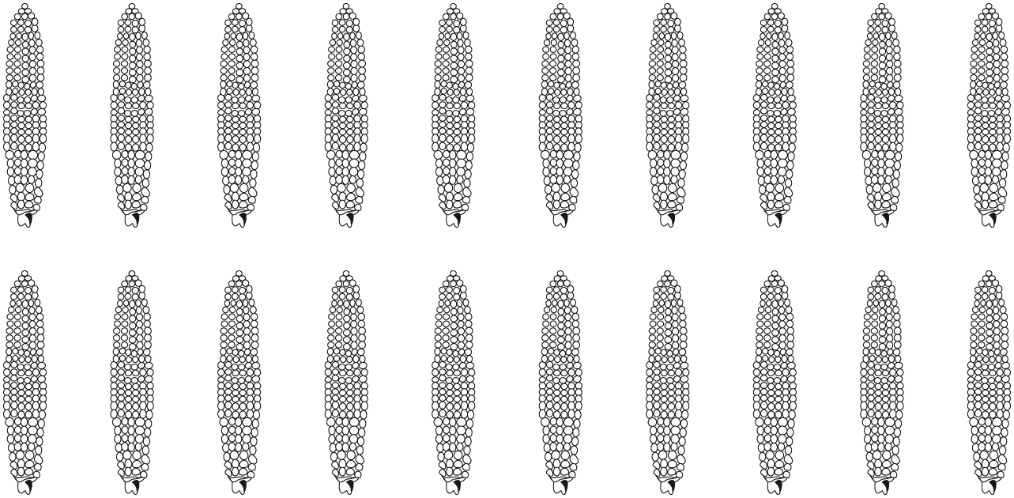
Number of cobs
Order from greatest to least

 | 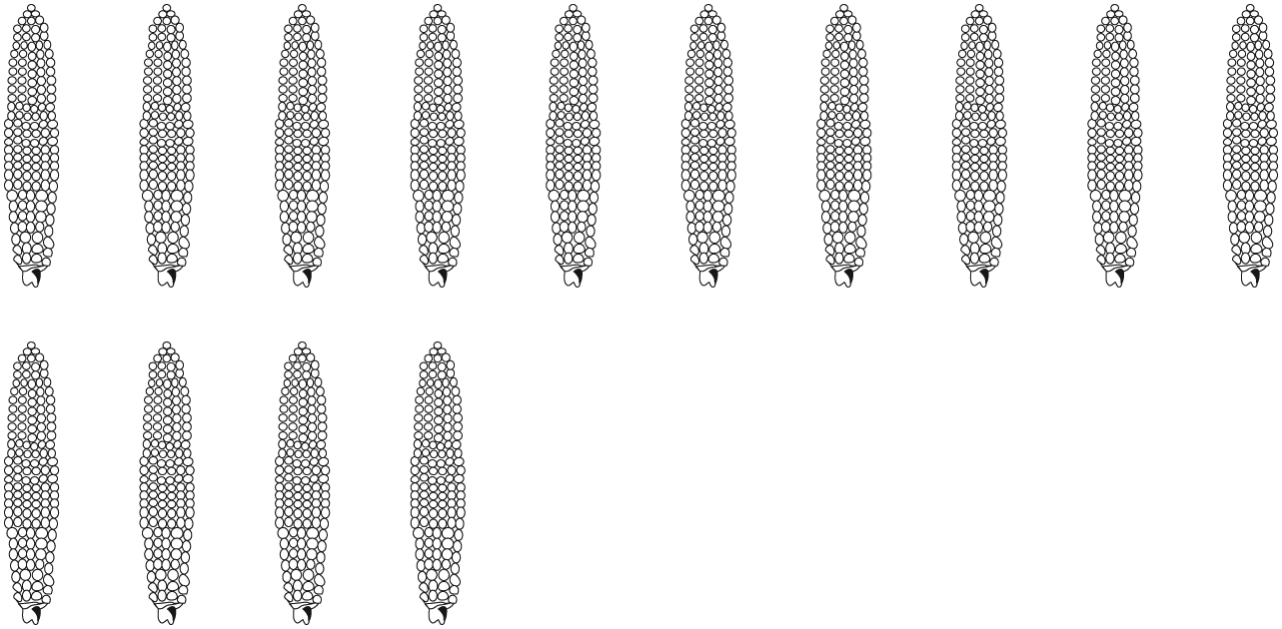 | 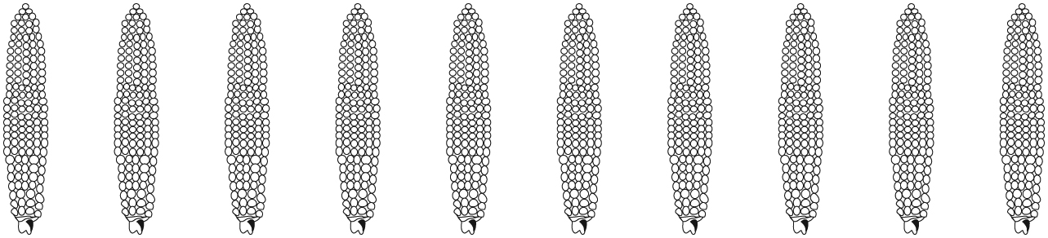 | 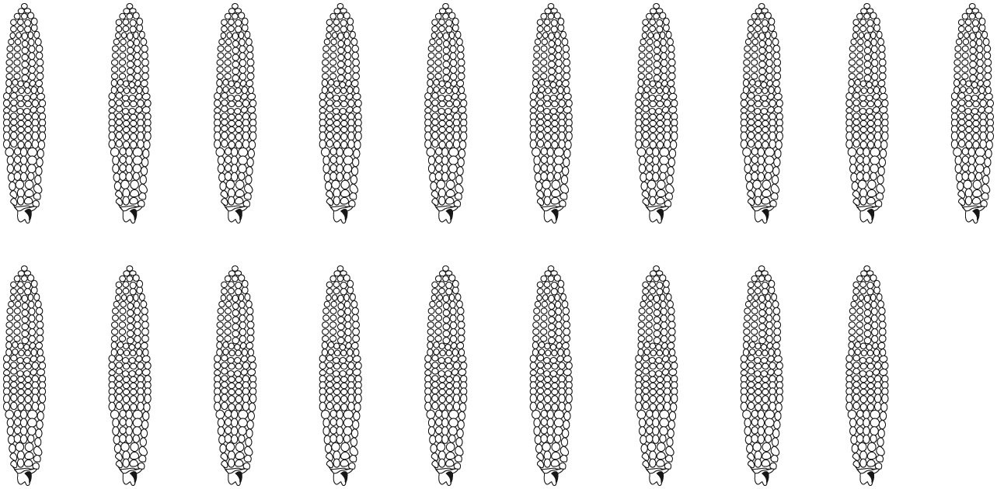
Number of cobs
Order from greatest to least

Ordering Corn Cobs Line Master 8–3
Name: _____________________________

Number of cobs
Order from greatest to least

 |  | 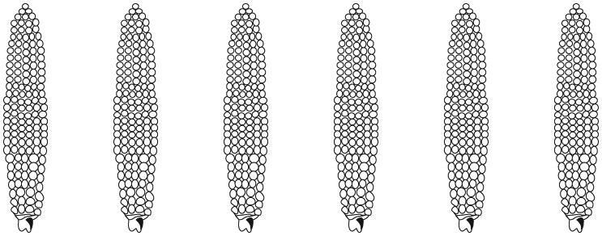 | 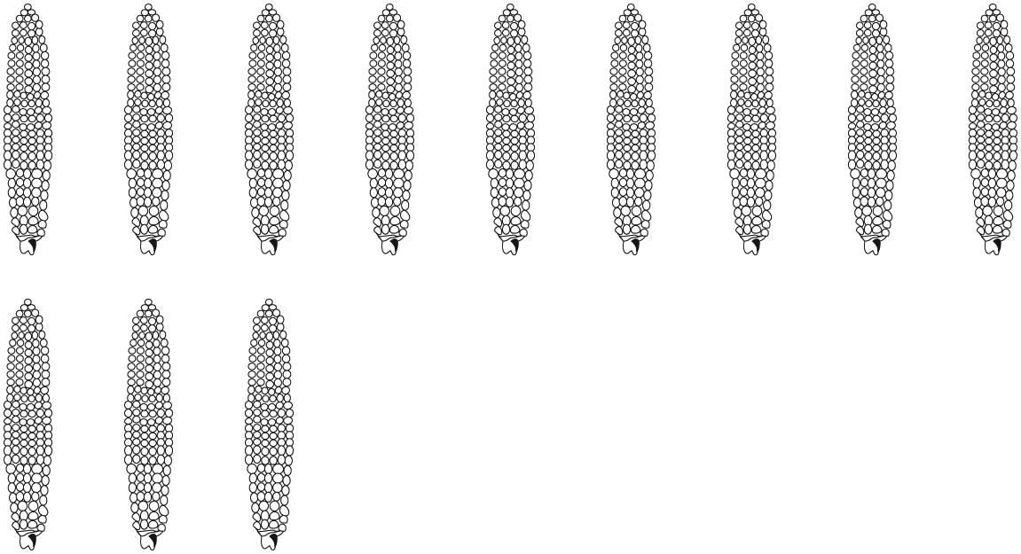
Number of cobs
Order from greatest to least

Greater, Lesser Line Master 9–1
Recording Sheet

Game 1 (Greater)
You need
- 2 ten-sided number-dice, 2 double ten-frames,
and 20 counters
How to play
- Take turns rolling and recording the number you roll.
- If you roll the greater number, add a counter to your double ten-frame.
- Do you have the most counters? You win!

Roll | Player 1 Name: | Player 2 Name:
1
2
3
4
5
6
7
8
9
10

Greater, Lesser Line Master 9–2
Recording Sheet

Game 1 (Greater)

Roll | Player 1 Name: | Player 2 Name:
11
12
13
14
15
16
17
18
19
20

Greater, Lesser Line Master 9–3
Recording Sheet

Game 2 (Lesser)
You need
- 2 ten-sided number-dice, 2 double ten-frames,
and 20 counters
How to play
- Take turns rolling and recording the number you roll.
- If you rolled the lesser number, add a counter to your double ten-frame.
- Do you have the most counters? You win!

Roll | Player 1 Name: | Player 2 Name:
1
2
3
4
5
6
7
8
9
10

Greater, Lesser Line Master 9–4
Recording Sheet

Game 2 (Lesser)

Roll | Player 1 Name: | Player 2 Name:
11
12
13
14
15
16
17
18
19
20

Build It! Recording Sheet Line Master 10
Name: _____________________________

1. Turn over a number card. Count out that number of bricks.
2. Build a stack of 10 bricks!
3. Do you have leftover bricks? Build another stack!
4. Make a record of your stacks. What do you notice?

_______________ _______________ _______________
Mini-Book Template Line Master 11

My Trip to the Corn Farm

My Name:

__________________________

Guess How Many! Line Master 12
Name: _____________________________

Container 1 |  |  | Container 3
My Estimate | My Count |  | My Estimate |  | My Count
Container 2 |  |  | Ordering My Counts
My Estimate | My Count |  | Greatest |  |  |  | Least
 |  |  | Least |  |  |  | Greatest

