On Safari! Line Master 1 (Assessment Master)
Name: _____________________________

Count sets to 20 | Not observed | Sometimes | Consistently
Says one number for each object counted (one-to-one correspondence)
Says counting by 2 numbers in correct sequence (stable order)
Knows that the last counting word tells how many are in the set (cardinality)
Counts and creates sets (to 20) by 1s and 2s
Knows that counting a set different ways does not change the number (conservation of number)
Add 1 or 2
Adds 1 to a set and states how many
Adds 2 to a set and states how many
Strengths:

Next Steps:

Connecting Home and School Line Master 2–1



NOTE TO THE TEACHER

You may wish to send families an On Safari! letter outlining a familiar activity or two they can do at home with their children.

Create a letter using this template and select one or two activities from the suggestions on the next page. Simply delete these instructions and cut and paste the activities you have selected, adapting them to fit your needs.

Connecting Home and School Line Master 2–2

Dear Family:

We have been working on On Safari! which focuses on Counting and Adding by 1s and 2s. Try this activity at home with your child.

--------------------------------------------------------------------------------------------------------
Reading the Story: As you read the story, enjoy counting the animals and the eyes. Encourage your child to chant the counting-by-2 sequence. You might encourage your child to clap some of the numbers and say others aloud (e.g., clap, clap, 6, 8, 10).
--------------------------------------------------------------------------------------------------------
Retelling the Story: Encourage a retelling of the story using small objects and the Math Mat (on the inside back cover). Say, for example: If there is 1 animal, how many eyes would we see? (Your child places 2 objects on the mat.) Say: Another animal arrives! How many eyes? (Your child places 2 more “eyes” on the mat.) Ask: How many eyes? Let’s check. Continue telling stories of animals arriving, asking your child to tell how many eyes there are after each addition. You can also have animals leave the mat one by one to give your child the opportunity to count back by 2.
--------------------------------------------------------------------------------------------------------
Count by 2s: Invite your child to count by 2s. They might count items that come in pairs (socks, shoes, mittens, eyes in your family). For example, laundry time is a good opportunity for your child to pair socks and count how many by 2s. You might also take the opportunity to count during everyday activities. For example, as you walk, count steps saying every other step aloud (step, 2, step, 4, step, 6, and so on).
--------------------------------------------------------------------------------------------------------
Listen and Count: Use a plastic or metal container and some small items (coins, buttons, nuts and bolts). Ask your child to listen and count silently as you drop 2 items at a time into the container. After dropping about 10 items, ask: How many do you think are in the can? Spill the contents and have your child pair the items and count by 2s to check. Repeat, dropping a different number of items.
--------------------------------------------------------------------------------------------------------

Sincerely,

___________________________

Counting-by-2s Mat Line Master 3

Numeral Cards Line Master 4

2 | 4
6 | 8
10 | 12
14 | 16
18 | 20

On Safari! Math Mat Line Master 5



Hundred Chart Line Master 6

1 | 2 | 3 | 4 | 5 | 6 | 7 | 8 | 9 | 10
11 | 12 | 13 | 14 | 15 | 16 | 17 | 18 | 19 | 20
21 | 22 | 23 | 24 | 25 | 26 | 27 | 28 | 29 | 30
31 | 32 | 33 | 34 | 35 | 36 | 37 | 38 | 39 | 40
41 | 42 | 43 | 44 | 45 | 46 | 47 | 48 | 49 | 50
51 | 52 | 53 | 54 | 55 | 56 | 57 | 58 | 59 | 60
61 | 62 | 63 | 64 | 65 | 66 | 67 | 68 | 69 | 70
71 | 72 | 73 | 74 | 75 | 76 | 77 | 78 | 79 | 80
81 | 82 | 83 | 84 | 85 | 86 | 87 | 88 | 89 | 90
91 | 92 | 93 | 94 | 95 | 96 | 97 | 98 | 99 | 100

Double Ten-Frame Line Master 7

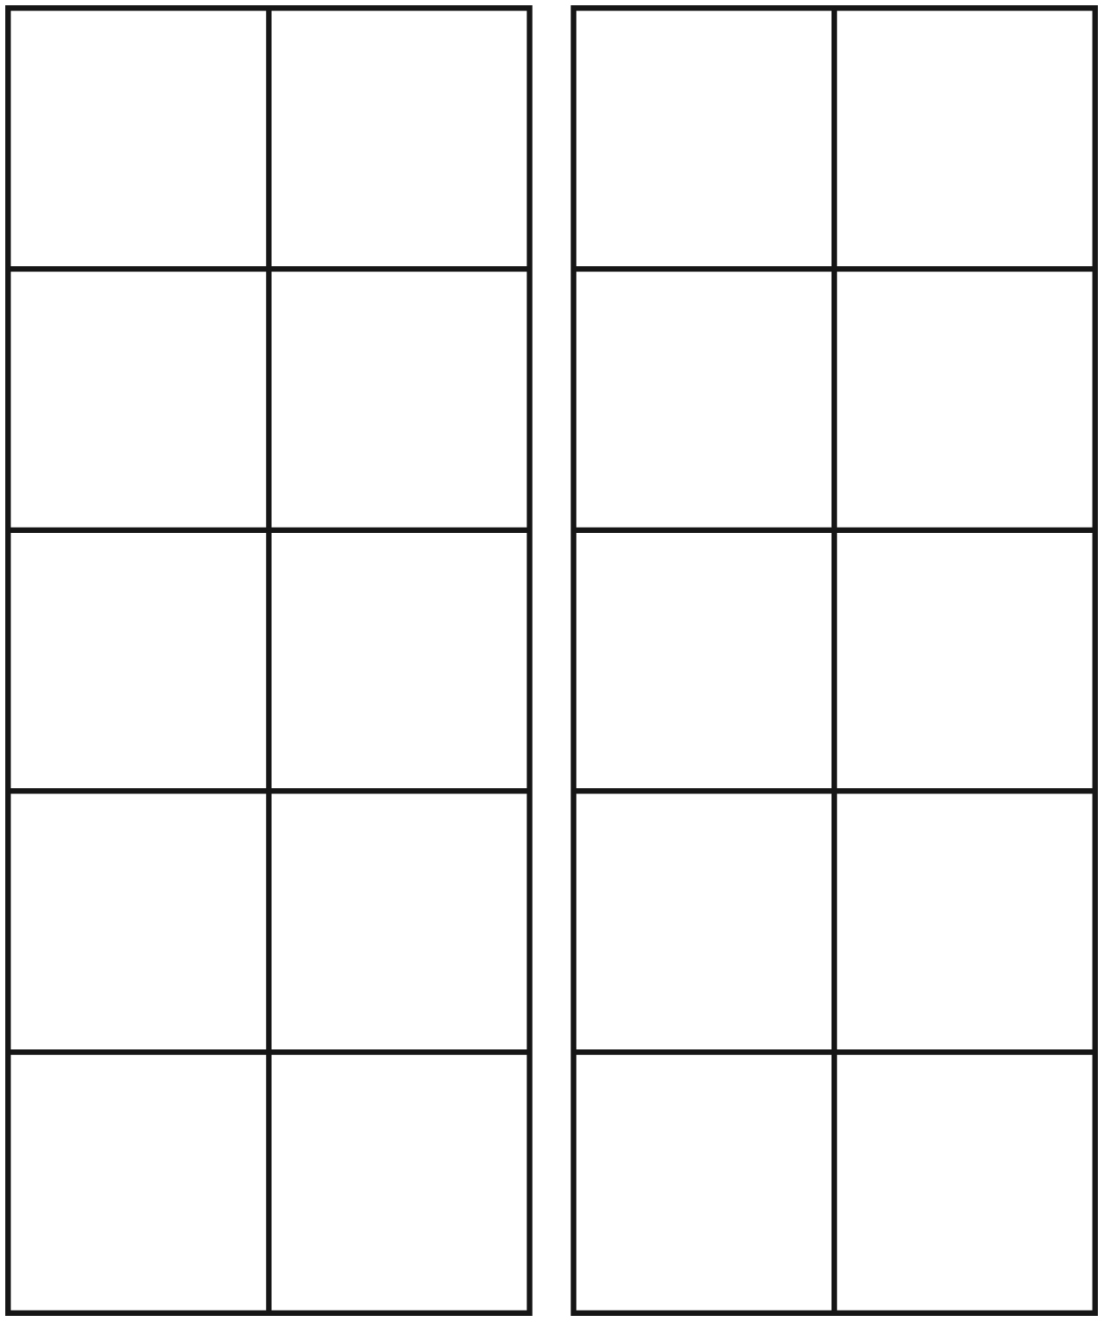

Mini Story Template: Animals 2 by 2 Line Master 8

2 4 6 8 10 12 14 16 18 20

How Many ______________?

By:

2 4 6 8 10 12 14 16 18 20

How Many? Problems Line Master 9–1
  There are 8 people.  How many eyes? ____________ | 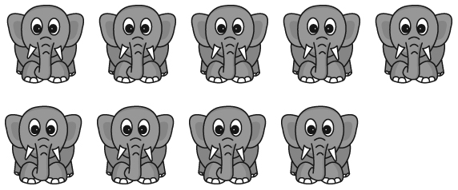  There are 9 elephants.  How many tusks? ____________
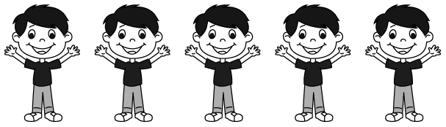  There are 5 children.  How many arms? ___________ | 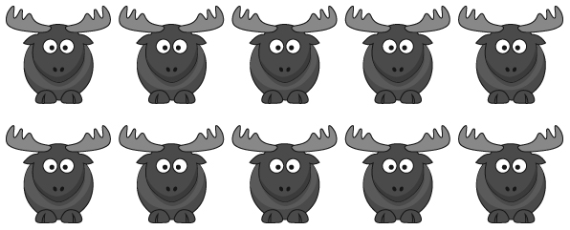  There are 10 moose.  How many antlers? __________

How Many? Problems Line Master 9–2
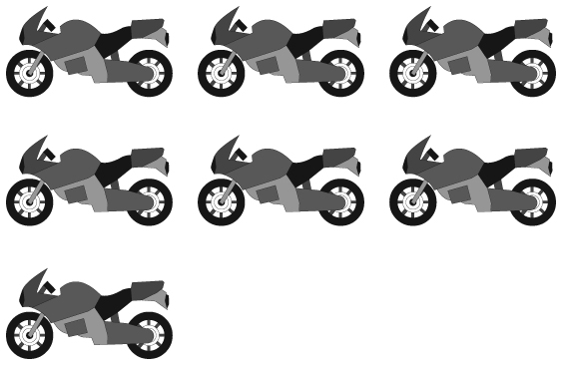  There are 7 motorcycles.  How many wheels? __________ |   There are 6 pairs of chopsticks.  How many chopsticks? _______
  There are 4 pairs of boots.  How many boots? ___________ | 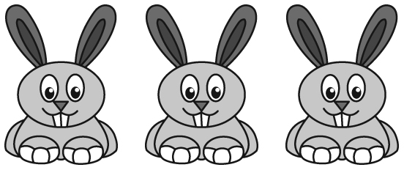  There are 3 rabbits.  How many ears? _____________

