**Number Cards (1–10)**

**Master 22a**

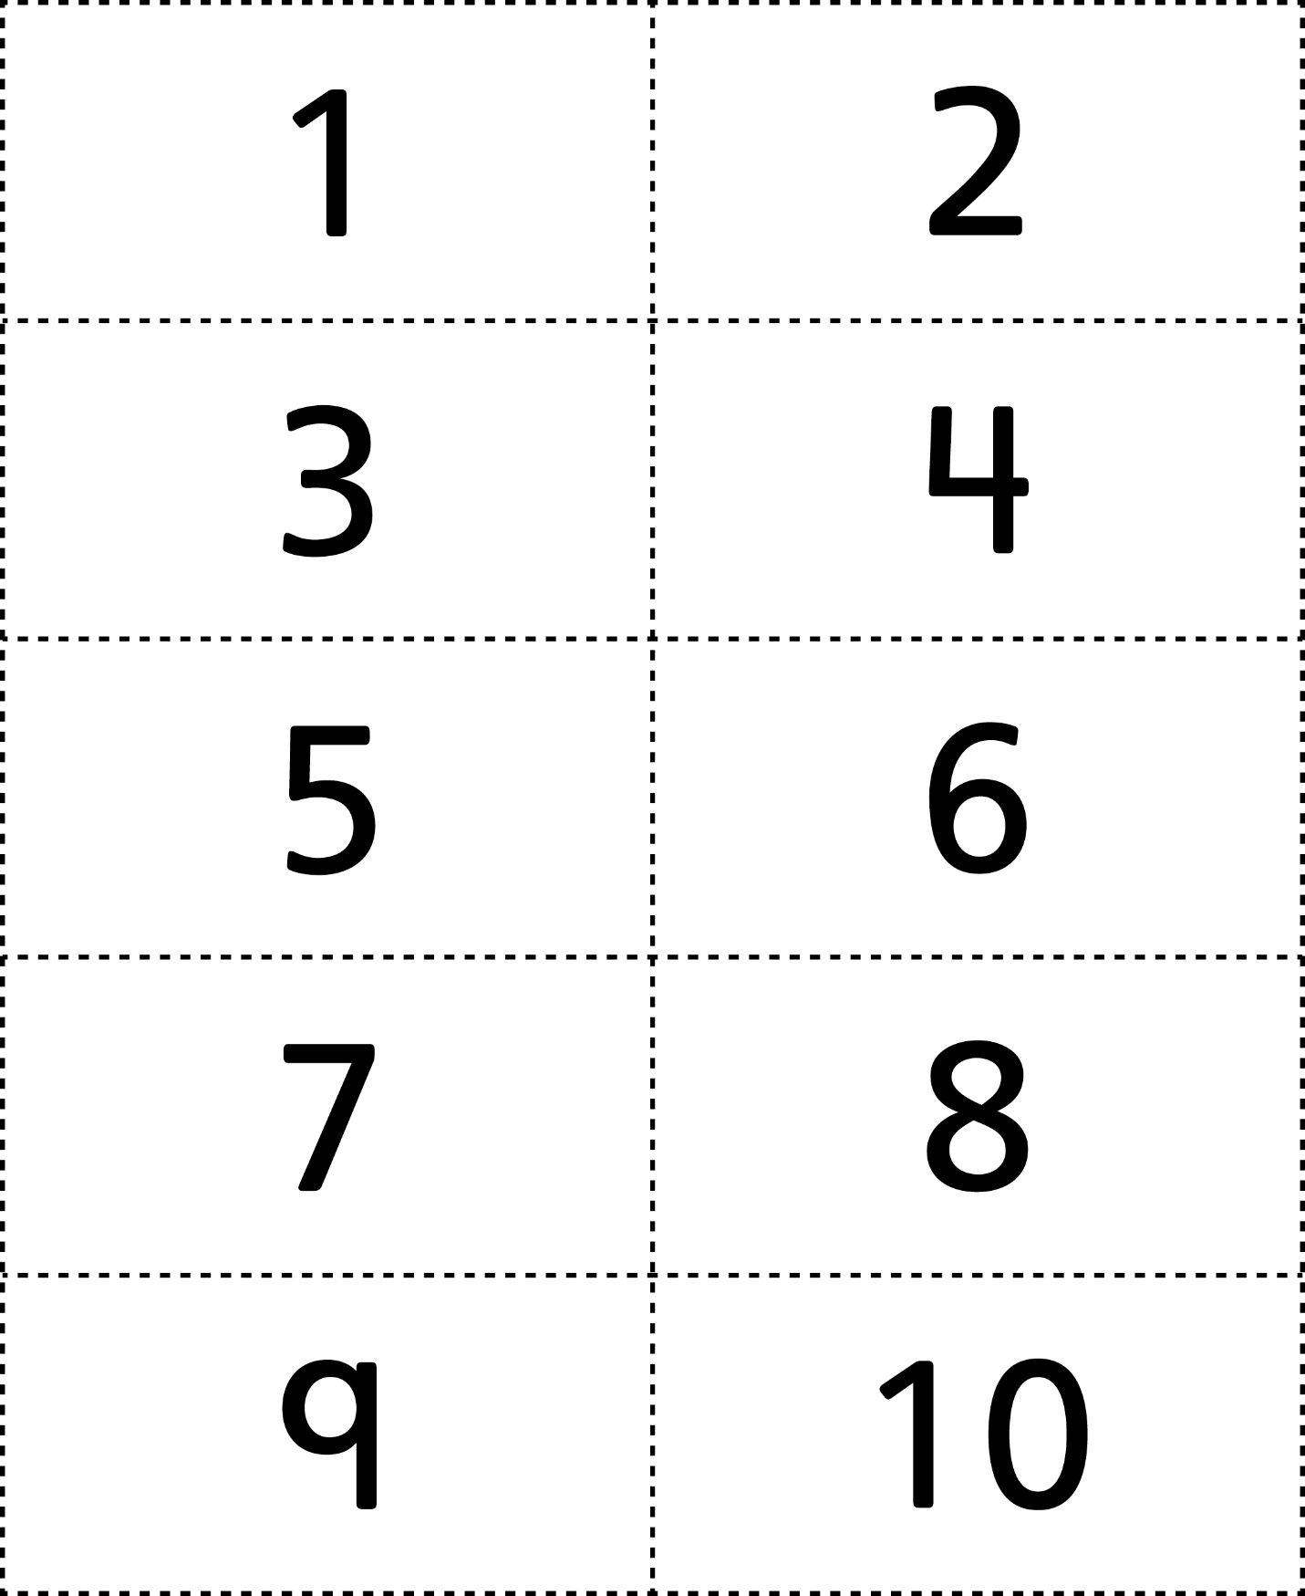



**Number Cards (11–20)**

**Master 22b**

