Extending and Describing Behaviours/Strategies
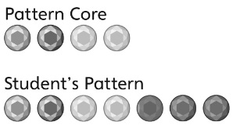  Student randomly draws circles to extend the pattern. | Student repeats only the last jewel in the core.  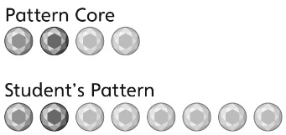 | 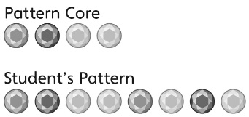  Student draws the jewels with the correct colours but places them in the wrong order.
Observations/Documentation
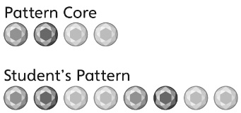  Student accurately extends the pattern but has difficulty describing the pattern. | Student accurately extends and describes the pattern but has difficulty representing it with letters. | Student accurately extends and describes the pattern and represents it with letters.
Observations/Documentation

Big Idea |  |  |  |  | Indicators From Learning Progression
Curriculum Expectations addressed

Student Names
Student can identify, represent, describe, and extend geometric repeating patterns involving one attribute.
(Activities 1, 5)
Student can identify, represent, describe, and extend numeric repeating patterns.
(Activities 2, 4, 5)
Student can identify the core of a repeating pattern. (Activities 1–5)
Student can find and describe numeric patterns on a hundred chart. (Activity 4)
Student can represent a repeating pattern with letters. (Activities 2, 5)
Student can translate a repeating pattern from one representation to another. (Activity 5)
Student can predict an element in a repeating pattern. (Activity 3)
Student uses math language to describe repeating patterns. (Activities 1–5)

Name: _______________________

 | Not Observed | Sometimes | Consistently
Identifies, represents, describes, and extends geometric repeating patterns involving one attribute.
(Activities 1, 5)
Identifies, represents, describes, and extends numeric repeating patterns.
(Activities 2, 4, 5)
Identifies the core of a repeating pattern. (Activities 1–5)
Finds and describes numeric patterns on a hundred chart. (Activity 4)
Represents a repeating pattern with letters. (Activities 2, 5)
Translates a repeating pattern from one representation to another. (Activity 5)
Predicts an element in a repeating pattern.
(Activity 3)
Uses math language to describe repeating patterns. (Activities 1–5)

Strengths:

Next Steps:

