**Core Cards**

**Master 4a**

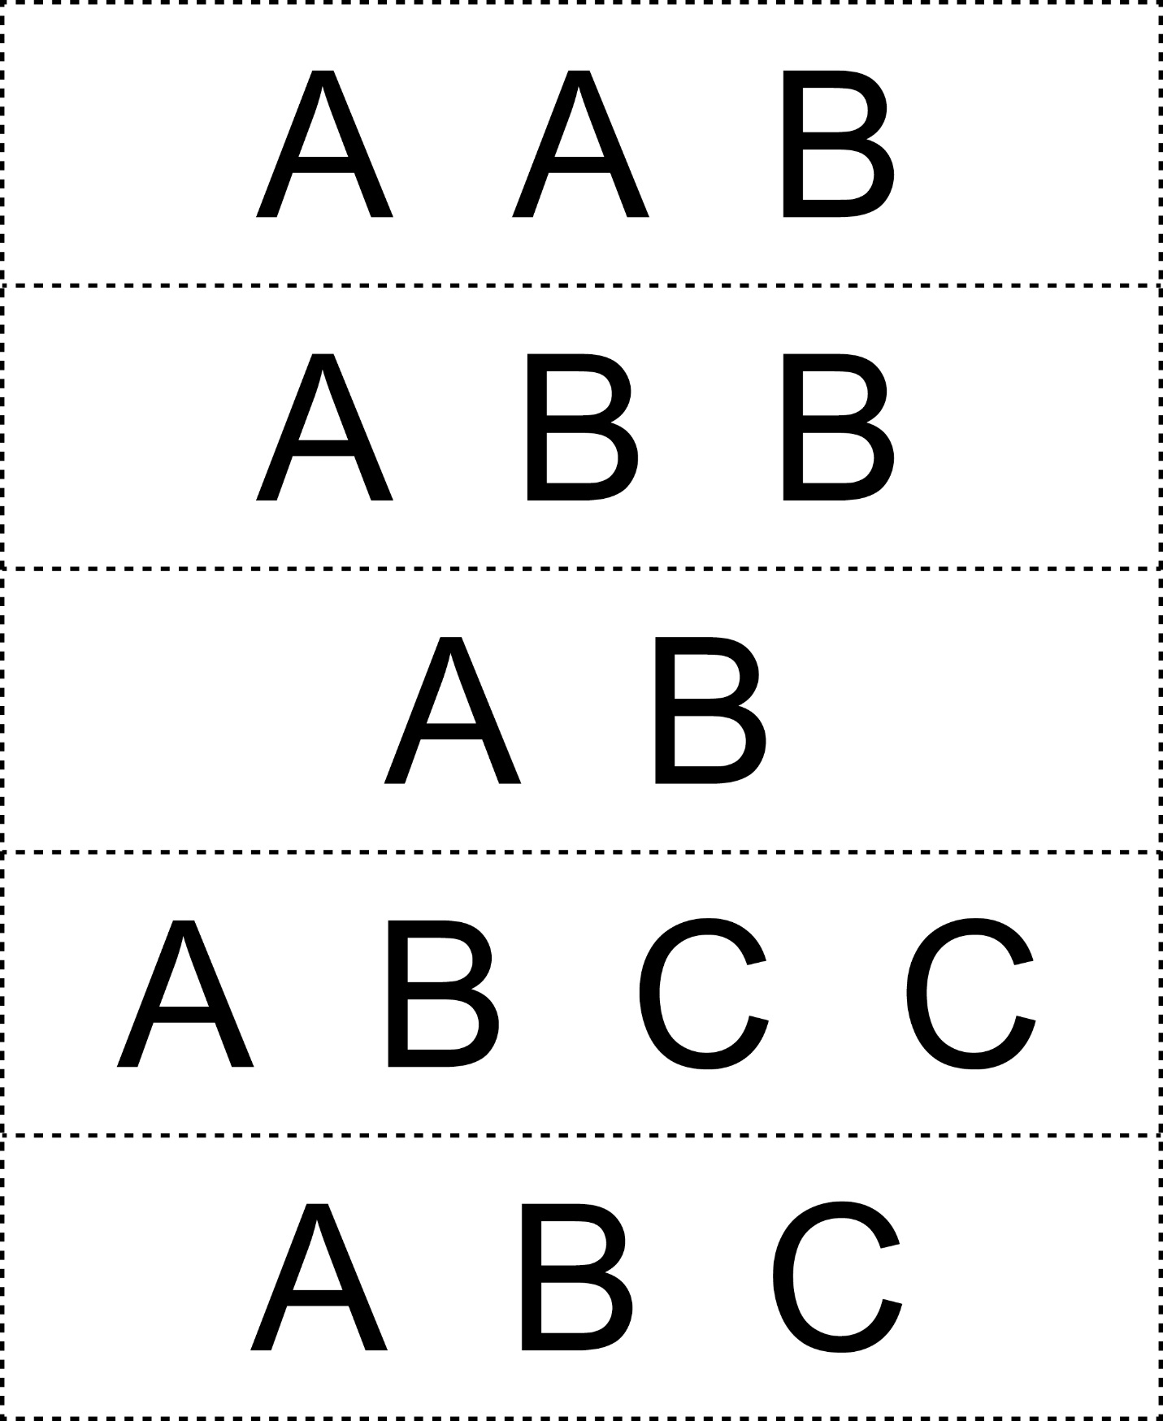



**Core Cards**

**Master 4b**

