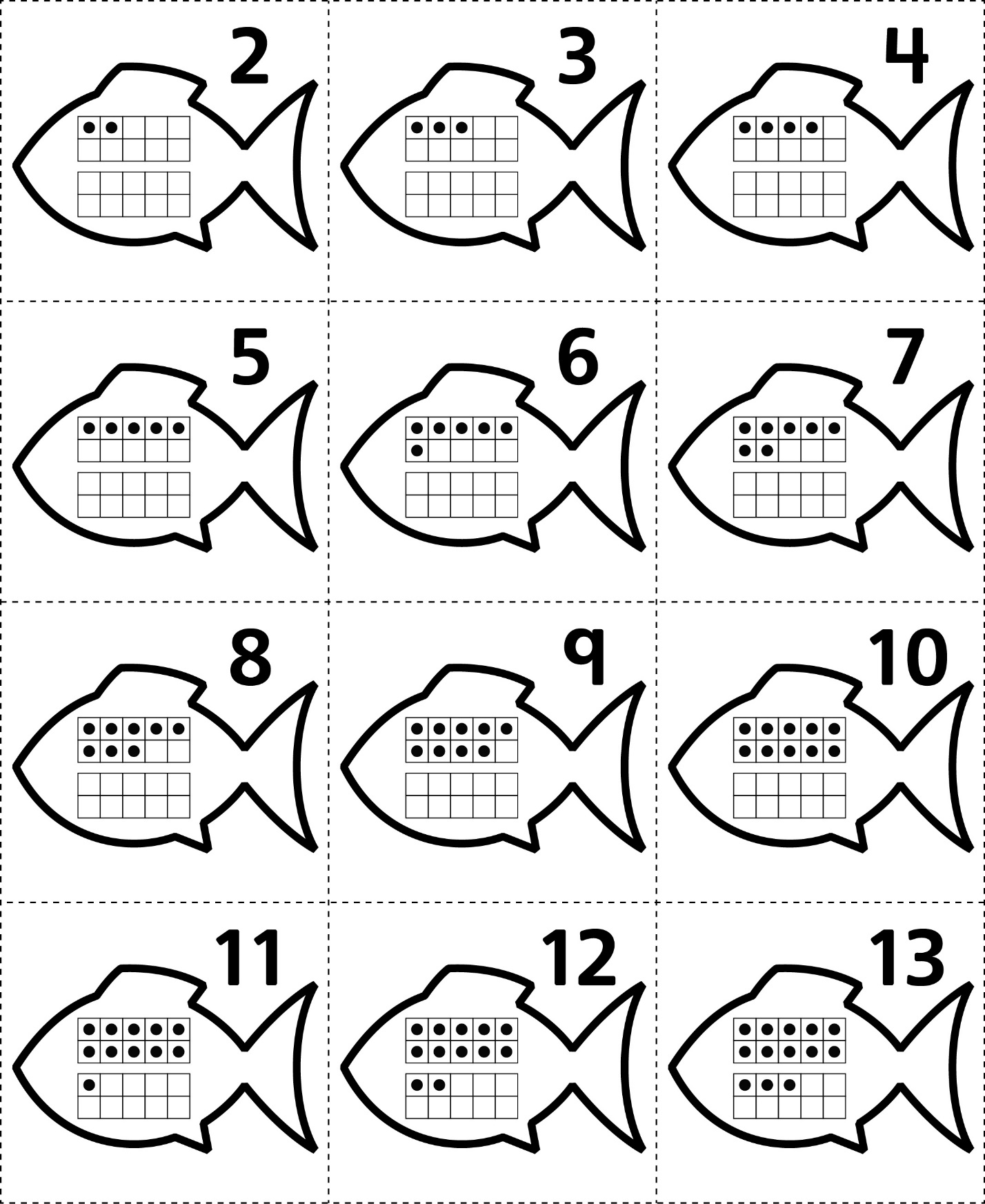**Answer Cards**

**Master 71a**

**Answer Cards**

**Master 71b**

