**Matching Cards**

**Master 60a**

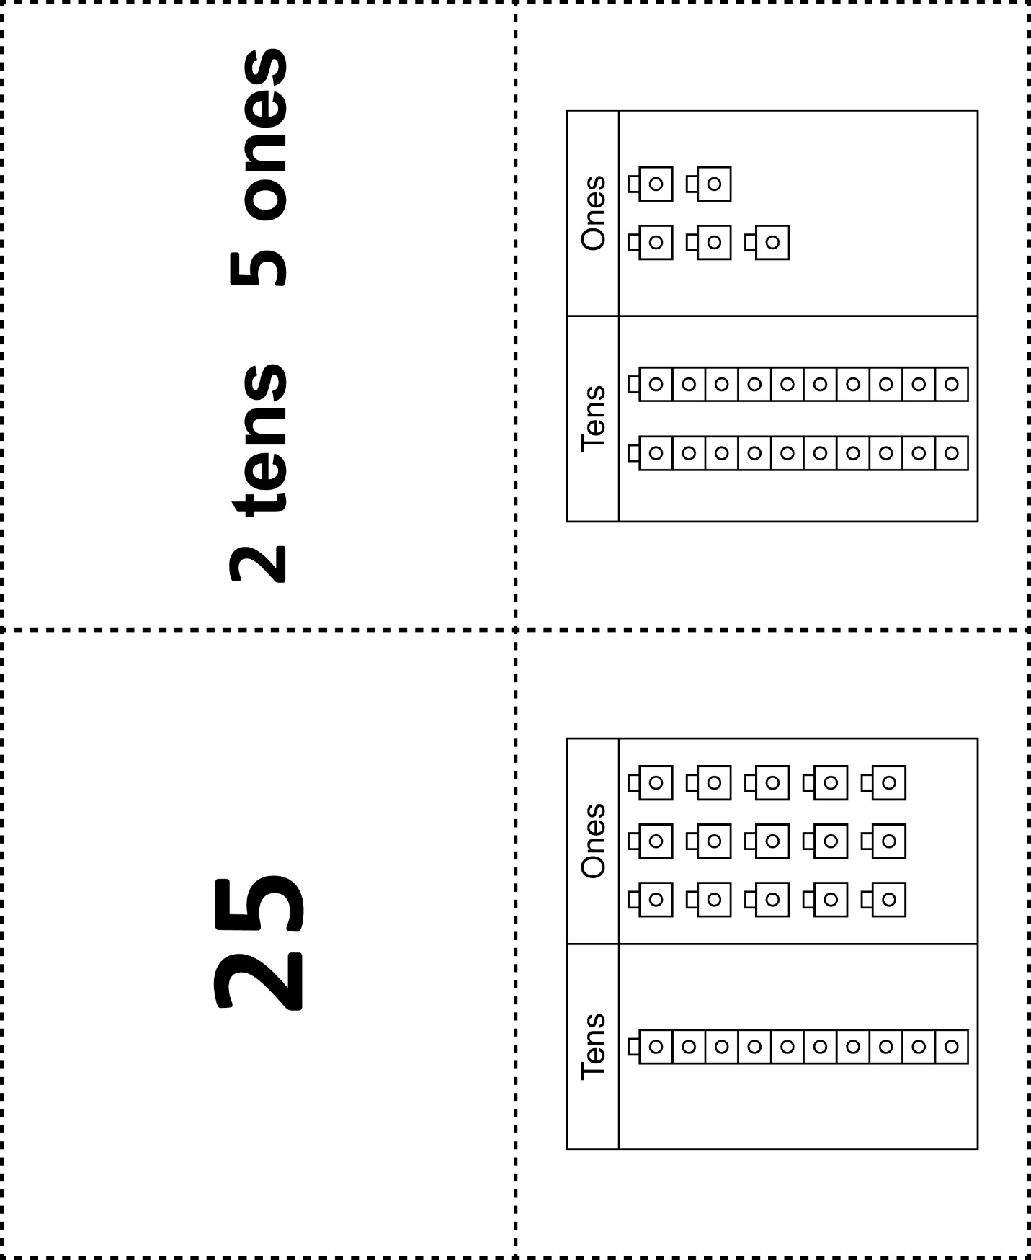



**Matching Cards**

**Master 60b**

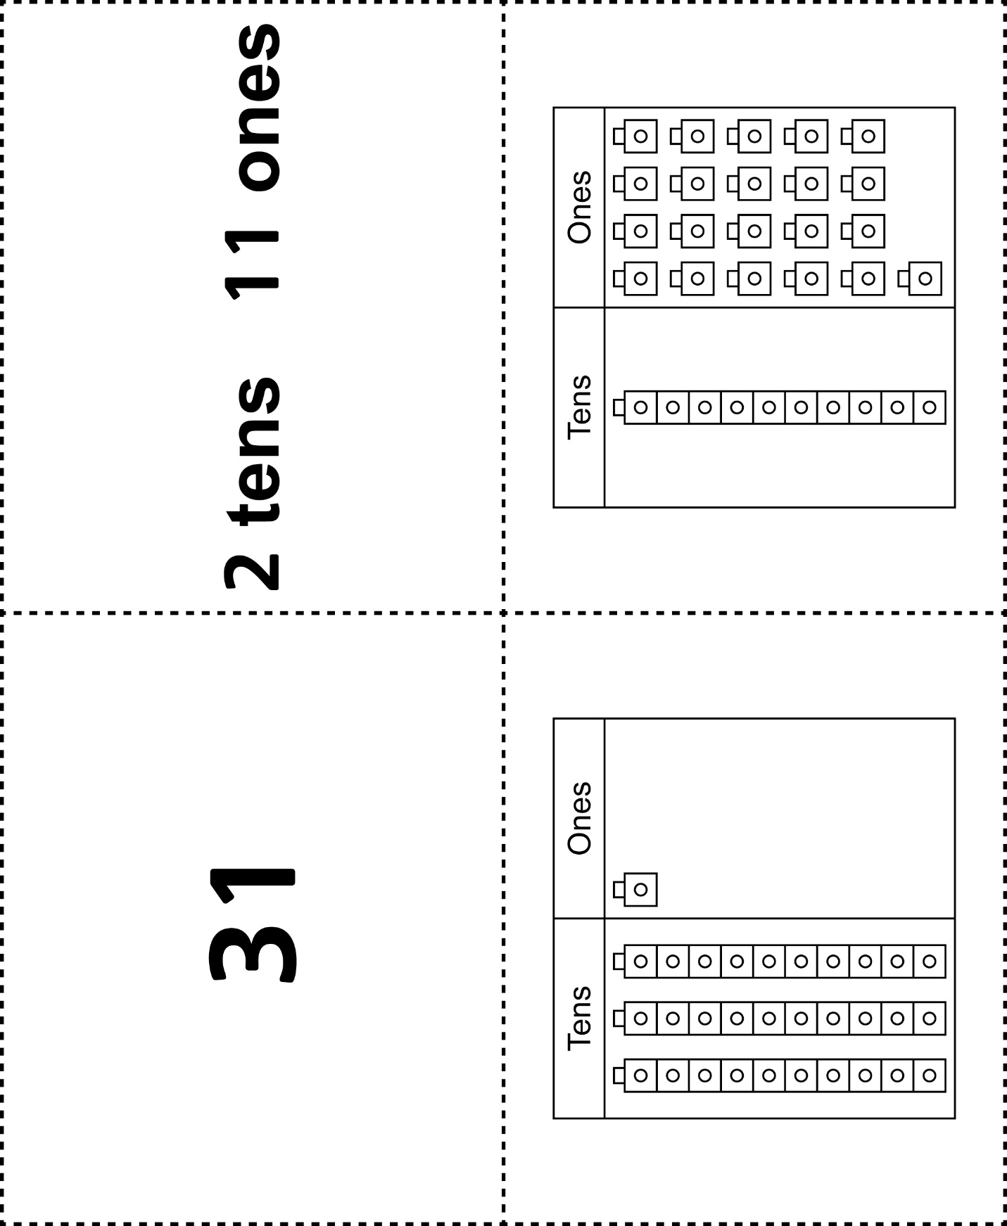

**Matching Cards**

**Master 60c**



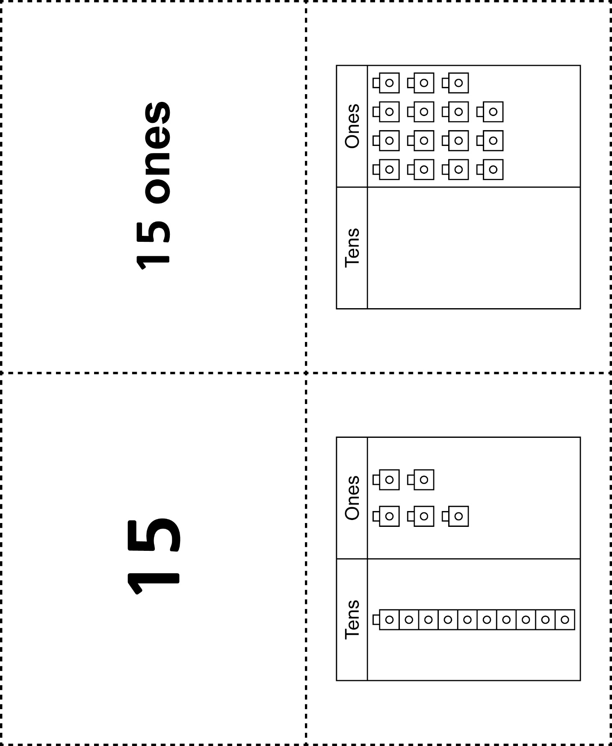

**Matching Cards**

**Master 60d**

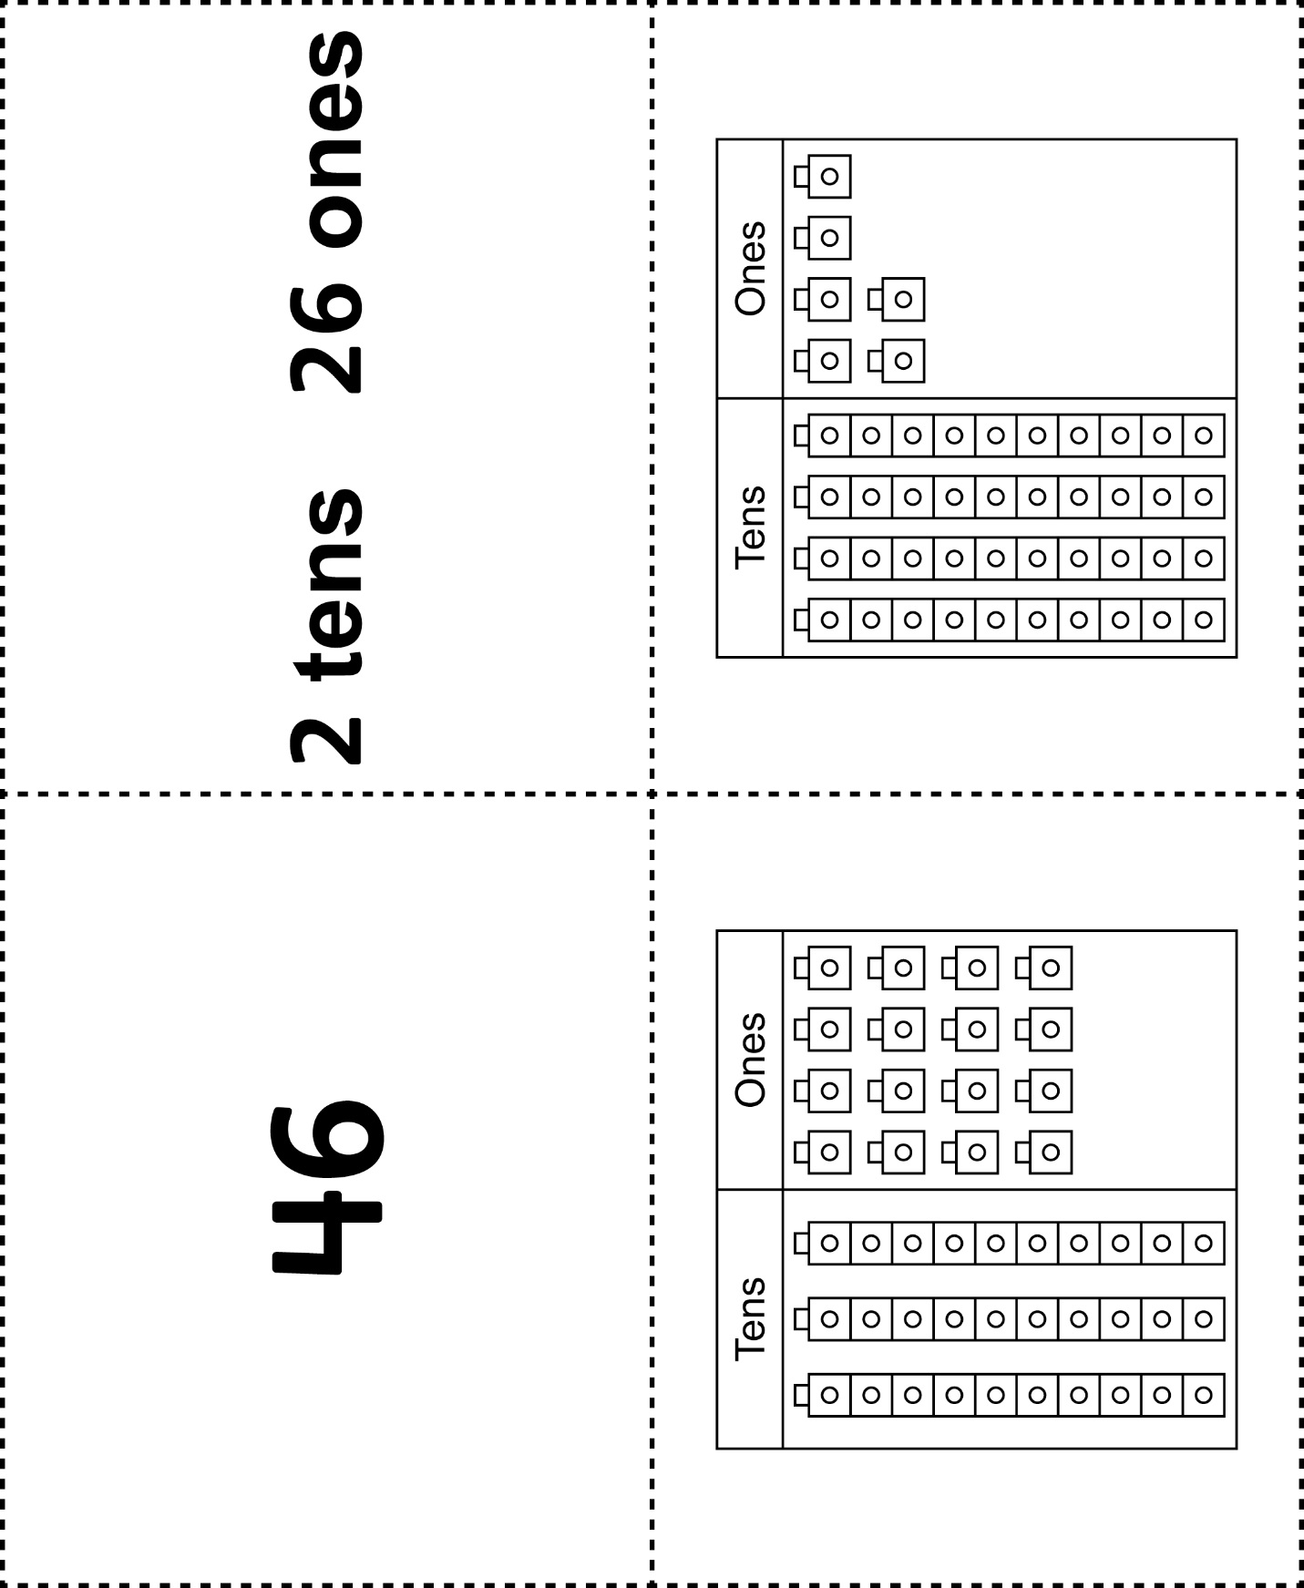



**Matching Cards**

**Master 60e**

|  |  |
| --- | --- |
|  |  |
|  |  |

