**Coin Cards**

**Master 50a**

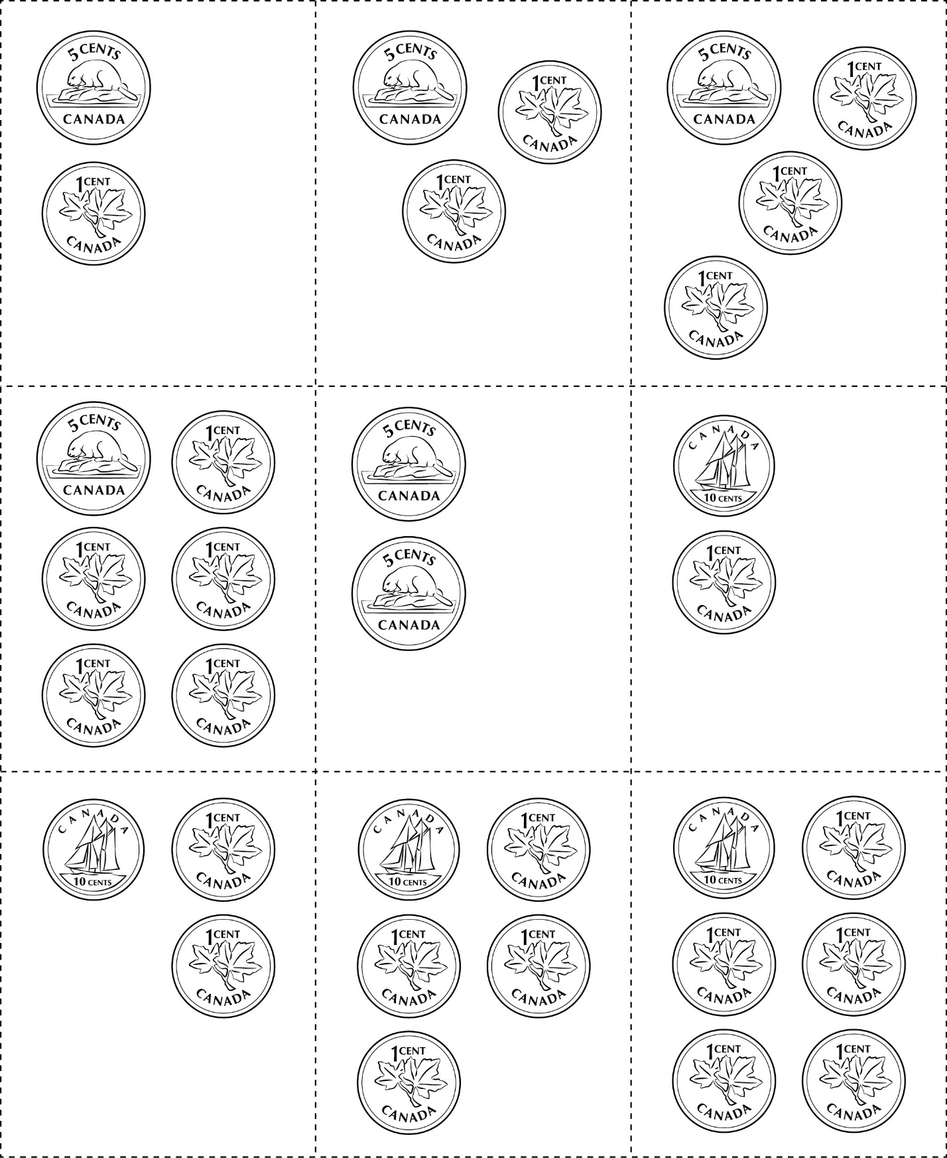



**Coin Cards**

**Master 50b**

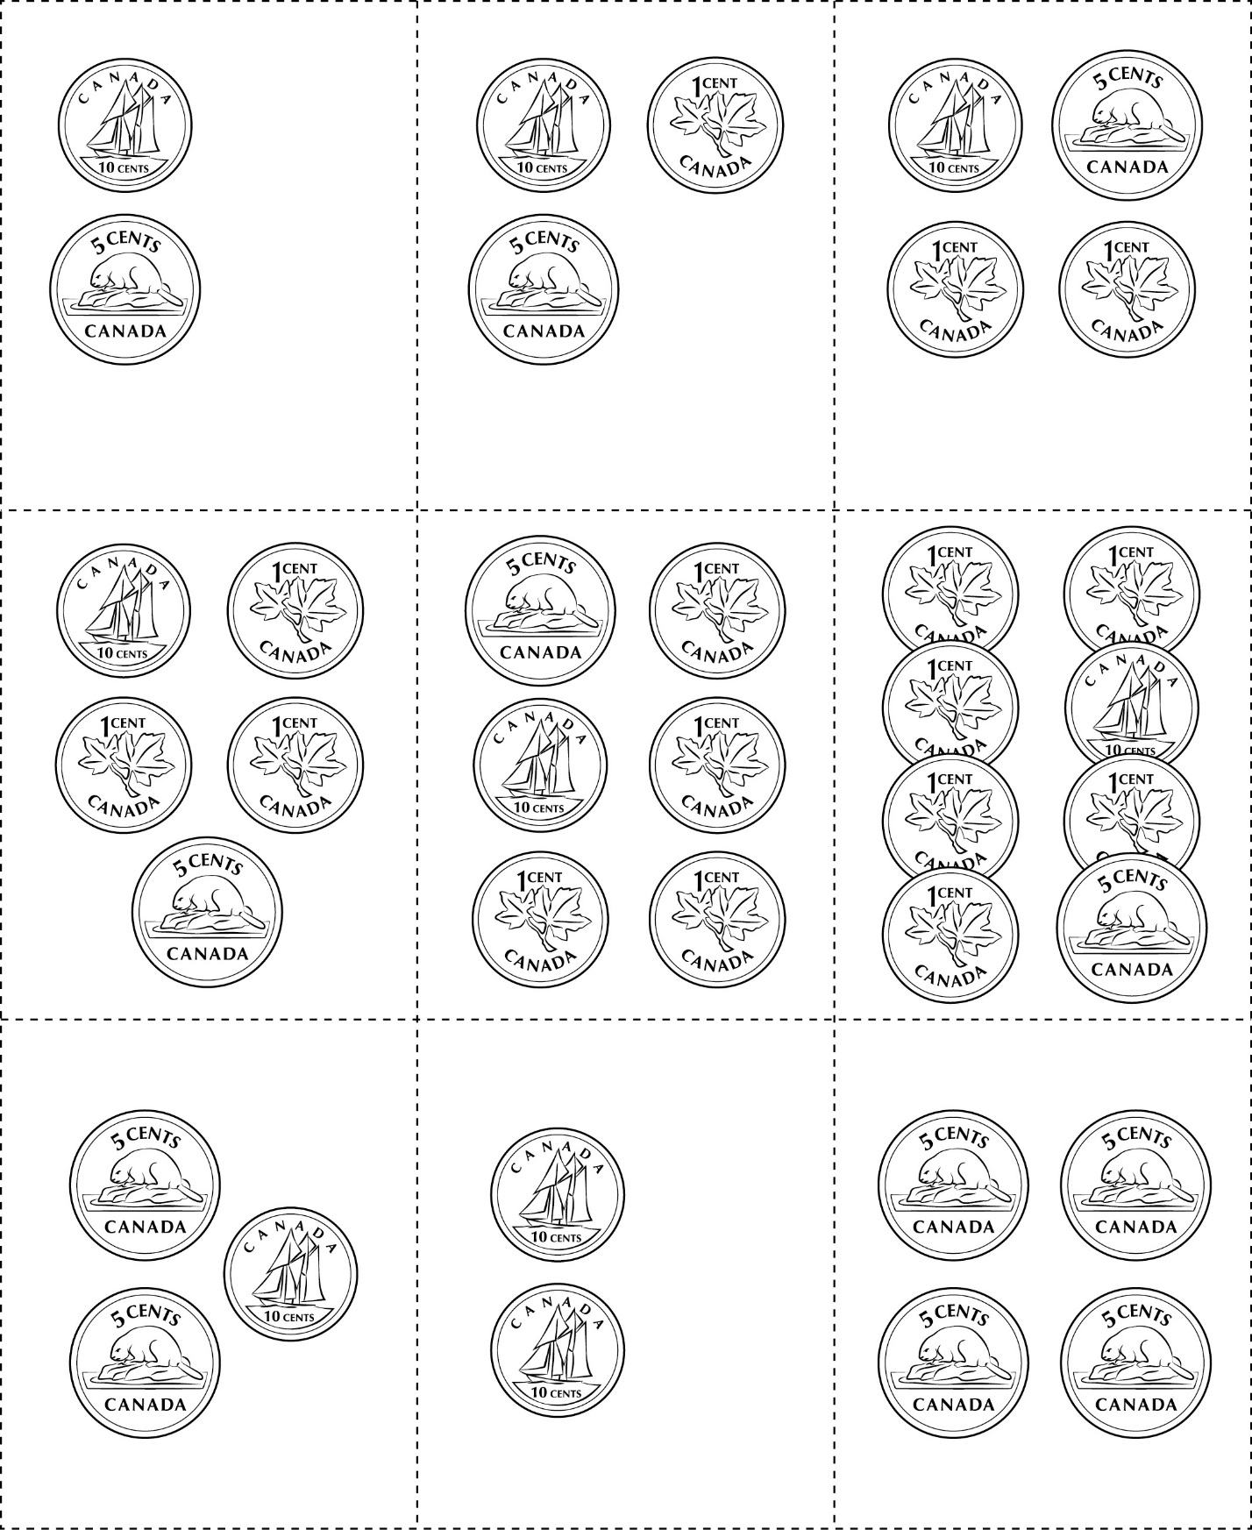



**Coin Cards**

**Master 50c**

(for Extension)

