Representing and Counting Behaviours/Strategies
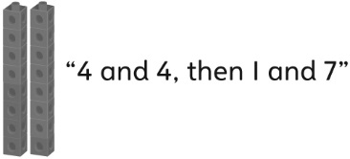  Student selects cubes randomly. | 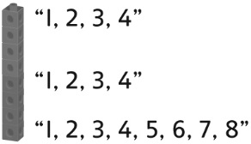  Student counts three times to confirm how many. | 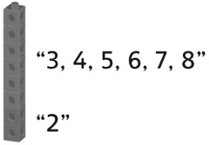  Student counts on to confirm how many.
Observations/Documentation
Student takes the tower apart and starts again to find a new way. | Student uses patterns to find all possible ways to model the number with cubes. | 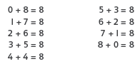  Student uses known number relationships to show all possible ways.
Observations/Documentation

