Skip-Counting Backward Behaviours/Strategies
Student mixes up the numbers in the skip-counting backward sequence.  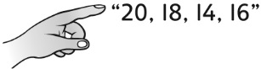 | Student counts backward by 2s to 10, then struggles to know which number comes next.  “20, 18, 16, 14, 12, 10, ?” | Student counts backward by 2s and 5s, but doesn’t know when to stop.  “20, 18, 16, 14, 12, 10, 8  Can I stop yet?” | Student counts backward by 2s from 20 and by 5s from 30 with confidence and understanding.
Observations/Documentation

