Representing, Comparing, and Ordering Numbers Behaviours/Strategies
Student does not recognize the numbers on the craft sticks. | Student does not say one number word for each counter counted when modelling the numbers. | Student randomly places the sticks on the card.  “27, 6, 19” | Student focuses on the last digit of the numbers.  “22, 43, 19”  “When I count, I say 2 before 3 and 3 before 9.”
Observations/Documentation
Student models the numbers with counters, then compares the sets using one-to-one matching. | Student models the numbers with counters, then counts to compare the sets. | Student places craft sticks down in reverse order.  “26, 19, 6” | 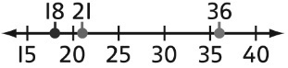  Students uses mental strategies to compare sets (36 comes after 21 and 21 comes after 18 on a number line).
Observations/Documentation

