**Number Cards (1–10)**

**Master 14a**

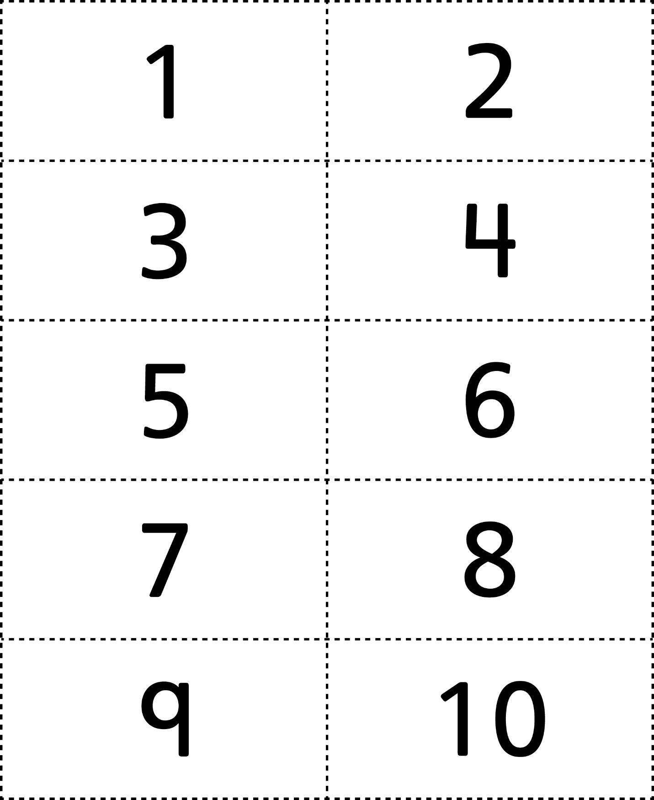



**Number Cards (11–20)**

**Master 14b**

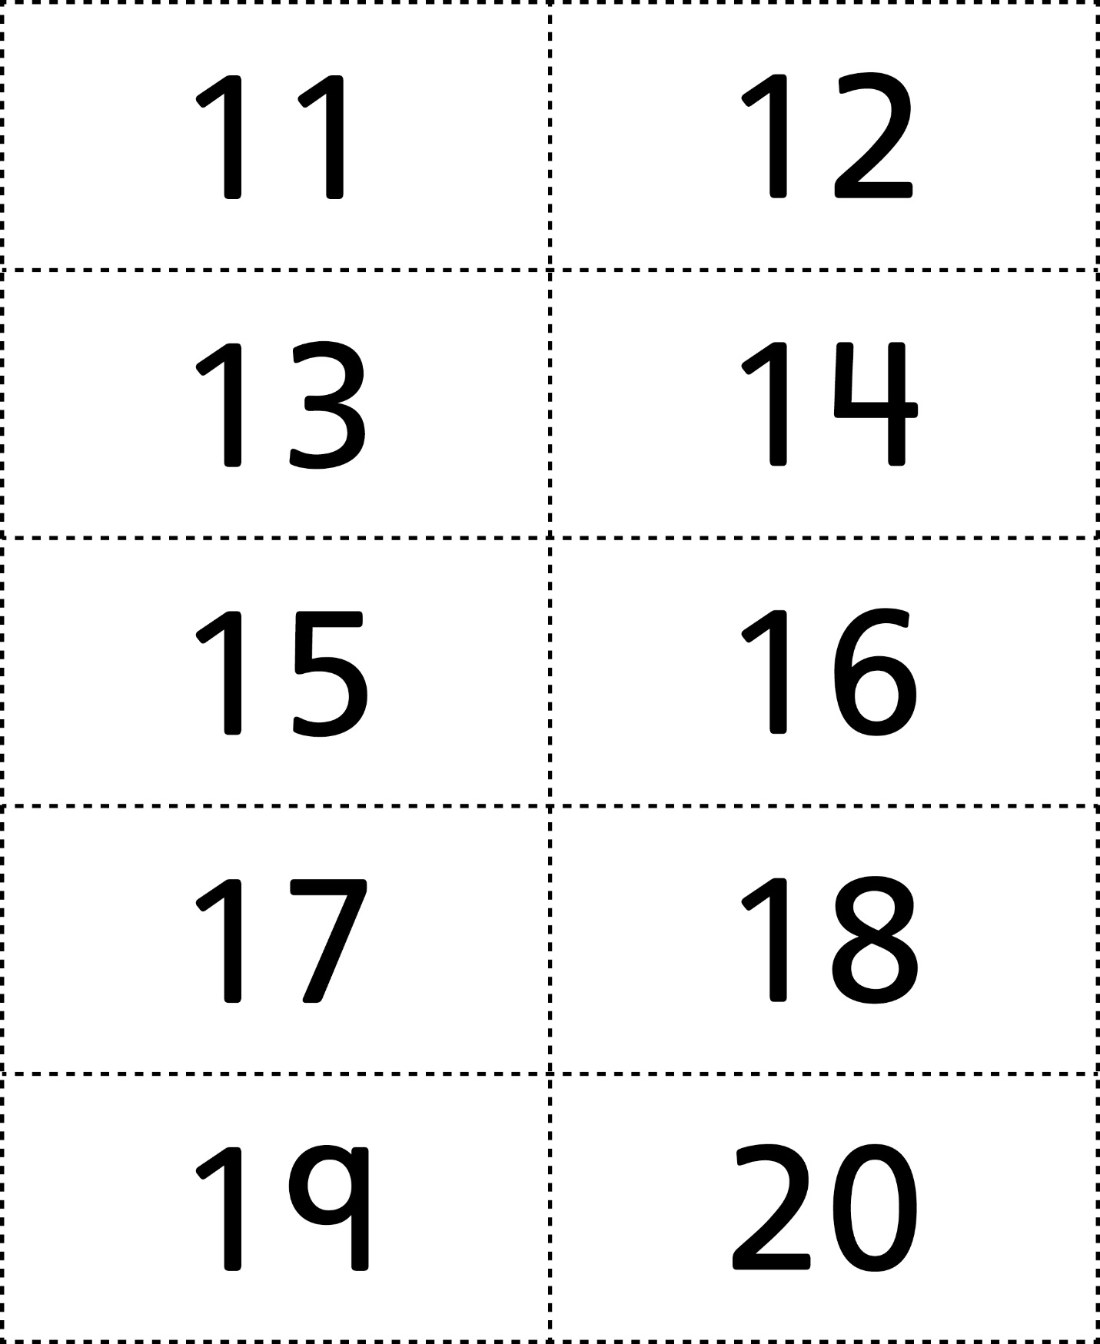



**Number Cards (21–30)**

**Master 14c**

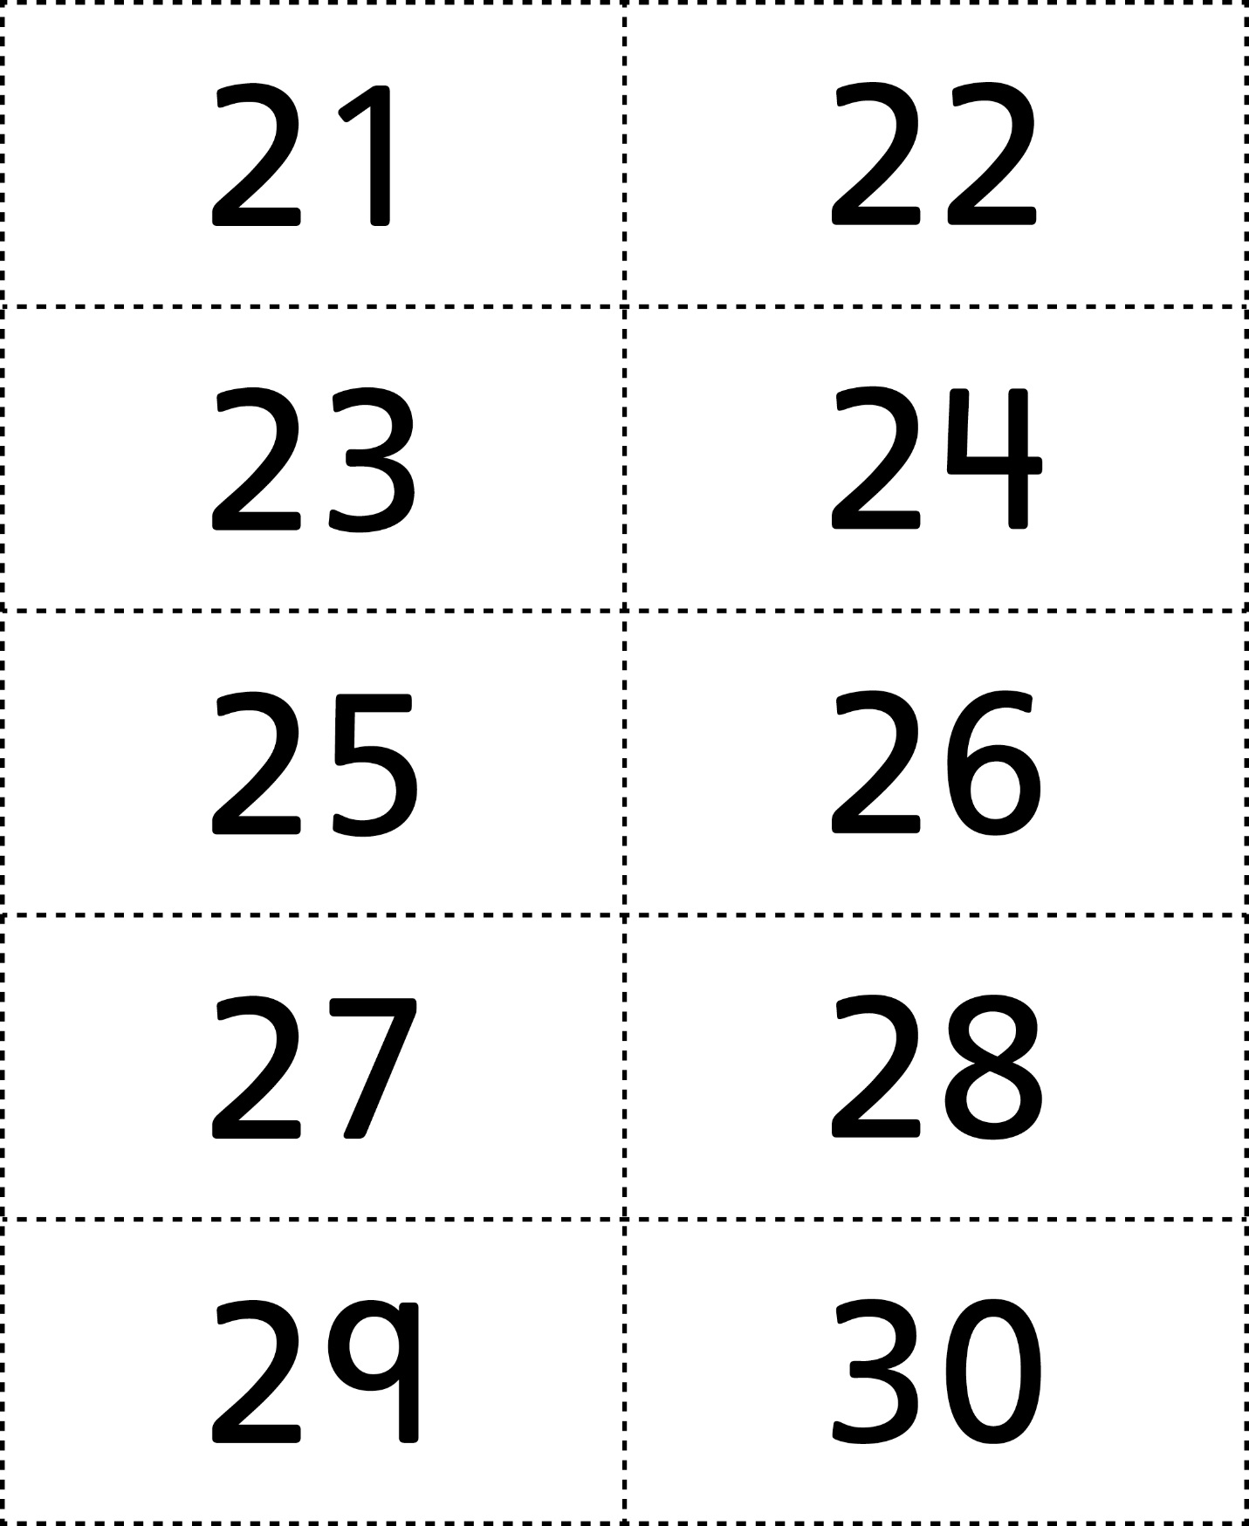



**Number Cards (31–40)**

**Master 14d**

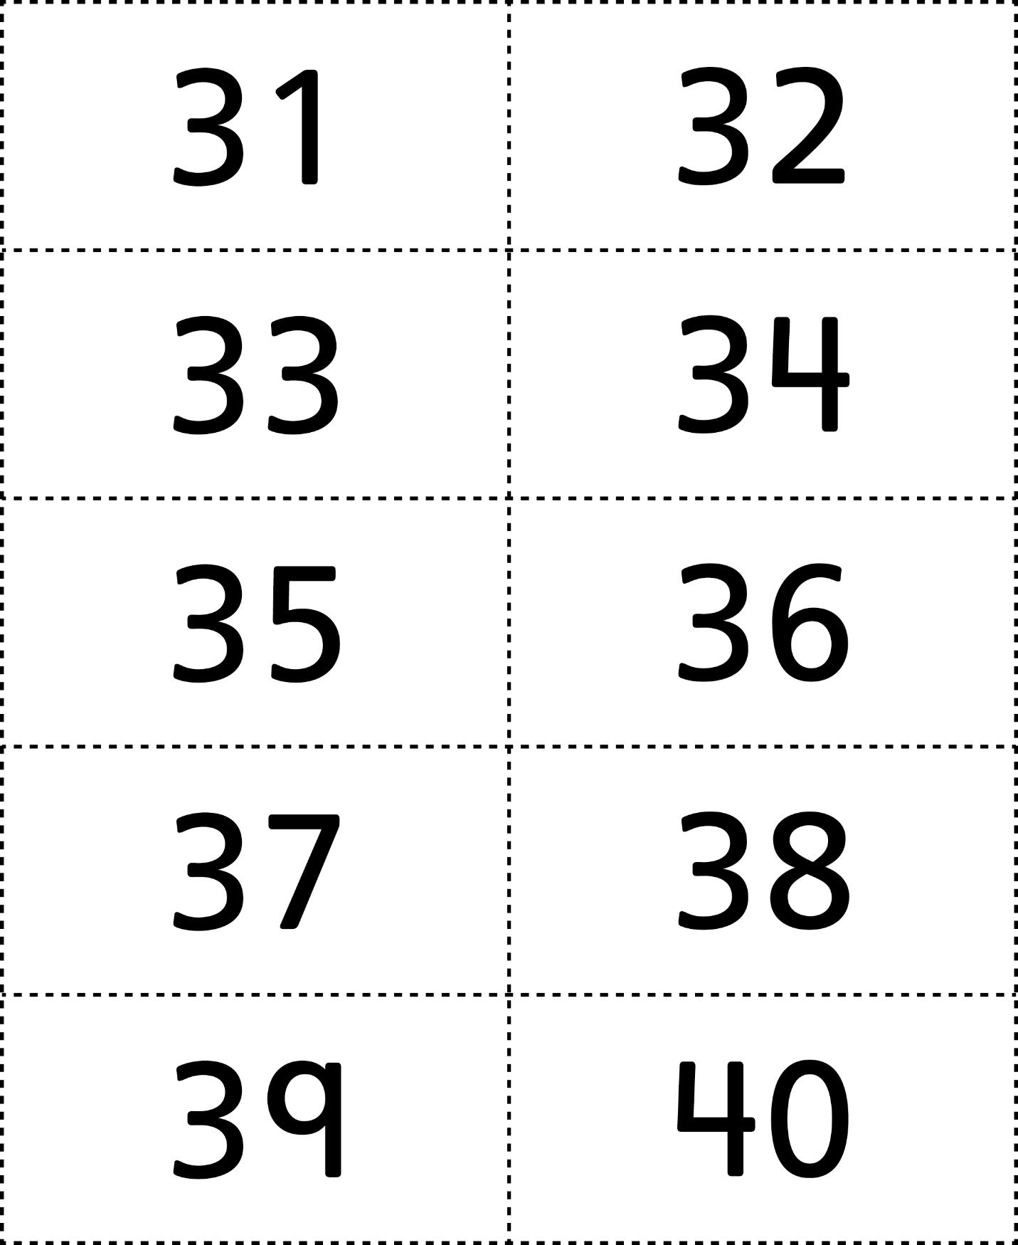



**Number Cards (41–50)**

**Master 14e**

