***Hopping Back* Game Boards**

**Master 9a**

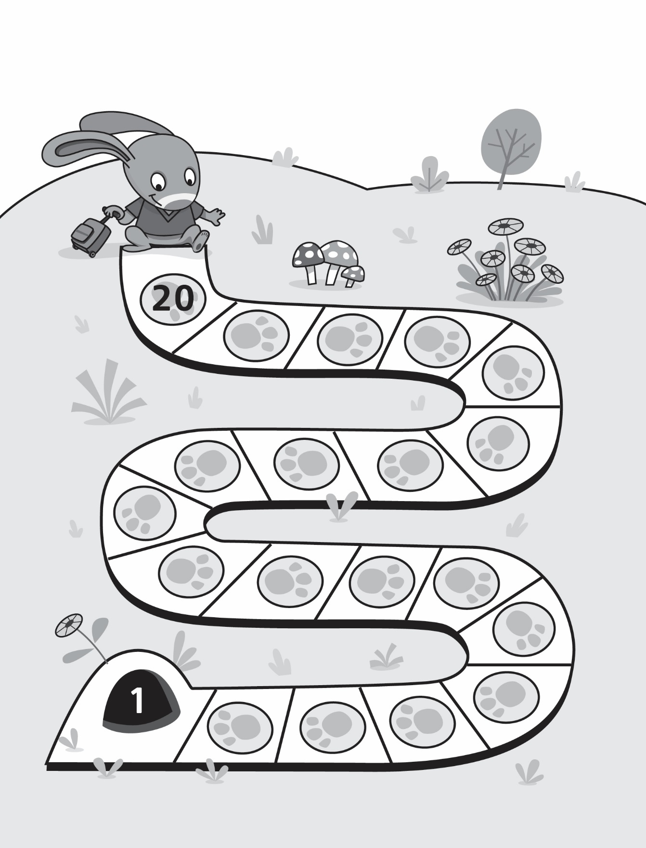

***Hopping Back* Game Boards**

**Master 9b**

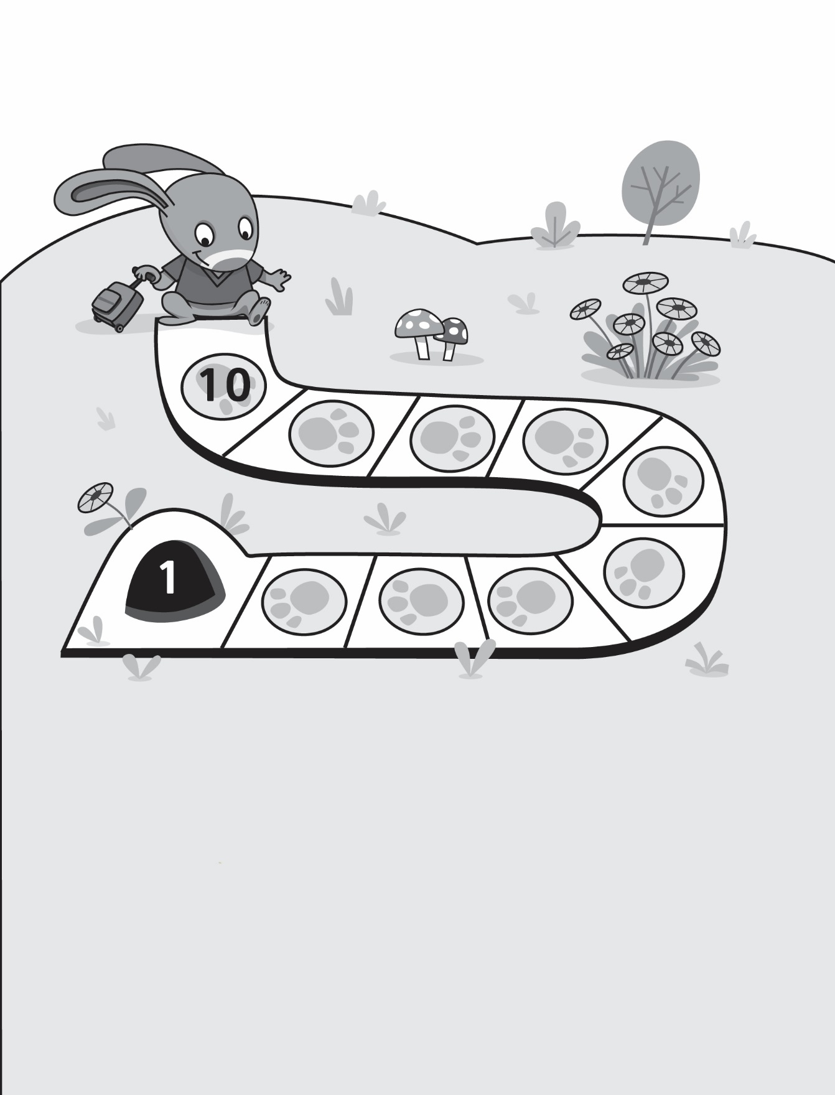

***Hopping Back* Game Boards**

**Master 9c**

