**Ordinal Number Cards**

**Master 46a**

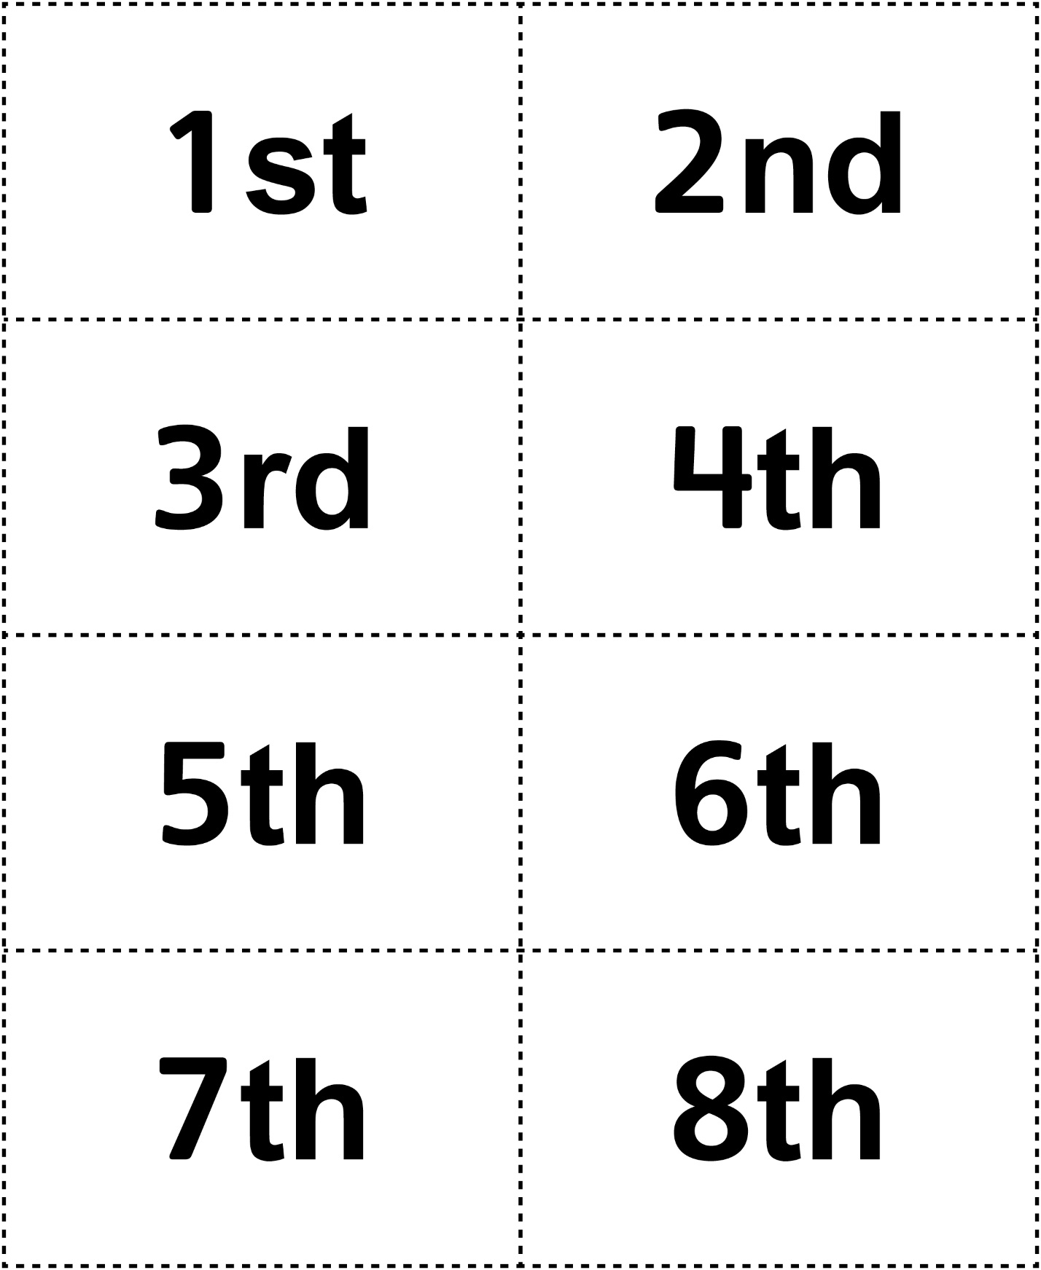



**Ordinal Number Cards**

**Master 46b**

